FIX Global Technical Committee

RegulatoryTradeIDGrp Enhancements

August 15, 2022

v0.2

Proposal Status: Draft

DISCLAIMER

THE INFORMATION CONTAINED HEREIN AND THE FINANCIAL INFORMATION EXCHANGE PROTOCOL (COLLECTIVELY, THE "FIX PROTOCOL") ARE PROVIDED "AS IS" AND NO PERSON OR ENTITY ASSOCIATED WITH THE FIX PROTOCOL MAKES ANY REPRESENTATION OR WARRANTY, EXPRESS OR IMPLIED, AS TO THE FIX PROTOCOL (OR THE RESULTS TO BE OBTAINED BY THE USE THEREOF) OR ANY OTHER MATTER AND EACH SUCH PERSON AND ENTITY SPECIFICALLY DISCLAIMS ANY WARRANTY OF ORIGINALITY, ACCURACY, COMPLETENESS, MERCHANTABILITY OR FITNESS FOR A PARTICULAR PURPOSE. SUCH PERSONS AND ENTITIES DO NOT WARRANT THAT THE FIX PROTOCOL WILL CONFORM TO ANY DESCRIPTION THEREOF OR BE FREE OF ERRORS. THE ENTIRE RISK OF ANY USE OF THE FIX PROTOCOL IS ASSUMED BY THE USER.

NO PERSON OR ENTITY ASSOCIATED WITH THE FIX PROTOCOL SHALL HAVE ANY LIABILITY FOR DAMAGES OF ANY KIND ARISING IN ANY MANNER OUT OF OR IN CONNECTION WITH ANY USER'S USE OF (OR ANY INABILITY TO USE) THE FIX PROTOCOL, WHETHER DIRECT, INDIRECT, INCIDENTAL, SPECIAL OR CONSEQUENTIAL (INCLUDING, WITHOUT LIMITATION, LOSS OF DATA, LOSS OF USE, CLAIMS OF THIRD PARTIES OR LOST PROFITS OR REVENUES OR OTHER ECONOMIC LOSS), WHETHER IN TORT (INCLUDING NEGLIGENCE AND STRICT LIABILITY), CONTRACT OR OTHERWISE, WHETHER OR NOT ANY SUCH PERSON OR ENTITY HAS BEEN ADVISED OF, OR OTHERWISE MIGHT HAVE ANTICIPATED THE POSSIBILITY OF, SUCH DAMAGES.

DRAFT OR NOT RATIFIED PROPOSALS (REFER TO PROPOSAL STATUS AND/OR SUBMISSION STATUS ON COVER PAGE) ARE PROVIDED "AS IS" TO INTERESTED PARTIES FOR DISCUSSION ONLY. PARTIES THAT CHOOSE TO IMPLEMENT THIS DRAFT PROPOSAL DO SO AT THEIR OWN RISK. IT IS A DRAFT DOCUMENT AND MAY BE UPDATED, REPLACED, OR MADE OBSOLETE BY OTHER DOCUMENTS AT ANY TIME. THE FPL GLOBAL TECHNICAL COMMITTEE WILL NOT ALLOW EARLY IMPLEMENTATION TO CONSTRAIN ITS ABILITY TO MAKE CHANGES TO THIS SPECIFICATION PRIOR TO FINAL RELEASE. IT IS INAPPROPRIATE TO USE FPL WORKING DRAFTS AS REFERENCE MATERIAL OR TO CITE THEM AS OTHER THAN “WORKS IN PROGRESS”. THE FPL GLOBAL TECHNICAL COMMITTEE WILL ISSUE, UPON COMPLETION OF REVIEW AND RATIFICATION, AN OFFICIAL STATUS ("APPROVED") OF/FOR THE PROPOSAL AND A RELEASE NUMBER.

This work is licensed under a Creative Commons Attribution-NoDerivatives 4.0 International License.

No proprietary or ownership interest of any kind is granted with respect to the FIX Protocol (or any rights therein).

Copyright 2003-2022 FIX Protocol Limited, all rights reserved.

Table of Contents

Document History 5
1 Introduction 6
2 Business Requirements 6
3 Issues and Discussion Points 6
4 Proposed Message Flow 6
5 FIX Message Tables 7
5.1 ExecutionReport(35=8) 7
5.2 TradeCaptureReport(35=AE) 8
6 FIX Component Blocks 9
6.1 Component MDFullGrp 9
6.2 Component MDIncGrp 10
7 Category Changes 10
Appendix A - Data Dictionary 11
Appendix B - Glossary Entries 12
Appendix C - Abbreviations 12
Appendix D - Usage Examples 12

Table of Figures

Document History
Revision | Date | Author | Revision Comments
v0.1 | August 11, 2022 | GTC PM | Initial draft
v0.2 | August 15, 2022 | GTC PM | Minor editorial changes

Introduction
This gap analysis proposal seeks to address a specific update to the CFTC Parts 43 and 45 reporting technical specification requirements, where both the Unique Swap Identifier (USI) and Unique Transaction Identifier (UTI) can be used for reporting purposes to the CFTC.

Business Requirements
The US Commodity Futures Trading Commission published an update to their Technical Specification for Parts 43 and 45 swap data reporting and public dissemination requirements September 30, 2021, Version 3.0 which can be found at this link:
https://www.cftc.gov/media/3496/DMO_Part43_45TechnicalSpecification022020/download
Supplementary information regarding the USI Data Standard can be found at this link:
https://www.cftc.gov/sites/default/files/idc/groups/public/@swaps/documents/dfsubmission/usidatastandards100112.pdf
In the updated guidelines, lines 102 and 103 from the table in Section 2 "Technical Specification and Validation Rules" indicated the following requirements (in summary of the image from the Technical Specification):
- USI - conditionally required if UTI is not populated, otherwise blank
- UTI - conditionally required if USI is not populated, otherwise blank

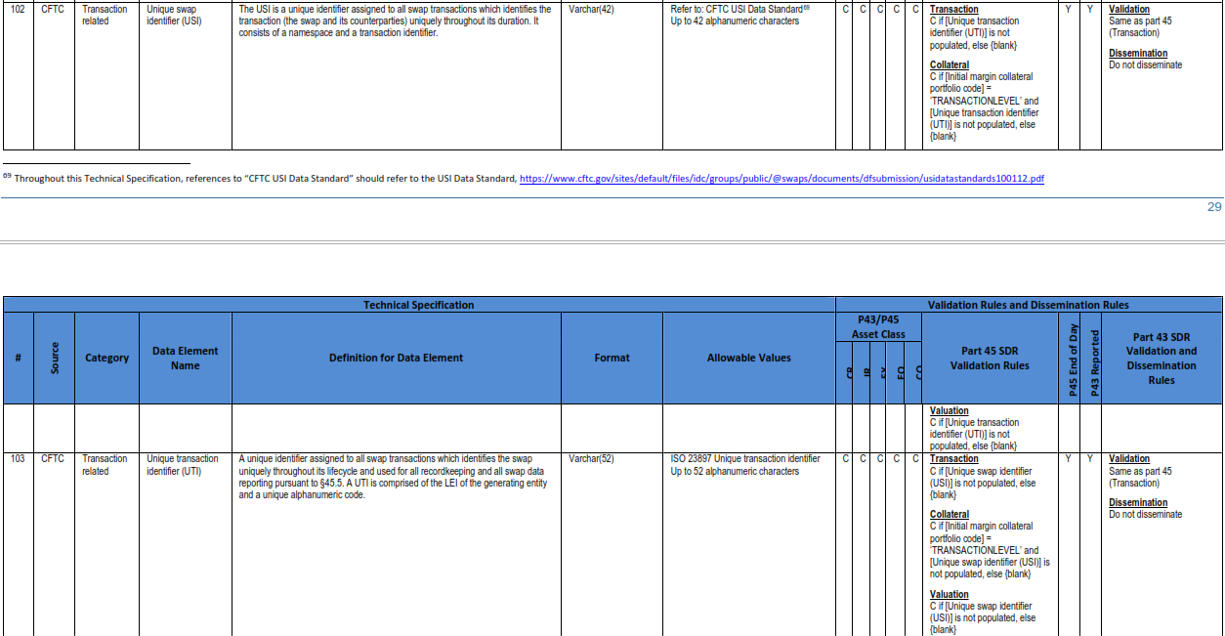
The USI follows the USI Data Standard as described in USI Data Standard link above, while the UTI is the ISO 23897.
When FIX was enhanced to support the Dodd-Frank Act's Parts 43/45 reporting requirements in 2012, the repeating components RegulatoryTradeIDGrp, SideRegulatoryTradeIDGrp and AllocRegulatoryTradeIDGrp were designed to meet the CFTC requirements as UTI was not yet a standard. The CFTC's USI Data Standard had called for a 2-field representation of the USI where the first "field" is the namespace identifying "the registered entity creating the USI" and the second "field" contains the transaction identifier, FIX's component was designed with this separation using the RegulatoryTradeID(1903) and RegulatoryTradeIDSource(1905) fields with the latter field being the field for the namespace.
The UTI ISO 23897 standard is defined as a single string where the entity creating the identifier is part of the UTI in the form of the entity's LEI (ISO 17442 Legal Entity Identifier), therefore a separate namespace is not needed.
In order to now meet the requirements of being able to convey both the USI and UTI in the same components in FIX, the following are the proposed changes to the RegulatoryTradeIDSource(1905) field's description in the FIX data dictionary:
- Add a field elaboration: In the context of CFTC usage for Unique Swap Identifier (USI), this field is required to convey the namespace of the entity creating the USI, in accordance to the USI Data Standard (https://www.cftc.gov/sites/default/files/idc/groups/public/@swaps/documents/dfsubmission/usidatastandards100112.pdf).
- Add a code set value to this field with a single value 1 = Unique Transaction Identifier (ISO 23897) to allow for explicit indication that the value in RegulatoryTradeID(1903) is a UTI value.
Implementations may choose to bilaterally agree to omit RegulatoryTradeIDSource(1905) if they are conveying UTI in RegulatoryTradeID(1903) as this field is not required in the repeating group. However, RegulatoryTradeIDSource(1905) is required to contain the namespace when conveying USI.

Issues and Discussion Points

Proposed Message Flow
There are not changes to existing message flows.

FIX Message Tables
No changes

FIX Component Blocks
No changes

Category Changes
No changes

Appendix A - Data Dictionary

Tag | FieldName | Action | Datatype | Description | FIXML Abbreviation | Add to / Deprecate from Message type or Component block
1905 | RegulatoryTradeIDSource | CHANGE | String | Identifies the reporting entity that originated the value in RegulatoryTradeID(1903). The reporting entity identifier may be assigned by a regulator.  Elaboration: In the context of CFTC usage for Unique Swap Identifier (USI), this field is required to convey the namespace of the entity creating the USI, in accordance to the USI Data Standard (https://www.cftc.gov/sites/default/files/idc/groups/public/@swaps/documents/dfsubmission/usidatastandards100112.pdf).  Supported values:  1 = Unique Transaction Identifier (ISO 23897) | Src
1910 | AllocRegulatoryTradeIDSource | CHANGE | String | Identifies the reporting entity that originated the value in AllocRegulatoryTradeID(1909). The reporting entity identifier may be assigned by a regulator.  Elaboration: In the context of CFTC usage for Unique Swap Identifier (USI), this field is required to convey the namespace of the entity creating the USI, in accordance to the USI Data Standard (https://www.cftc.gov/sites/default/files/idc/groups/public/@swaps/documents/dfsubmission/usidatastandards100112.pdf).  Uses enums from RegulatoryTradeIDSource(1905) | Src
1973 | SideRegulatoryTradeIDSource | CHANGE | String | Identifies the reporting entity that originated the value in SideRegulatoryTradeID(1972). The reporting entity identifier may be assigned by a regulator.  Elaboration: In the context of CFTC usage for Unique Swap Identifier (USI), this field is required to convey the namespace of the entity creating the USI, in accordance to the USI Data Standard (https://www.cftc.gov/sites/default/files/idc/groups/public/@swaps/documents/dfsubmission/usidatastandards100112.pdf).  Uses enums from RegulatoryTradeIDSource(1905) | Src

Appendix B - Glossary Entries

Term | Definition | Field where used

Appendix C - Abbreviations

Term | Proposed Abbreviation | Proposed Messages, Components, Fields where used
Anonymous | anonyms

Appendix D - Usage Examples

[Examples may be entered below this line]

