Global Post-trade Working Group

FX Trade Aggregation Proposal

[Sept. 21, 2018]

[Revision 0.4]

Proposal Status: Public Comment

DISCLAIMER

THE INFORMATION CONTAINED HEREIN AND THE FINANCIAL INFORMATION EXCHANGE PROTOCOL (COLLECTIVELY, THE "FIX PROTOCOL") ARE PROVIDED "AS IS" AND NO PERSON OR ENTITY ASSOCIATED WITH THE FIX PROTOCOL MAKES ANY REPRESENTATION OR WARRANTY, EXPRESS OR IMPLIED, AS TO THE FIX PROTOCOL (OR THE RESULTS TO BE OBTAINED BY THE USE THEREOF) OR ANY OTHER MATTER AND EACH SUCH PERSON AND ENTITY SPECIFICALLY DISCLAIMS ANY WARRANTY OF ORIGINALITY, ACCURACY, COMPLETENESS, MERCHANTABILITY OR FITNESS FOR A PARTICULAR PURPOSE. SUCH PERSONS AND ENTITIES DO NOT WARRANT THAT THE FIX PROTOCOL WILL CONFORM TO ANY DESCRIPTION THEREOF OR BE FREE OF ERRORS. THE ENTIRE RISK OF ANY USE OF THE FIX PROTOCOL IS ASSUMED BY THE USER.

NO PERSON OR ENTITY ASSOCIATED WITH THE FIX PROTOCOL SHALL HAVE ANY LIABILITY FOR DAMAGES OF ANY KIND ARISING IN ANY MANNER OUT OF OR IN CONNECTION WITH ANY USER'S USE OF (OR ANY INABILITY TO USE) THE FIX PROTOCOL, WHETHER DIRECT, INDIRECT, INCIDENTAL, SPECIAL OR CONSEQUENTIAL (INCLUDING, WITHOUT LIMITATION, LOSS OF DATA, LOSS OF USE, CLAIMS OF THIRD PARTIES OR LOST PROFITS OR REVENUES OR OTHER ECONOMIC LOSS), WHETHER IN TORT (INCLUDING NEGLIGENCE AND STRICT LIABILITY), CONTRACT OR OTHERWISE, WHETHER OR NOT ANY SUCH PERSON OR ENTITY HAS BEEN ADVISED OF, OR OTHERWISE MIGHT HAVE ANTICIPATED THE POSSIBILITY OF, SUCH DAMAGES.

DRAFT OR NOT RATIFIED PROPOSALS (REFER TO PROPOSAL STATUS AND/OR SUBMISSION STATUS ON COVER PAGE) ARE PROVIDED "AS IS" TO INTERESTED PARTIES FOR DISCUSSION ONLY. PARTIES THAT CHOOSE TO IMPLEMENT THIS DRAFT PROPOSAL DO SO AT THEIR OWN RISK. IT IS A DRAFT DOCUMENT AND MAY BE UPDATED, REPLACED, OR MADE OBSOLETE BY OTHER DOCUMENTS AT ANY TIME. THE FPL GLOBAL TECHNICAL COMMITTEE WILL NOT ALLOW EARLY IMPLEMENTATION TO CONSTRAIN ITS ABILITY TO MAKE CHANGES TO THIS SPECIFICATION PRIOR TO FINAL RELEASE. IT IS INAPPROPRIATE TO USE FPL WORKING DRAFTS AS REFERENCE MATERIAL OR TO CITE THEM AS OTHER THAN “WORKS IN PROGRESS”. THE FPL GLOBAL TECHNICAL COMMITTEE WILL ISSUE, UPON COMPLETION OF REVIEW AND RATIFICATION, AN OFFICIAL STATUS ("APPROVED") OF/FOR THE PROPOSAL AND A RELEASE NUMBER.

No proprietary or ownership interest of any kind is granted with respect to the FIX Protocol (or any rights therein).

Copyright 2003-2018 FIX Protocol Limited, all rights reserved.

Table of Contents

Document History 5
1 Introduction 6
2 Business Requirements 6
2.1 Summary of changes 6
3 Issues and Discussion Points 6
4 Proposed Message Flow 7
4.1 Trade aggregation 7
4.2 Adding to aggregated trade 9
5 FIX Message Tables 11
5.1 TradeAggregationRequest(35=tbd) 11
5.2 TradeAggregationReport(35=tbd) 12
5.3 NewOrderSingle(35=D) 14
5.4 OrderCancelReplaceRequest(35=G) 15
5.5 AllocationInstruction(35=J) 16
5.6 ExecutionReport(35=8) 17
6 FIX Component Blocks 18
6.1 OrderAggregationGrp 18
6.2 ExecutionAggregationGrp 19
6.3 RateSource 20
Appendix A - Data Dictionary 21
Appendix B - Glossary Entries 23
Appendix C - Abbreviations 23
Appendix D - Usage Examples 23

Table of Figures

Figure 1: Basic trade aggregation 7
Figure 2: Adding to existing aggregated trade 9

Document History
Revision | Date | Author | Revision Comments
0.1 | Aug. 10, 2018 | PTWG, edited by L. Taikitsadaporn | Initial draft
0.2 | Sept. 10, 2018 | PTWG, edited by L. Taikitsadaporn | Revised based on in-person meeting in NY Aug. 20.
0.3 | Sept. 18, 2018 | PTWG, edited by L. Taikitsadaporn | Revised based on PTWG conference call on Sept. 13, 2018.
0.4 | Sept. 20, 2018 | GTC | Revised based on FPL GTC call on Sept. 20, 2018.

Introduction
This gap analysis proposal is submitted by the Global Post-Trade Working Group to address a requirement identified by the PTWG related to the post-trade process for FX trading. The PTWG has a separate initiative document a recommended practice for using FIX to support FX trade and post-trade communication directly between buy-side and sell-side firms. In the process of preparing the recommended practices gaps were identified within the scope of supporting FX spot, vanilla forwards and non-deliverable forward transactions.

Business Requirements
A key aspect of FX trading between buy-side institutions and sell-side FX banks is a need to aggregate trades. Currently on 3rd party platforms, this is facilitated by the platforms. However, as part of the initiative by the Global Post-Trade Working Group to conduct more bilateral interactions between the firms, a gap was identified on the operational aspects of trade aggregation. Trade aggregation is done post trade, where individual trades are identified to be aggregated by the buy-side and communicated to the sell-side. Once aggregated the "child trades" no longer exist from the broker's perspective - the aggregated trade is the trade that now exist in their books. This becomes the trade that the dealers know about which will be allocated.

Summary of changes
The changes proposed to meet the key requirements along with additional requirements are as follows:
- New messages to support trade aggregation: TradeAggregationRequest(35=tbd) and TradeAggregationReport(35=tbd)
- Enhance RateSource component with a new field to identify the FX benchmark rate fix or cut-time. The FX benchmark rate fix is market practice spot rate fixing time used for valuation and pricing. There are different algorithms to calculate the spot rate fix depending on the publisher, however, these benchmark rate fixes are published only at certain time of day and is market location specific. To support this a new field is being added to RateSource component called FXBenchmarkRateFix(tbd)
- An ability to identify whether the FX rate is an offshore or onshore rate. Offshore rate exists for certainly currencies due to restrictions on the delivery of the currency. To meet this requirement a new field, OffshoreIndicator(tbd) is proposed to indicate whether the rate is "regular", "offshore" or "onshore". A rate identified as "regular" is a currency where there is no distinction of offshore and onshore rates.

Issues and Discussion Points
The PTWG discussed the merits of using existing message TradeCaptureReport(35=AE) for the purpose of trade aggregation instead of introducing new message types and flows. While it is beneficial to use the existing messages, the consensus within the group was that the TradeCaptureReport(35=AE) is already being heavily used by market participants for several different purposes. This has resulted in a significant complexity of the existing message which should not be further increased.
Additionally, the trade aggregation initiated by the buy-side is an instruction to the sell-side to aggregate, rather than reporting of trades to be aggregated, where there is an operational workflow that would need to be supported.
In order to avoid overloading the TradeCaptureReport (35=AE) message, the group concluded it will be best to segregate the specific flow of trade aggregation by introducing the new messages TradeAggregationRequest (tbd) and TradeAggregationReport (tbd). Eventually these new message types could serve as an example for additional messages supporting related specific workflows e.g. trade separation. The concept of grouping trades exists also in the AllocationInstruction(35=J) message where listed derivative clearinghouses allows trades to be identified to be grouped together for allocation. This method was also discussed and considered by the PTWG. However, the PTWG concluded that this method causes too much confusion with the buy-sides' and sell-sides' operational process of actually allocating to sub-accounts or fund accounts for final confirmation and then trade settlement. For similar reasons, it was concluded that new messages would better provide clearer delineation between the two types of post-trade processes.

Proposed Message Flow

Trade aggregation
The basic flow for FX trade aggregation is illustrated below. The buy-side may optionally send their view of average price across the trades being sent for aggregation of identified trades.
In the event the sell-side rejects the buy-side's trade aggregation request, e.g. if the sell-side doesn't agree with the buy-side's average price or for unknown reference trades, resolving the error is expected to be conducted offline (i.e. via phone call).
In the scenario where the buy-side does not agree with the average aggregated price provided by the sell-side, the PTWG expects that the buy-side will pick up the phone to resolve the issue with the sell-side. Once the manual correction is made by both the buy-side and sell-side, the same sell-side's TradeID(1003) can be used in allocation process.
It should be noted that in the FX market, for the FX brokers, once a set of fills have been aggregated and the aggregated trade is created in their books, there is no easy way to "unwind" it back into the individual fills. For the purpose of the PTWG and FX use, both sides would correct the error manually.

Figure 1: Basic trade aggregation
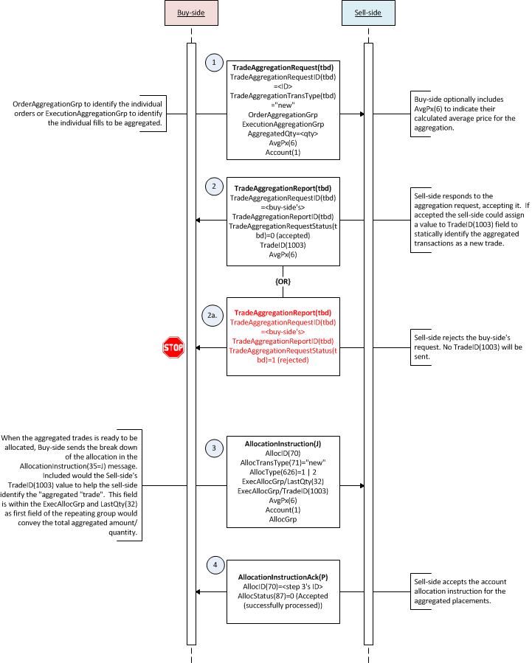

Adding to aggregated trade
The buy-side may add additional order(s) or fill(s) to a previously aggregated trade. The workflow is same as creating a new aggregated trade, however, the key for the FX dealers is the need for the TradeID(1003) value of the previous aggregated trade to be specified. When the dealer accepts the additional order/trades to be aggregated, a new TradeID(1003) value will be assigned.
The workflow diagram below illustrates this specific use case.

Figure 2: Adding to existing aggregated trade
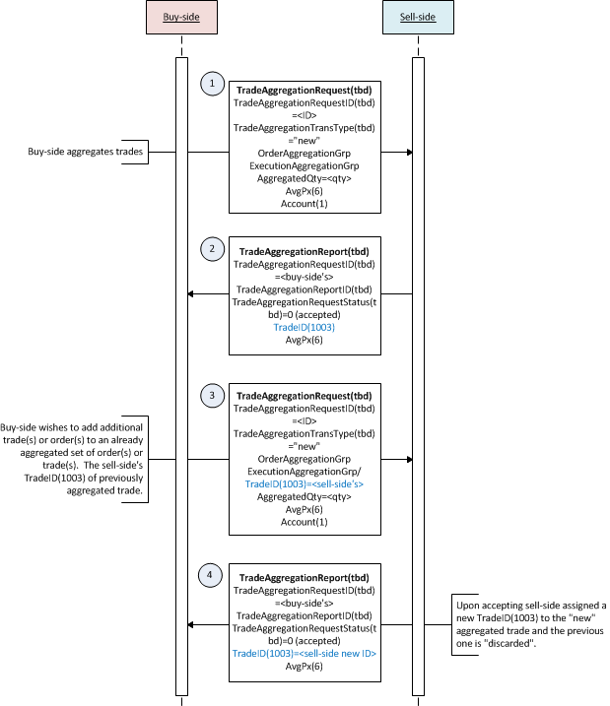

FIX Message Tables

TradeAggregationRequest(35=tbd)
To be completed at the time of the proposal – all information provided will be stored in the repository
Message Name |  | TradeAggregationRequest
Message Abbreviated Name (for FIXML) |  | TrdAggrtnReq
Category |  | Post trade
Action |  | _X_New __Change
Message Synopsis | TradeAggregationRequest(35=tbd) is used to request that the identified trades between the initiator and respondent be aggregated together for further processing.
Message Elaboration

To be finalized by FPL Technical Office
(MsgType(tag 35) Enumeration
Repository Component ID

Tag | Field Name | Req'd | Action | Mappings and Usage Comments | FIX Spec Comments
Standard Header |  | Y |  |  | MsgType=tbd
tbd | TradeAggregationRequestID | Y |  |  | Unique identifier for the message.
tbd | RefTradeAggregationRequestID | N |  |  | Required when TradeAggregationTransType(tbd)=1 (Cancel) or 2 (Replace)
tbd | TradeAggregationTransType | Y |  | Note that for the recommended practices only “new” is supported
tbd | AggregatedQty | N |  | This may optionally be used to show the aggregated amount/quantity in this message based on the orders or executions identified in either of the components below.
15 | Currency | N |  | Identifies the dealt currency for aggregation.
6 | AvgPx | N |  | The all-in average price, if specified, for the aggregation.
54 | Side | Y
2349 | PricePrecision | N
OrderAggregationGrp component |  | N |  |  | Maybe used to specify the IDs of the orders being aggregated together.
ExecutionAggregationGrp component |  | N |  | This will be mandatory for FX recommended practices | Maybe used to specify the IDs of the execution fills being aggregated together.
1 | Account | N |  | Aggregation or holding account identifier.
Instrument component |  | Y
Parties component |  | N
Standard Trailer |  | Y

TradeAggregationReport(35=tbd)
To be completed at the time of the proposal – all information provided will be stored in the repository
Message Name |  | TradeAggregationReport
Message Abbreviated Name (for FIXML) |  | TrdAggrtnRpt
Category |  | Post trade
Action |  | _X_New __Change
Message Synopsis | TradeAggregationReport(35=tbd) is used to respond to the TradeAggregationRequest(35=tbd0 message. It provides the status of the request (e.g. accepted or rejected) and may also provide additional information supplied by the respondent.
Message Elaboration

To be finalized by FPL Technical Office
(MsgType(tag 35) Enumeration
Repository Component ID

Tag | Field Name | Req'd | Action | Mappings and Usage Comments | FIX Spec Comments
Standard Header |  | Y |  |  | MsgType=tbd
tbd | TradeAggregationReportID | Y |  |  | Unique identifier for the report message.
tbd | TradeAggregationRequestID | N |  |  | Unique identifier for the TradeAggregationRequest(35=tbd) message being responded to.
tbd | TradeAggregationRequestStatus | Y
1003 | TradeID | N |  | This would be used by the sell-side to provide an aggregated trade identifier if the request was accepted. | Conditionally required when TradeAggregationRequestStatus(tbd)=0 (Accepted).  The trade identifier for the group of aggregated trades.
tbd | TradeAggregationRejectReason | N
tbd | AggregatedQty | N |  |  | Conditionally required when TradeAggregationRequestStatus(tbd)=0 (Accepted).
6 | AvgPx | N |  | The all-in average rate for the aggregated trades. | Conditionally required when TradeAggregationRequestStatus(tbd)=0 (Accepted).
tbd | AvgSpotRate | N
tbd | AvgForwardPoints | N
64 | SettlDate | N
Instrument component |  | N |  |  | Conditionally required when TradeAggregationRequestStatus(tbd)=0 (Accepted).
56 | Side | N |  |  | Conditionally required when TradeAggregationRequestStatus(tbd)=0 (Accepted).
1328 | RejectText | N |  | Optionally used to provide a text narrative for rejecting the request.
1664 | EncodedRejectTextLen | N |  |  | Must be set if EncodedRejectText(1665) field is specified and must immediately precede it.
1665 | EncodedRejectText | N |  |  | Encoded (non-ASCII characters) representation of the RejectText(1328) field in the encoded format specified via the MessageEncoding(347) field.
Standard Trailer |  | Y

NewOrderSingle(35=D)
To be completed at the time of the proposal – all information provided will be stored in the repository
Message Name |  | NewOrderSingle
Message Abbreviated Name (for FIXML)
Category
Action |  | __New X__Change
Message Synopsis

Message Elaboration

To be finalized by FPL Technical Office
(MsgType(tag 35) Enumeration
Repository Component ID

Tag | Field Name | Req'd | Action | Mappings and Usage Comments | FIX Spec Comments
Standard Header |  | Y |  |  | MsgType=D
11 | ClOrdID
2422 | OrderRequestID
(…truncated…)
121 | ForexReq
120 | SettlCurrency
RateSource component |  | N | ADD
tbd | OffshoreIndicator | N | ADD
775 | BookingType
58 | Text
(…truncated…)
Standard Trailer |  | Y

OrderCancelReplaceRequest(35=G)
To be completed at the time of the proposal – all information provided will be stored in the repository
Message Name |  | NewOrderSingle
Message Abbreviated Name (for FIXML)
Category
Action |  | __New X__Change
Message Synopsis

Message Elaboration

To be finalized by FPL Technical Office
(MsgType(tag 35) Enumeration
Repository Component ID

Tag | Field Name | Req'd | Action | Mappings and Usage Comments | FIX Spec Comments
Standard Header |  | Y |  |  | MsgType=D
37 | OrderID
2422 | OrderRequestID
(…truncated…)
121 | ForexReq
120 | SettlCurrency
RateSource component |  | N | ADD
tbd | OffshoreIndicator | N | ADD
775 | BookingType
58 | Text
(…truncated…)
Standard Trailer |  | Y

AllocationInstruction(35=J)
To be completed at the time of the proposal – all information provided will be stored in the repository
Message Name |  | AllocationInstruction
Message Abbreviated Name (for FIXML)
Category
Action |  | __New X__Change
Message Synopsis

Message Elaboration

To be finalized by FPL Technical Office
(MsgType(tag 35) Enumeration
Repository Component ID

Tag | Field Name | Req'd | Action | Mappings and Usage Comments | FIX Spec Comments
Standard Header |  | Y |  |  | MsgType=D
70 | AllocID | Y
2758 | AllocRequestID | N
(…truncated…)
SpreadOfBenchmarkCurveData |  | N
15 | Currency | N
74 | AvgPxPrecision | N
tbd | OffshoreIndicator | N | ADD
Parties |  | N
(…truncated…)
Standard Trailer |  | Y

ExecutionReport(35=8)

To be completed at the time of the proposal – all information provided will be stored in the repository
Message Name |  | ExecutionReport
Message Abbreviated Name (for FIXML) |  | ExecRpt
Category |  | (no change)
Action |  | __New _X_Change
Message Synopsis | (no change)
Message Elaboration | (no change)
To be finalized by FPL Technical Office
(MsgType(tag 35) Enumeration |  | 8
Repository Component ID

Tag | Field Name | Req'd | Action | Mappings and Usage Comments | FIX Spec Comments
Standard Header |  | Y
Component Block ApplicationSequenceControl
37 | OrderID
2422 | OrderRequestID
(…truncated…)
118 | NetMoney
119 | SettleCurrAmt
120 | SettlCurrency
Component Block
RateSource
tbd | OffshoreIndicator | N | ADD
(…truncated…)
Standard Trailer |  | Y

FIX Component Blocks

OrderAggregationGrp

To be completed at the time of the proposal – all information provided will be included in the repository
Component Name |  | OrderAggregationGrp
Component Abbreviated Name (for FIXML) |  | OrdAggrtn
Component Type |  | _X__ Block Repeating ___ Block
Category |  | [enter the category name here]
Action |  | _X_New __Change
Component Synopsis | Identifies the orders being aggregated together.
Component Elaboration | [enter the component elaboration here]
To be finalized by FPL Technical Office
Repository Component ID

[Other additional text detailing usage of the component may be entered below this line]
Component FIXML Abbreviation: <OrdAggrtn>
Tag | Field Name |  | Req'd | Action | Mappings and Usage Comments | Comments
73 | NoOrders |  | N
→ | 11 | ClOrdID | N |  |  | Required if NoOrders(73) > 0.
→ | 37 | OrderID | N
→ | 38 | OrderQty | N |  |  | Required if NoOrders(73) > 0.
→ | 799 | OrderAvgPx | N
</OrdAggrtn>

ExecutionAggregationGrp

To be completed at the time of the proposal – all information provided will be included in the repository
Component Name |  | ExecutionAggregationGrp
Component Abbreviated Name (for FIXML) |  | ExecAggrtn
Component Type |  | _X__ Block Repeating ___ Block
Category |  | [enter the category name here]
Action |  | _X_New __Change
Component Synopsis | Identifies the fills being aggregated together.
Component Elaboration | [enter the component elaboration here]
To be finalized by FPL Technical Office
Repository Component ID

Component FIXML Abbreviation: <ExecAggrtn>
Tag | Field Name |  | Req'd | Action | Mappings and Usage Comments | Comments
124 | NoExecs |  | N
→ | 32 | LastQty | N |  |  | Required if NoExecs(124) > 0
→ | 17 | ExecID | N |  |  | Either ExecID(17) or TradeID(1003) must be specified.
→ | 1003 | TradeID | N |  |  | Either ExecID(17) or TradeID(1003) must be specified.
→ | 31 | LastPx | N
</ExecAggrtn>

RateSource

To be completed at the time of the proposal – all information provided will be included in the repository
Component Name |  | RateSource
Component Abbreviated Name (for FIXML) |  | RtSrc
Component Type |  | _X__ Block Repeating ___ Block
Category |  | [enter the category name here]
Action |  | __New X__Change
Component Synopsis | (no change)
Component Elaboration | [enter the component elaboration here]
To be finalized by FPL Technical Office
Repository Component ID

Component FIXML Abbreviation: <RtSrc>
Tag | Field Name |  | Req'd | Action | Mappings and Usage Comments | Comments
1445 | NoRateSources |  | N
→ | 1446 | RateSource | N
→ | 1447 | RateSourceType | N
→ | 1448 | ReferencePage | N | CHANGE |  | Conditionally required when RateSource(1446)=99 (Other) May be used when RateSource(1446)=99 (Other)
→ | 2412 | RateSourceReferencePageHeading | N
→ | tbd | FXBenchmarkRateFix | N | ADD
</RtSrc>

Appendix A - Data Dictionary

Tag | FieldName | Action | Datatype | Description | FIXML Abbreviation | Add to / Deprecate from Message type or Component block
tbd | TradeAggregationRequestID | New | String | The message identifier for the trade aggregation request. | TrdAggrtnReqID | TradeAggregationRequest  TradeAggregationReport
tbd | RefTradeAggregationRequestID | New | String | Reference identifier to a previously sent trade aggregation message being cancelled or replaced. | RefTrdAggrtnReqID | TradeAggregationRequest
tbd | TradeAggregationTransType | New | int | Identifies the trade aggregation transaction type.  0 = New  1 = Cancel  2 = Replace | TrdAggrtnTransTyp | TradeAggregationRequest
tbd | AggregatedQty | New | Qty | Total quantity of orders or fills quantity aggregated. | AggQty | TradeAggregationRequest  TradeAggregationReport
tbd | TradeAggregationRequestStatus | New | int | Status of the trade aggregation request.  0 = Accepted  1 = Rejected | TrdAggrtnStat | TradeAggregationReport
tbd | TradeAggregationRejectReason | New | int  Reserved100 | Reason for trade aggregation request being rejected.  0 = Unknown order(s)  1 = Unknown execution/fill(s)  99 = Other | TrdAggrtnRejRsn | TradeAggregationReport
tbd | TradeAggregationReportID | New | String | Unique identifier for the TradeAggregationReport(35=tbd). | TrdAggrtnRptID | TradeAggregationReport
tbd | AvgSpotRate | New | Price | The average FX spot rate. | AvgSpotRt | TradeAggregationReport
tbd | AvgForwardPoints | New | PriceOffset | The average forward points. May be a negative value. | AvgFwdPnts | TradeAggregationReport
tbd | OffshoreIndicator | New | int | Indicates the type of the currency rate being used. This is relevant for currencies that have offshore rate that different from onshore rate.  0 = Regular - Default if not specified.  [Elaboration: The notion of onshore and offshore rates does not apply.]  1 = Offshore  [Elaboration: Used to indicate that the rate specified is an offshore rate which differs from its onshore rate.]  2 = Onshore  [Elaboration: Used to indicate that the rate specified is an onshore rate which differs from its offshore rate.] | OffshrInd | NewOrderSingle  OrderCancelReplaceRequest  AllocationInstruction  ExecutionReport
tbd | FXBenchmarkRateFix | New | String | Specifies the foreign exchange benchmark rate fixing to be used in valuing the transaction. For example "London 4 p.m." or "Tokyo 3 p.m." | BnchmkRtFix | RateSource component

Appendix B - Glossary Entries

Term | Definition | Field where used

Appendix C - Abbreviations

Term | Proposed Abbreviation | Proposed Messages, Components, Fields where used
Aggregation | Aggrtn | TradeAggregationRequest(35=tbd)

Appendix D - Usage Examples

