CME Group

CME Average Pricing Enhancements

February 15, 2018
Revision 0.5
Proposal Status: Public Comment

DISCLAIMER

THE INFORMATION CONTAINED HEREIN AND THE FINANCIAL INFORMATION EXCHANGE PROTOCOL (COLLECTIVELY, THE "FIX PROTOCOL") ARE PROVIDED "AS IS" AND NO PERSON OR ENTITY ASSOCIATED WITH THE FIX PROTOCOL MAKES ANY REPRESENTATION OR WARRANTY, EXPRESS OR IMPLIED, AS TO THE FIX PROTOCOL (OR THE RESULTS TO BE OBTAINED BY THE USE THEREOF) OR ANY OTHER MATTER AND EACH SUCH PERSON AND ENTITY SPECIFICALLY DISCLAIMS ANY WARRANTY OF ORIGINALITY, ACCURACY, COMPLETENESS, MERCHANTABILITY OR FITNESS FOR A PARTICULAR PURPOSE. SUCH PERSONS AND ENTITIES DO NOT WARRANT THAT THE FIX PROTOCOL WILL CONFORM TO ANY DESCRIPTION THEREOF OR BE FREE OF ERRORS. THE ENTIRE RISK OF ANY USE OF THE FIX PROTOCOL IS ASSUMED BY THE USER.

NO PERSON OR ENTITY ASSOCIATED WITH THE FIX PROTOCOL SHALL HAVE ANY LIABILITY FOR DAMAGES OF ANY KIND ARISING IN ANY MANNER OUT OF OR IN CONNECTION WITH ANY USER'S USE OF (OR ANY INABILITY TO USE) THE FIX PROTOCOL, WHETHER DIRECT, INDIRECT, INCIDENTAL, SPECIAL OR CONSEQUENTIAL (INCLUDING, WITHOUT LIMITATION, LOSS OF DATA, LOSS OF USE, CLAIMS OF THIRD PARTIES OR LOST PROFITS OR REVENUES OR OTHER ECONOMIC LOSS), WHETHER IN TORT (INCLUDING NEGLIGENCE AND STRICT LIABILITY), CONTRACT OR OTHERWISE, WHETHER OR NOT ANY SUCH PERSON OR ENTITY HAS BEEN ADVISED OF, OR OTHERWISE MIGHT HAVE ANTICIPATED THE POSSIBILITY OF, SUCH DAMAGES.

DRAFT OR NOT RATIFIED PROPOSALS (REFER TO PROPOSAL STATUS AND/OR SUBMISSION STATUS ON COVER PAGE) ARE PROVIDED "AS IS" TO INTERESTED PARTIES FOR DISCUSSION ONLY. PARTIES THAT CHOOSE TO IMPLEMENT THIS DRAFT PROPOSAL DO SO AT THEIR OWN RISK. IT IS A DRAFT DOCUMENT AND MAY BE UPDATED, REPLACED, OR MADE OBSOLETE BY OTHER DOCUMENTS AT ANY TIME. THE FPL GLOBAL TECHNICAL COMMITTEE WILL NOT ALLOW EARLY IMPLEMENTATION TO CONSTRAIN ITS ABILITY TO MAKE CHANGES TO THIS SPECIFICATION PRIOR TO FINAL RELEASE. IT IS INAPPROPRIATE TO USE FPL WORKING DRAFTS AS REFERENCE MATERIAL OR TO CITE THEM AS OTHER THAN “WORKS IN PROGRESS”. THE FPL GLOBAL TECHNICAL COMMITTEE WILL ISSUE, UPON COMPLETION OF REVIEW AND RATIFICATION, AN OFFICIAL STATUS ("APPROVED") OF/FOR THE PROPOSAL AND A RELEASE NUMBER.

No proprietary or ownership interest of any kind is granted with respect to the FIX Protocol (or any rights therein).

Copyright 2003-2018 FIX Protocol Limited, all rights reserved.

Table of Contents

Document History 5
1 Introduction 7
1.1 Summary of Proposed Changes 7
2 Business Requirements 7
2.1 Give-up Group Reporting 7
2.2 Miscellaneous 8
3 Issues and Discussion Points 9
4 Proposed Message Flow 10
4.1 Client Sub-Allocation through Allocation Messages 10
4.2 AllocRequestID(2758) used for Message Correspondence 12
5 FIX Message Tables 13
5.1 AllocationInstruction (35=J) 13
5.2 AllocationInstructionAck (35=P) 14
5.3 AllocationInstructionAlertRequest (35=DU) 14
5.4 AllocationInstructionAlertRequestAck (35=tbd) 15
5.5 AllocationReport (35=AS) 16
5.6 AllocationReportAck (35=AT) 17
6 FIX Component Blocks 19
6.1 Component AllocGrp 19
6.2 Component AllocAckGrp 20
6.3 Component TrdCapRptAckSideGrp 21
6.4 Component TrdCapRptSideGrp 22
7 Category Changes 23
Appendix A - Data Dictionary 24
Appendix B - Glossary Entries 27
Appendix C - Abbreviations 27
Appendix D - Usage Examples 27

Table of Figures

Figure 1 Client Sub-Allocation through Allocation Messages 11
Figure 2 AllocRequestID(2758) used for Message Correspondence 12

Document History
Revision | Date | Author | Revision Comments
0.1 | Jan. 30, 2018 | Brook Path Partners, Inc. for CME Group | Initial draft
0.2 | Jan. 31, 2018 | John Plante, CME Group and Brook Path Partners, Inc. for CME Group | • Minor revisions to initial draft.  • Replaced Text(58) in new AllocationInstructionAlertRequestAck(35=tbd) with RejectText(1328)
0.3 | Feb. 8, 2018 | John Plante, CME Group and Brook Path Partners, Inc. for CME Group | • In AllocationInstructionAlertRequestAck(35=tbd) replaced Text(58) with RejectText(1328).  • Supplied usage text wherever AllocRequestID(2758) is added.  • Supplied usage text where PreviousAllocGroupID(tbd) is added.  Provided further business requirements for TradeReportType(856)=tbd (Unsolicited Update).  • Reworked the flow diagrams to conform to CME's previous EP118 submission.
0.4 | Feb. 12, 2018 | Brook Path Partners, Inc. for CME Group | • Changed "you" to "Client B" in 2.1 bullet 3.  • Restored original usage text for AllocRequestID(2758) in AllocationInstructionAlertRequest(35=DU) adding a sentence regarding its use for linkage.  • Corrected two callouts in Figure 1, added cross-references from 2.1 to Figure 2 and corrected formatting.
0.5 | Feb. 15, 2018 and Feb. 27, 2018 | Brook Path Partners, Inc. for CME Group | • Elaborated hierarchy of group ID in 2.1 bullet 3 and corrected formatting.  • Changed the new TradeReportType(856) enumeration to "Non-material Update" and reworded the elaboration. Added elaborations to TradeReportType(856) enums 4 and 5.  • Corrected typos in Figure 1 and added further text to callouts regarding the hierarchy of group ids.  • Added AllocationInstructionAlert(35=BM) to Figure 2.  • Removed redundant fields from the AllocationInstructionAlertRequestAck (35=tbd).  • Renamed RequestStatus(tbd) to AllocRequestStatus(tbd) and gave it its own enumerations.  • Further minor format corrections and typo in Figure 1.

Introduction

This proposal – a follow-up to EP240 – includes further enhancements needed to assist trade give-up by clients of a Central Counterparty (CCP) clearing house. The enhancements include additions to give-up instruction, reporting and acknowledgement as well as an unrelated additional enumeration to TradeReportType(856).

Summary of Proposed Changes
The summary of proposed changes to support the business requirements described in Section 2 are:
- Add enumerations to AllocGroupStatus(2767) indicating 1) a change in allocation group is pending and 2) is completed.
- Add a new PreviousAllocGroupID(tbd) field to TrdCapRptSideGrp component, TrdCapRptAckSideGrp component and AllocationReport(35=AS) for tracking of change to allocation group.
- Add the AllocRequestID(2758) from AllocationInstructionAlertRequest(35=DU) to AllocationInstruction(35=J), AllocationReport(35=AS), AllocationInstructionAck(35=P) and AllocationReportAck(35=AT) to improve message correspondence.
- Add the following fields to the AllocGrp component in AllocationInstruction(35=J) and AllocationReport(35=AS) and the AllocAckGrp component in AllocationInstructionAck(35=P) and AllocationReportAck(35=AT):
  - AllocAvgPxIndicator(tbd) to override the block-level average pricing at the allocation level
  - AllocAvgPxGroupID(tbd) to override the block-level group assignment at the allocation level
- Add the Parties component to the AllocInstructionAlertRequest to indicate the firm and the exchange in order to identify the correct AllocGroup.
- Create a new AllocationInstructionAlertRequestAck(35=tbd) message to properly respond to AllocationInstructionAlertRequest(35=DU) without having to fudge an AllocationInstructionAlert(35=BM) on reject. Include all fields from AllocationInstructionAlertRequest(35=DU) plus RequestStatus(tbd) (Accepted, Completed, Rejected) and RejectText(1328).

Business Requirements

Give-up Group Reporting
When clients mark a trade for give-up they expect the CCP's response to contain details of the give-up grouping. At the block level this will be on the client's TrdCapRptSideGrp instance of the TradeCaptureReport or TrdCapRptAckSideGrp instance of the TradeCaptureReportAck. On subsequent allocation (i.e. the trade is allocated by Party A to Party B, and subsequently Party B allocates again to Party C) the allocation messages are used and must support the same elements, some at the allocation level rather than at the block, and they may override values assigned at the block level.

Specific requirements are:
- When an allocated trade moves from one allocation group to another, or if it is removed from a group, we must communicate to customers what group it was moved out of using a previous group ID field as well as the status of the change.
- In order to provide an ID that can be used from the alert request through the allocation process we propose adding the request ID included on the AllocationInstructionAlertRequest(35=DU) to AllocInstruction(35=J), AllocationReport(35=AS), AllocationInstructionAck(35=P) and AllocationReportAck(35=AT). See Figure 2.Both for sub-allocations, and generally to enable multiple instructions to be conveyed in one message, we propose adding another instance of AvgPxIndicator and AvgPxGroupID inside the NoAllocs(78) repeating group of AllocationInstruction(35=J), AllocationReport(35=AS), AllocationInstructionAck(35=P) and AllocationReportAck(35=AT) so that if a trade is sub-allocated, the reallocation could use a different type of allocation/average pricing model and appear in a different group than the original trade. The reasons for doing this are two-fold. First, if a trade is allocated to Client B and Client B wants to then reallocate it to multiple other clients, Client B can do so in one message. Second, on the AllocationInstruction(35=J) sent by the re-allocating firm, and on the AllocationReport(35=AS) they get back confirming the take-up, we want to preserve the details of the original allocation at the top level, then put the re-allocation information in the AllocGrp component. See Figure 1. The hierarchy has a depth of only two levels - the identifier in the base and the identifier within the AllocGrp. The identifier within AllocGrp only applies if present; if omitted then the identifier at the base applies. Messages to the new take-up client show only the identifier that applies moved to the base if overridden in the give-up instruction.
- Responding to an AllocationInstructionAlertRequest(35=DU) with an AllocationInstructionAlert(35=BM) can cause some problems, particularly if the group requested does not exist – it is difficult to create an empty AllocationInstructionAlert(35=BM) to send back. We propose adding a light-weight AllocationInstructionAlertRequestAck(35=tbd) message with all of the fields on the request, plus status and text fields to explain problems. A Parties component is also needed on the request and acknowledgement to differentiate group IDs unique per exchange, per firm, per business day. See Figure 2.

Miscellaneous
We propose adding an enumeration to TradeReportType(856) - Non-material update - to indicate a non-material supplemental data notification. The specific use case is "filled and cleared trade enrichment". Certain data elements belonging to the client and executing broker made available subsequent to order submission to the CCP, e.g. order identifiers, need to be provided to the clearing broker. The enumeration is meant to clarify that the TradeCaptureReport(35=AE) message with this attribute is not part of any other workflow.

Issues and Discussion Points

 | Issue | Date | Status | Discussion
1
2

Proposed Message Flow

Client Sub-Allocation through Allocation Messages
After initial trade submission and allocation FIX Allocation Messages are used for notification, acceptance and sub-allocation. In the figure below a new average price group identifier is assigned at the AllocGrp level in Client B's sub-allocation instruction. Both the original and new average price group identifiers are preserved in both sub-allocation instruction from and reports to Client B.
The flow diagram below shows new overriding instances of AvgPxIndicator(819) and AvgPxGroupID(1731) inside the NoAllocs(78) repeating group of AllocationInstruction(35=J) and AllocationReport(35=AS) when a trade is sub-allocated. The sub-allocation could use a different type of allocation/average pricing model and appear in a different group than the original trade. The hierarchy has a depth of only two levels - the identifier in the base and the identifier within the AllocGrp. The identifier within AllocGrp only applies if present; if omitted then the identifier at the base applies. Messages to the new take-up client show only the identifier that applies moved to the base if overridden in the give-up instruction.

Figure 1 Client Sub-Allocation through Allocation Messages
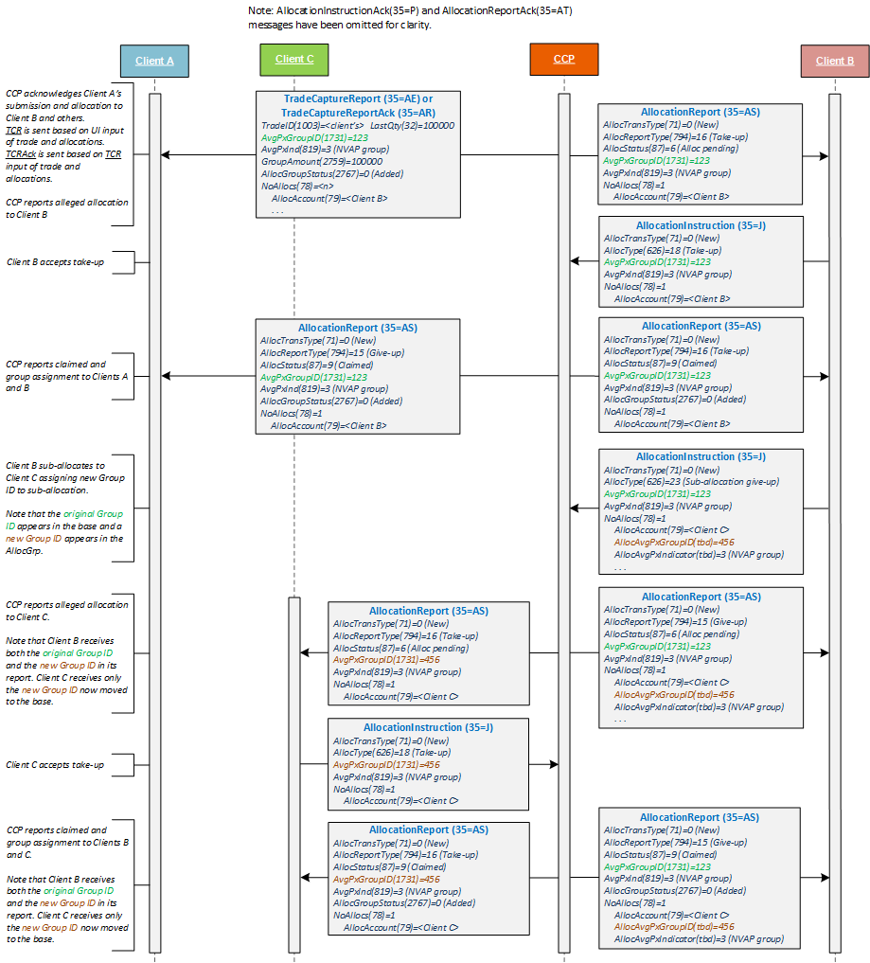

AllocRequestID(2758) used for Message Correspondence
Clients who initiate allocation through AllocationInstructionAlertRequest(35=DU) may use its AllocRequestID(2758) for correspondence of related allocation messages. The proposed AllocationInstructionAlertRequestAck(35=tbd) is shown below rejecting or accepting the AllocationInstructionAlertRequest(35=DU).

Figure 2 AllocRequestID(2758) used for Message Correspondence
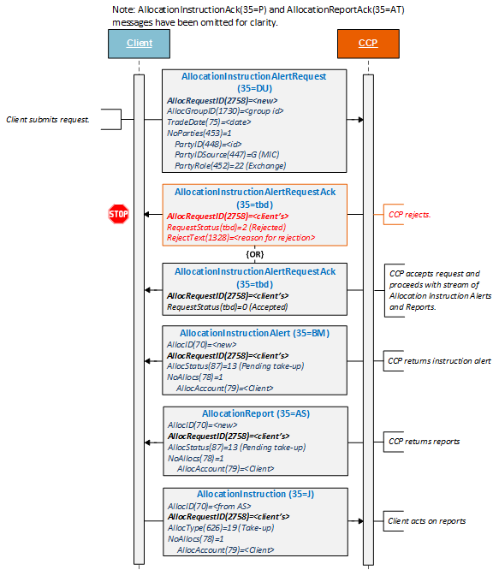

FIX Message Tables

AllocationInstruction (35=J)

To be completed at the time of the proposal – all information provided will be stored in the repository
Message Name |  | AllocationInstruction
Message Abbreviated Name (for FIXML) |  | AllocInstrctn
Category |  | (no change)
Action |  | __New _X_Change
Message Synopsis | (no change)
Message Elaboration | (no change)
To be finalized by FPL Technical Office
(MsgType(tag 35) Enumeration |  | J
Repository Component ID

Tag | Field Name | Req'd | Action | Mappings and Usage Comments | FIX Spec Comments
Standard Header |  | Y |  |  | MsgType=J
70 | AllocID | Y
2758 | AllocRequestID | N | ADD |  | May be used to link to a previously submitted AllocationInstructionAlertRequest(35=DU) message.
71 | AllocTransType | Y
626 | AllocType | Y
793 | SecondaryAllocID
(…truncated…)
Standard Trailer |  | Y

AllocationInstructionAck (35=P)

To be completed at the time of the proposal – all information provided will be stored in the repository
Message Name |  | AllocationInstructionAck
Message Abbreviated Name (for FIXML) |  | AllocInstrctnAcl
Category |  | (no change)
Action |  | __New _X_Change
Message Synopsis | (no change)
Message Elaboration | (no change)
To be finalized by FPL Technical Office
(MsgType(tag 35) Enumeration |  | P
Repository Component ID

Tag | Field Name | Req'd | Action | Mappings and Usage Comments | FIX Spec Comments
Standard Header |  | Y |  |  | MsgType=P
70 | AllocID | Y
2758 | AllocRequestID | N | ADD |  | May be used to link to a previously submitted AllocationInstructionAlertRequest(35=DU).
Instrument component
Parties component
793 | SecondaryAllocID
(…truncated…)
Standard Trailer |  | Y

AllocationInstructionAlertRequest (35=DU)

To be completed at the time of the proposal – all information provided will be stored in the repository
Message Name |  | AllocationInstructionAlertRequest
Message Abbreviated Name (for FIXML) |  | AllocInstrctnAlertReq
Category |  | (no change)
Action |  | __New _X_Change
Message Synopsis | (no change)
Message Elaboration | (no change)
To be finalized by FPL Technical Office
(MsgType(tag 35) Enumeration |  | DU
Repository Component ID

Tag | Field Name | Req'd | Action | Mappings and Usage Comments | FIX Spec Comments
Standard Header |  | Y |  |  | MsgType=DU
2758 | AllocRequestID | N | CHANGE |  | Unique identifier for this message. If used, other allocation messages may link to the request through this field.
1730 | AllocGroupID
1731 | AvgPxGroupID
75 | TradeDate
Parties component |  | N | ADD
Standard Trailer |  | Y

AllocationInstructionAlertRequestAck (35=tbd)

To be completed at the time of the proposal – all information provided will be stored in the repository
Message Name |  | AllocationInstructionAlertRequestAck
Message Abbreviated Name (for FIXML) |  | AllocInstrctnAlertReqAck
Category |  | Post Trade / Allocation
Action |  | _X_New __Change
Message Synopsis | This message is used in a clearinghouse 3-party allocation model to acknowledge a AllocationInstructionAlertRequest(35=DU) message for an AllocationInstructionAlert(35=BM) message from the clearinghouse.
Message Elaboration

To be finalized by FPL Technical Office
(MsgType(tag 35) Enumeration |  | <tbd>
Repository Component ID

Tag | Field Name | Req'd | Action | Mappings and Usage Comments | FIX Spec Comments
Standard Header |  | Y |  |  | MsgType=<tbd>
2758 | AllocRequestID | Y | ADD |  | Used when responding to an AllocationInstructionAlertRequest(35=DU).
tbd | AllocRequestStatus | Y | NEW
1328 | RejectText |  | ADD |  | May be used to further describe rejection reasons when RequestStatus(tbd)=2 (Rejected)
1664 | EncodedRejectTextLen |  | ADD |  | Must be set if EncodedRejectText(1665) field is specified and must immediately precede it.
1665 | EncodedRejectText |  | ADD |  | Encoded (non-ASCII characters) representation of the RejectText(1328) field in the encoded format specified via the MessageEncoding(347) field.
Standard Trailer |  | Y

AllocationReport (35=AS)

To be completed at the time of the proposal – all information provided will be stored in the repository
Message Name |  | AllocationReport
Message Abbreviated Name (for FIXML) |  | AllocRpt
Category |  | (no change)
Action |  | __New _X_Change
Message Synopsis | (no change)
Message Elaboration | (no change)
To be finalized by FPL Technical Office
(MsgType(tag 35) Enumeration |  | AS
Repository Component ID

Tag | Field Name | Req'd | Action | Mappings and Usage Comments | FIX Spec Comments
Standard Header |  | Y |  |  | MsgType=AS
755 | AllocReportID
70 | AllocID
2758 | AllocRequestID | N | ADD |  | May be used to link to a previously submitted AllocationInstructionAlertRequest(35=DU).
71 | AllocTransType
795 | AllocReportRefID
796 | AllocCancReplaceReason
793 | SecondaryAllocID
1730 | AllocGroupID
tbd | PreviousAllocGroupID | N | NEW |  | May be used to identify the previous AllocGroupID(1730) being changed by this message when AllocGroupStatus(2767)=tbd (Changed).
2759 | GroupAmount | N | ADD
2767 | AllocGroupStatus | N | ADD
1728 | FirmGroupID
794 | AllocReportType
(…truncated…)
Standard Trailer |  | Y

AllocationReportAck (35=AT)

To be completed at the time of the proposal – all information provided will be stored in the repository
Message Name |  | AllocationReportAck
Message Abbreviated Name (for FIXML) |  | AllocRptAck
Category |  | (no change)
Action |  | __New _X_Change
Message Synopsis | (no change)
Message Elaboration | (no change)
To be finalized by FPL Technical Office
(MsgType(tag 35) Enumeration |  | AT
Repository Component ID

Tag | Field Name | Req'd | Action | Mappings and Usage Comments | FIX Spec Comments
Standard Header |  | Y |  |  | MsgType=AT
755 | AllocReportID
70 | AllocID
2758 | AllocRequestID | N | ADD |  | May be used to link to a previously submitted AllocationInstructionAlertRequest(35=DU) message.
715 | ClearingBusinessDate
819 | AvgPxIndicator
(…truncated…)
Standard Trailer |  | Y

FIX Component Blocks

Component AllocGrp

To be completed at the time of the proposal – all information provided will be included in the repository
Component Name |  | AllocGrp
Component Abbreviated Name (for FIXML) |  | Alloc
Component Type |  | _X__ Block Repeating ___ Block
Category |  | [enter the category name here]
Action |  | __New _X_Change
Component Synopsis | (no change)
Component Elaboration | (no change)
To be finalized by FPL Technical Office
Repository Component ID

Component FIXML Abbreviation: <Alloc>
Tag | Field Name | Req'd | Action | Mappings and Usage Comments | Comments
78 | NoAllocs
79 | AllocAccount
(…truncated…)
2483 | AllocRiskLimitCheckStatus
2761 | AllocGroupAmount
tbd | AllocAvgPxGroupID | N | ADD
tbd | AllocAvgPxIndicator | N | ADD
TradeAllocAmtGrp component
</Alloc>

Component AllocAckGrp

To be completed at the time of the proposal – all information provided will be included in the repository
Component Name |  | AllocAckGrp
Component Abbreviated Name (for FIXML) |  | AllocAck
Component Type |  | _X__ Block Repeating ___ Block
Category |  | [enter the category name here]
Action |  | __New _X_Change
Component Synopsis | (no change)
Component Elaboration | (no change)
To be finalized by FPL Technical Office
Repository Component ID

Component FIXML Abbreviation: <AllocAck>
Tag | Field Name | Req'd | Action | Mappings and Usage Comments | Comments
78 | NoAllocs
79 | AllocAccount
(…truncated…)
1754 | VersusPurchasePrice
1755 | CurrentCostBasis
tbd | AllocAvgPxGroupID | N | ADD
tbd | AllocAvgPxIndicator | N | ADD
</AllocAck>

Component TrdCapRptAckSideGrp

To be completed at the time of the proposal – all information provided will be included in the repository
Component Name |  | TrdCapRptAckSideGrp
Component Abbreviated Name (for FIXML) |  | RptSide
Component Type |  | _X__ Block Repeating ___ Block
Category |  | [enter the category name here]
Action |  | __New _X_Change
Component Synopsis | (no change)
Component Elaboration | (no change)
To be finalized by FPL Technical Office
Repository Component ID

Component FIXML Abbreviation: <RptSide>
Tag | Field Name | Req'd | Action | Mappings and Usage Comments | Comments
552 | NoSides
54 | Side
(…truncated…)
826 | TradeAllocIndicator
1730 | AllocGroupID
tbd | PreviousAllocGroupID | N | ADD |  | Identifies the previous AllocGroupID(1730) being changed when AllocGroupStatus(2767)=tbd (Changed).
2759 | GroupAmount
2767 | AllocGroupStatus
(…truncated…)
</RptSide>

Component TrdCapRptSideGrp

To be completed at the time of the proposal – all information provided will be included in the repository
Component Name |  | TrdCapRptSideGrp
Component Abbreviated Name (for FIXML) |  | RptSide
Component Type |  | _X__ Block Repeating ___ Block
Category |  | [enter the category name here]
Action |  | __New _X_Change
Component Synopsis | (no change)
Component Elaboration | (no change)
To be finalized by FPL Technical Office
Repository Component ID

Component FIXML Abbreviation: <RptSide>
Tag | Field Name | Req'd | Action | Mappings and Usage Comments | Comments
552 | NoSides
54 | Side
(…truncated…)
1848 | TradeAllocGroupInstruction
1730 | AllocGroupID
tbd | PreviousAllocGroupID | N | ADD |  | Identifies the previous AllocGroupID(1730) being changed by this message when AllocGroupStatus(2767)=tbd (Changed).
2759 | GroupAmount
2767 | AllocGroupStatus
(…truncated…)
</RptSide>

Category Changes
None.

Appendix A - Data Dictionary

Tag | FieldName | Action | Datatype | Description | FIXML Abbreviation | Add to / Deprecate from Message type or Component block
tbd | AllocRequestStatus | NEW | int | Status of the AllocationInstructionAlertRequest(35=DU).  0 = Accepted  1 = Rejected | ReqStat | Add to AllocationInstructionAlertRequestAck
tbd | AllocAvgPxIndicator | NEW | int | Average pricing indicator at the allocation level.  Uses enumerations from AvgPxIndicator(819). | AvgPxInd | Add to AllocGrp component and AllocAckGrp component
tbd | AllocAvgPxGroupID | NEW | String | Used by submitting firm to group trades being sub-allocated into an average price group. The trades in the average price group will be used to calculate an average price for the group. | AvgPxGrpID | Add to AllocGrp component and AllocAckGrp component
tbd | PreviousAllocGroupID | NEW | String | When reporting a group change by the central counterparty to allocations of trades for the same instrument traded at the same price this identifies the previous group identifier. | PrevGrpID | Add to TradeCaptureReport, TradeCaptureReportAck and AllocationReport messages
856 | TradeReportType | CHANGE | int | Type of Trade Report  0 = Submit  1 = Alleged  2 = Accept  3 = Decline  4 = Addendum  Add elaboration:  [Elaboration: Used to provide material supplemental data to a previously submitted trade.]  5 = No/Was  Add elaboration:  [Elaboration: Used to report a full replacement of a previously submitted trade.]  6 = Trade Report Cancel  7 = (Locked-In) Trade Break  8 = Defaulted  9 = Invalid CMTA  10 = Pended  11 = Alleged New  12 = Alleged Addendum  13 = Alleged No/Was  14 = Alleged Trade Report Cancel  15 = Alleged (Locked-In) Trade Break  16 = Verify  17 = Dispute  Add enumeration:  tbd = Non-material Update  [Elaboration: Used to provide non-material supplemental data to a previously submitted trade.]  Note: CME requests value 18 due to concurrent implementation.
2767 | AllocGroupStatus | CHANGE | int | Status of the trade give-up relative to the group identified in AllocGroupID(1730).  0 = Added  1 = Canceled  2 = Replaced  Add enumerations:  tbd = Changed  [Elaboration: An allocated trade or give-up has moved from one allocation group to another.]  tbd = Pending  [Elaboration: A request to assign or change an allocation group is pending.]  Note: CME requests values 3 and 4 respectively due to concurrent implementation.

Appendix B - Glossary Entries

Term | Definition | Field where used

Appendix C - Abbreviations

Term | Proposed Abbreviation | Proposed Messages, Components, Fields where used

Appendix D - Usage Examples

