Bloomberg L.P.

Confirmation Extension

October 18, 2018

Revision 0.3

Proposal Status: Public Comment

DISCLAIMER

THE INFORMATION CONTAINED HEREIN AND THE FINANCIAL INFORMATION EXCHANGE PROTOCOL (COLLECTIVELY, THE "FIX PROTOCOL") ARE PROVIDED "AS IS" AND NO PERSON OR ENTITY ASSOCIATED WITH THE FIX PROTOCOL MAKES ANY REPRESENTATION OR WARRANTY, EXPRESS OR IMPLIED, AS TO THE FIX PROTOCOL (OR THE RESULTS TO BE OBTAINED BY THE USE THEREOF) OR ANY OTHER MATTER AND EACH SUCH PERSON AND ENTITY SPECIFICALLY DISCLAIMS ANY WARRANTY OF ORIGINALITY, ACCURACY, COMPLETENESS, MERCHANTABILITY OR FITNESS FOR A PARTICULAR PURPOSE. SUCH PERSONS AND ENTITIES DO NOT WARRANT THAT THE FIX PROTOCOL WILL CONFORM TO ANY DESCRIPTION THEREOF OR BE FREE OF ERRORS. THE ENTIRE RISK OF ANY USE OF THE FIX PROTOCOL IS ASSUMED BY THE USER.

NO PERSON OR ENTITY ASSOCIATED WITH THE FIX PROTOCOL SHALL HAVE ANY LIABILITY FOR DAMAGES OF ANY KIND ARISING IN ANY MANNER OUT OF OR IN CONNECTION WITH ANY USER'S USE OF (OR ANY INABILITY TO USE) THE FIX PROTOCOL, WHETHER DIRECT, INDIRECT, INCIDENTAL, SPECIAL OR CONSEQUENTIAL (INCLUDING, WITHOUT LIMITATION, LOSS OF DATA, LOSS OF USE, CLAIMS OF THIRD PARTIES OR LOST PROFITS OR REVENUES OR OTHER ECONOMIC LOSS), WHETHER IN TORT (INCLUDING NEGLIGENCE AND STRICT LIABILITY), CONTRACT OR OTHERWISE, WHETHER OR NOT ANY SUCH PERSON OR ENTITY HAS BEEN ADVISED OF, OR OTHERWISE MIGHT HAVE ANTICIPATED THE POSSIBILITY OF, SUCH DAMAGES.

DRAFT OR NOT RATIFIED PROPOSALS (REFER TO PROPOSAL STATUS AND/OR SUBMISSION STATUS ON COVER PAGE) ARE PROVIDED "AS IS" TO INTERESTED PARTIES FOR DISCUSSION ONLY. PARTIES THAT CHOOSE TO IMPLEMENT THIS DRAFT PROPOSAL DO SO AT THEIR OWN RISK. IT IS A DRAFT DOCUMENT AND MAY BE UPDATED, REPLACED, OR MADE OBSOLETE BY OTHER DOCUMENTS AT ANY TIME. THE FPL GLOBAL TECHNICAL COMMITTEE WILL NOT ALLOW EARLY IMPLEMENTATION TO CONSTRAIN ITS ABILITY TO MAKE CHANGES TO THIS SPECIFICATION PRIOR TO FINAL RELEASE. IT IS INAPPROPRIATE TO USE FPL WORKING DRAFTS AS REFERENCE MATERIAL OR TO CITE THEM AS OTHER THAN “WORKS IN PROGRESS”. THE FPL GLOBAL TECHNICAL COMMITTEE WILL ISSUE, UPON COMPLETION OF REVIEW AND RATIFICATION, AN OFFICIAL STATUS ("APPROVED") OF/FOR THE PROPOSAL AND A RELEASE NUMBER.

No proprietary or ownership interest of any kind is granted with respect to the FIX Protocol (or any rights therein).

Copyright 2003-2018 FIX Protocol Limited, all rights reserved.

Table of Contents

1 Introduction 6
2 Business Requirements 6
2.1 Summary of changes 6
3 Issues and Discussion Points 6
4 Proposed Message Flow 8
5 FIX Message Tables 10
5.1 Confirmation (35=AK) 10
5.2 ConfirmationAck (35=AU) 11
6 FIX Component Blocks 12
6.1 Component MatchExceptionGrp 12
6.2 Component MatchingDataPointGrp 13
7 Category Changes 13
Appendix A - Data Dictionary 14
Appendix B - Glossary Entries 19
Appendix C - Abbreviations 19
Appendix D - Usage Examples 19

Table of Figures

Figure 1 Matching Facility Flow 9
Document History
Revision | Date | Author | Revision Comments
0.1 | October 11, 2018 | Brook Path Partners, Inc., for Bloomberg L.P. | • Initial version.
0.2 | October 16, 2018 | Brook Path Partners, Inc., for Bloomberg L.P. | • Add the MatchExceptionGrp and MatchingDataPointGrp components.
0.3 | October 19, 2018 | Brook Path Partners, Inc., for Bloomberg L.P. | • Minor changes based on presentation feedback  • Sample message added to Appendix D - Usage Examples.

Introduction
This gap analysis seeks to enhance the workflow when a third-party facility provides the confirmation matching function between the dealer and the investment manager. When there is a mismatch the matching facility should hold the confirmation pending and report the mis-match status and details awaiting action from the investment manager without rejecting the confirmation outright.

Business Requirements
When a matching facility fails to match a Confirmation(35=AK) due to various reasons such as breach of tolerance levels, the facility will forward a Confirmation(35=AK) message to the Investment Manager with MatchStatus(573)=<tbd> (Mismatched), while the submitter of the Confirmation(35=AK) will receive a ConfirmationAck(35=AU) with MatchStatus(573)= <tbd> (Mismatched).
The proposal to assign a new MatchStatus(573) value rather than to extend an existing value is to differentiate the new richer content of the confirmation messages from simply AffirmStatus(940)=2 (Rejected) with a single value in ConfirmRejReason(774). The new components accompanying MatchStatus(573)=<tbd> (Mismatched) establish the conversation points that will need to take place between buy-side and sell-side to resolve differences.
The matching facility will communicate back to the customer the matching attributes and tolerance that caused the match to fail, for this the new MatchExceptionGrp component is proposed to convey these exceptions.
Lastly a new component, MatchingDataPointGrp, is also proposed in order for the matching facility to identify the current setting for the attributes used for matching between the specific parties to the trade.
The two new components are used together in order to identify for both the customer and broker what the current settings are and which attributes failed the matching criteria and tolerance.

Summary of changes
The following summarizes the changes proposed
- Add MatchSttus(573) to the Confirmation(35=AK) message to a matching facility can convey match status within the message to the recipient.
- Add a new MatchStatus(573) = <tbd> (Mismatched) enumeration value.
- Add the new MatchingDataPointGrp and MatchExceptionGrp components to Confirmation(35=AK) and ConfirmationAck(35=AU).

Issues and Discussion Points
The following table raises any issues and discussions, along with their resolution.
Table 1: Issues and Discussions
# | Subject | Reference | Change Request | Resolution
1 | Proposed new MatchStatus(573) value to be "m" (lower case M). |  | Currently this field is defined as a char data type field but the existing values are integer values. Bloomberg has been using the custom value "m" (lower case M) to represent "mismatched". We would like to request whether it is possible to make this value "m" part of the standard with this submission. | Bloomberg accepted assignment of the next available enumeration digit.

Proposed Message Flow
Note in the figure below that the matching facility returns [in the red message elements] MatchedStatus=Mismatched to both the buy-side and sell-side and retains the confirmation data pending resolution.
As with the current AffirmStatus(940)=2 (Rejected), final resolution of the variance is either for the buy-side to resubmit corrected allocation instructions or for the sell-side to cancel the mismatched Confirmation(35=AK) messages and resubmit corrected ones.

Figure 1 Matching Facility Flow
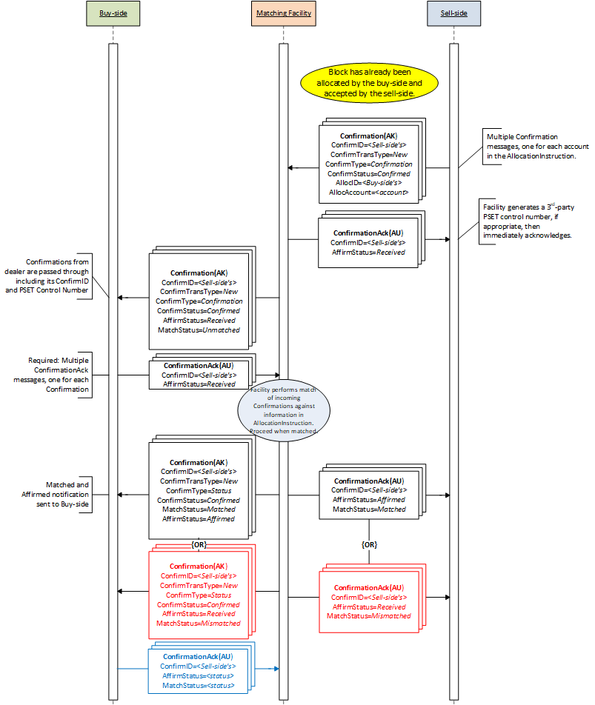

FIX Message Tables

Confirmation (35=AK)

To be completed at the time of the proposal – all information provided will be stored in the repository
Message Name |  | Confirmation
Message Abbreviated Name (for FIXML) |  | Cnfm
Category |  | (no change)
Action |  | __New _X_Change
Message Synopsis | (no change)
Message Elaboration | (no change)
To be finalized by FPL Technical Office
(MsgType(tag 35) Enumeration |  | J
Repository Component ID |  | 19

Tag | Field Name | Req'd | Action | Mappings and Usage Comments | FIX Spec Comments
Standard Header |  | Y |  |  | MsgType=AK
(…truncated…)
650 | LegalConfirm
665 | ConfirmStatus
573 | MatchStatus |  | ADD
940 | AffirmStatus
2390 | TradeConfirmationReferenceID
(…truncated…)
<CommissionDataGrp> component
<Stipulations> component
<MiscFeesGrp> component
<MatchExceptionGrp> component |  |  | NEW
<MatchingDataPointGrp> component |  |  | NEW
(…truncated…)
Standard Trailer |  | Y

ConfirmationAck (35=AU)

To be completed at the time of the proposal – all information provided will be stored in the repository
Message Name |  | ConfirmationAck
Message Abbreviated Name (for FIXML) |  | CnfmAck
Category |  | (no change)
Action |  | __New _X_Change
Message Synopsis | (no change)
Message Elaboration | (no change)
To be finalized by FPL Technical Office
(MsgType(tag 35) Enumeration |  | J
Repository Component ID |  | 19

Tag | Field Name | Req'd | Action | Mappings and Usage Comments | FIX Spec Comments
Standard Header |  | Y |  |  | MsgType=AK
(…truncated…)
774 | ConfirmRejReason |  |  |  | Required for ConfirmStatus = 1 (rejected)
573 | MatchStatus |  |  |  | Denotes whether the financial details provided on the Confirmation were successfully matched.
<MatchExceptionGrp> component |  |  | NEW
<MatchingDataPointGrp> component |  |  | NEW
58 | Text |  | CHANGE |  | Can include explanation for ConfirmRejReason = 99 (Other)AllocRejCode = 7 (other)
354 | EncodedTextLen |  |  |  | Must be set if EncodedText field is specified and must immediately precede it.
355 | EncodedText |  |  |  | Encoded (non-ASCII characters) representation of the Text field in the encoded format specified via the MessageEncoding field.
Standard Trailer |  | Y

FIX Component Blocks

Component MatchExceptionGrp
To be completed at the time of the proposal – all information provided will be included in the repository
Component Name |  | MatchExceptionGrp
Component Abbreviated Name (for FIXML) |  | MtchExcptn
Component Type |  | _X__ Block Repeating ___ Block
Category |  | Common
Action |  | _X_New ___Change
Component Synopsis | The MatchExceptionGrp component details the matching exceptions and variances identified during the matching process based on the defined matching criteria and tolerances.
Component Elaboration

To be finalized by FPL Technical Office
Repository Component ID |  | [[id]]

Component FIXML Abbreviation: <MtchExcptn>
Tag | Field Name |  | Req'd | ICR | Action | Mappings and Usage Comments | FIX Spec Comments
tbd | NoMatchExceptions |  | N |  | NEW
 | tbd | MatchExceptionType | N |  | NEW |  | Required if NoMatchExceptions(tbd) > 0.
 | tbd | MatchExceptionElementType | N |  | NEW |  | Required if NoMatchExceptions(tbd) > 0.
 | tbd | MatchExceptionElementName | N |  | NEW
 | tbd | MatchExceptionAllocValue | N |  | NEW
 | tbd | MatchExceptionConfirmValue | N |  | NEW
 | tbd | MatchExceptionToleranceValue | N |  | NEW
 | tbd | MatchExceptionToleranceValueType | N |  | NEW
 | tbd | MatchExceptionText | N |  | NEW
</MtchExcptn>

Component MatchingDataPointGrp
To be completed at the time of the proposal – all information provided will be included in the repository
Component Name |  | MatchingDataPointGrp
Component Abbreviated Name (for FIXML) |  | MtchgDataPnt
Component Type |  | _X__ Block Repeating ___ Block
Category |  | Common
Action |  | _X_New ___Change
Component Synopsis | The MatchingDataPointGrp component details all the trade attributes and tolerances used for trade matching.
Component Elaboration

To be finalized by FPL Technical Office
Repository Component ID |  | [[id]]

Component FIXML Abbreviation: <MtchgDataPnt>
Tag | Field Name |  | Req'd | ICR | Action | Mappings and Usage Comments | FIX Spec Comments
tbd | NoMatchingDataPoints |  | N |  | NEW
 | tbd | MatchingDataPointIndicator | N |  | NEW |  | Required if NoMatchingDataPoints(tbd) > 0.
 | tbd | MatchingDataPointValue | N |  | NEW |  | Required if NoMatchingDataPoints(tbd) > 0.
 | tbd | MatchingDataPointType | N |  | NEW |  | Required if NoMatchingDataPoints(tbd) > 0.
 | tbd | MatchingDataPointName | N |  | NEW
</MtchgDataPnt>

Category Changes
(no changes)

Appendix A - Data Dictionary

Tag | FieldName | Action | Datatype | Description | FIXML Abbreviation | Add to / Deprecate from Message type or Component block
tbd | NoMatchExceptions | NEW | NumInGroup | Number of match exceptions in the repeating group. | — | Add to MatchExceptionGrp
tbd | MatchExceptionType | NEW | int | Type of matching exception.  Enumerations:  0 = No matching confirmation  1 = No matching allocation  2 = Allocation data element missing  3 = Confirmation data element missing  4 = Data difference not within tolerance  5 = Match within tolerance  99 = Other | @Typ | Add to MatchExceptionGrp
tbd | MatchExceptionElementType | NEW | int | Identifies the data point used in the matching operation which resulted in an exception.  Uses enumerations from MatchDataPointType(tbd). | @ID | Add to MatchExceptionGrp
tbd | MatchExceptionElementName | NEW | String | The matching exception data point name,for example: "Trade currency". This may be used for display purposes, providing a corresponding description for the value in MatchExecptionElementType(tbd). | @Name | Add to MatchExceptionGrp
tbd | MatchExceptionAllocValue | NEW | String | The allocating party's data value used in the match operation. | @AllocVal | Add to MatchExceptionGrp
tbd | MatchExceptionConfirmValue | NEW | String | The confirming party's data value used in the match operation. | @CnfmVal | Add to MatchExceptionGrp
tbd | MatchExceptionToleranceValue | NEW | float | The data element's tolerance value. Omitted if no tolerance is allowed or not applicable. | @TlrncVal | Add to MatchExceptionGrp
tbd | MatchExceptionToleranceValueType | NEW | int | The type of value in MatchExceptionToleranceValue(tbd). Omitted if no tolerance is allowed or not applicable.  [Elaboration: For example, if the tolerance for accrued interest is 0.01% of total accrued interest then MatchExceptionElementType(tbd)=1 (Accrued), MatchExceptionToleranceValueType(tbd)=2 (Percentage) and MatchExecptionToleranceValue(tbd)=0.0001. If tolerance for the exchange rate of an FX trade is "0.001" then MatchExceptionElementType(tbd)=2 (Price), MatchExceptionToleranceValueType(tbd)=1 (Fixed) and MatchExecptionToleranceValue(tbd)=0.001.]  Enumerations:  1 = Fixed amount - Default if not specified  2 = Percentage | @TlrncValTyp | Add to MatchExceptionGrp
tbd | MatchExceptionText | NEW | String | Plain English description of the exception. | @Txt | Add to MatchExceptionGrp
tbd | NoMatchingDataPoints | NEW | NumInGroup | Number of matching data points in the repeating group. | — | Add to MatchingDataPointGrp
tbd | MatchingDataPointIndicator | NEW | int | Data point's matching type.  Enumerations:  1 = Mandatory  2 = Optional | @Typ | Add to MatchingDataPointGrp
tbd | MatchingDataPointValue | NEW | String | Value of the matching data point. | @Val | Add to MatchingDataPointGrp
tbd | MatchingDataPointType | NEW | int | Identifies the data point used in the matching operation.  [Elaboration: Values may not have applicable tolerance values, in this case this means the data point was used for matching but did not match.]  Enumerations:  1 = Accrued interest  2 = Deal price  3 = Trade date  [Elaboration: Tolerance not applicable]  4 = Settlement date  [Elaboration: Tolerance not applicable]  5 = Side indicator  [Elaboration: Tolerance not applicable]  6 = Tradedcurrency  [Elaboration: Tolerance not applicable]  7 = Account ID  [Elaboration: Tolerance not applicable]  8 = Executing broker ID  [Elaboration: Tolerance not applicable]  9 = Settlement currency and amount  10 = Investment manager ID  [Elaboration: Tolerance not applicable]  11 = Net amount  12 = Place of settlement  [Elaboration: Tolerance not applicable]  13 = Commissions  14 = Securityidentifier  [Elaboration: Tolerance not applicable]  15 = Quantity allocated  16 = Principal  17 = Fees  18 = Tax | @ID | Add to MatchingDataPointGrp
tbd | MatchingDataPointName | NEW | String | The matching data point name, for example: "Trade currency". This may be used for display purposes, providing a corresponding description for the value in matchingDataPointType(tbd). | @Name | Add to MatchingDataPointGrp
573 | MatchStatus | CHANGE | char | The status of this trade with respect to matching or comparison.  0 = Compared, matched or affirmed  1 = Uncompared, unmatched or unaffirmed  2 = Advisory or alert  Add enumeration:  <tbd> = Mismatched  [Elaboration: Indicates that data points from the AllocationInstruction(35=J) and Confirmation(35=AK) are matched but there are variances. MatchExceptionGrp component may be used to detail on the mis-matched data fields.] | @MtchStat

Appendix B - Glossary Entries

Term | Definition | Field where used

Appendix C - Abbreviations

Term | Proposed Abbreviation | Proposed Messages, Components, Fields where used

Appendix D - Usage Examples
The sample ConfirmationAck(35=AU) below shows a response to the sell-side reporting mis-matched fields in its Confirmation(35-AK) message. The proposed new fields and values are highlighted. A Confirmation(35=AK) message with the same new elements would be sent to the buy-side.

<StandardHeader> component |  | 35=AU | ConfirmationAck
664 | ConfirmID | ABCDEFGHI
75 | TradeDate | 20181019
60 | TransactTime
940 | AffirmStatus | 1 | Received
573 | MatchStatus | tbd | Mismatched
<MatchExceptionGrp> component
tbd | NoMatchExceptions | 4
tbd | →MatchExceptionType | 4 | Data difference not within tolerance
tbd | →MatchExceptionElementType | 16 | Commissions
tbd | →MatchExceptionElementName | Commissions
tbd | →MatchExceptionAllocValue | 5
tbd | →MatchExceptionConfirmValue | 100
tbd | →MatchExceptionToleranceValue | 2
tbd | →MatchExceptionToleranceValueType | 1 | Fixed amount
tbd | →MatchExceptionType | 4 | Data difference not within tolerance
tbd | →MatchExceptionElementType | 22 | Fees
tbd | →MatchExceptionElementName | Fees
tbd | →MatchExceptionAllocValue | 5
tbd | →MatchExceptionConfirmValue | 100
tbd | →MatchExceptionToleranceValue | 1
tbd | →MatchExceptionToleranceValueType | 1 | Fixed amount
tbd | →MatchExceptionType | 4 | Data difference not within tolerance
tbd | →MatchExceptionElementType | 14 | Net Amount
tbd | →MatchExceptionElementName | Net Amount
tbd | →MatchExceptionAllocValue | 11185
tbd | →MatchExceptionConfirmValue | 10900
tbd | →MatchExceptionToleranceValue | 100
tbd | →MatchExceptionToleranceValueType | 1 | Fixed amount
tbd | →MatchExceptionType | 4 | Data difference not within tolerance
tbd | →MatchExceptionElementType | 23 | Tax
tbd | →MatchExceptionElementName | Tax
tbd | →MatchExceptionAllocValue | 5
tbd | →MatchExceptionConfirmValue | 100
tbd | →MatchExceptionToleranceValue | 1
tbd | →MatchExceptionToleranceValueType | 1 | Fixed amount
end <MatchExceptionGrp> component
<StandardTrailer> component

