Repo Working Group

Bilateral Repo Trade and Post-Trade Proposal

June 15, 2020

Revision 0.4

Proposal Status: Public Comment

DISCLAIMER

THE INFORMATION CONTAINED HEREIN AND THE FINANCIAL INFORMATION EXCHANGE PROTOCOL (COLLECTIVELY, THE "FIX PROTOCOL") ARE PROVIDED "AS IS" AND NO PERSON OR ENTITY ASSOCIATED WITH THE FIX PROTOCOL MAKES ANY REPRESENTATION OR WARRANTY, EXPRESS OR IMPLIED, AS TO THE FIX PROTOCOL (OR THE RESULTS TO BE OBTAINED BY THE USE THEREOF) OR ANY OTHER MATTER AND EACH SUCH PERSON AND ENTITY SPECIFICALLY DISCLAIMS ANY WARRANTY OF ORIGINALITY, ACCURACY, COMPLETENESS, MERCHANTABILITY OR FITNESS FOR A PARTICULAR PURPOSE. SUCH PERSONS AND ENTITIES DO NOT WARRANT THAT THE FIX PROTOCOL WILL CONFORM TO ANY DESCRIPTION THEREOF OR BE FREE OF ERRORS. THE ENTIRE RISK OF ANY USE OF THE FIX PROTOCOL IS ASSUMED BY THE USER.

NO PERSON OR ENTITY ASSOCIATED WITH THE FIX PROTOCOL SHALL HAVE ANY LIABILITY FOR DAMAGES OF ANY KIND ARISING IN ANY MANNER OUT OF OR IN CONNECTION WITH ANY USER'S USE OF (OR ANY INABILITY TO USE) THE FIX PROTOCOL, WHETHER DIRECT, INDIRECT, INCIDENTAL, SPECIAL OR CONSEQUENTIAL (INCLUDING, WITHOUT LIMITATION, LOSS OF DATA, LOSS OF USE, CLAIMS OF THIRD PARTIES OR LOST PROFITS OR REVENUES OR OTHER ECONOMIC LOSS), WHETHER IN TORT (INCLUDING NEGLIGENCE AND STRICT LIABILITY), CONTRACT OR OTHERWISE, WHETHER OR NOT ANY SUCH PERSON OR ENTITY HAS BEEN ADVISED OF, OR OTHERWISE MIGHT HAVE ANTICIPATED THE POSSIBILITY OF, SUCH DAMAGES.

DRAFT OR NOT RATIFIED PROPOSALS (REFER TO PROPOSAL STATUS AND/OR SUBMISSION STATUS ON COVER PAGE) ARE PROVIDED "AS IS" TO INTERESTED PARTIES FOR DISCUSSION ONLY. PARTIES THAT CHOOSE TO IMPLEMENT THIS DRAFT PROPOSAL DO SO AT THEIR OWN RISK. IT IS A DRAFT DOCUMENT AND MAY BE UPDATED, REPLACED, OR MADE OBSOLETE BY OTHER DOCUMENTS AT ANY TIME. THE FPL GLOBAL TECHNICAL COMMITTEE WILL NOT ALLOW EARLY IMPLEMENTATION TO CONSTRAIN ITS ABILITY TO MAKE CHANGES TO THIS SPECIFICATION PRIOR TO FINAL RELEASE. IT IS INAPPROPRIATE TO USE FPL WORKING DRAFTS AS REFERENCE MATERIAL OR TO CITE THEM AS OTHER THAN “WORKS IN PROGRESS”. THE FPL GLOBAL TECHNICAL COMMITTEE WILL ISSUE, UPON COMPLETION OF REVIEW AND RATIFICATION, AN OFFICIAL STATUS ("APPROVED") OF/FOR THE PROPOSAL AND A RELEASE NUMBER.

No proprietary or ownership interest of any kind is granted with respect to the FIX Protocol (or any rights therein).

Copyright 2003-2020 FIX Protocol Limited, all rights reserved.

Table of Contents

Document History 5
1 Introduction 6
2 Business Requirements 6
2.1 Summary of changes 8
3 Issues and Discussion Points 9
4 Proposed Message Flows 9
4.1 Repo life-cycle events 9
4.1.1 Increase/Decrease open repo terms 9
4.1.2 Rerate 11
4.2 Early termination 12
4.2.1 Early termination during re-negotiation 12
4.2.2 Post-trade Early termination 14
5 FIX Message Tables 14
5.1 Quote(35=S) 14
5.2 QuoteResponse(35=AJ) 16
5.3 QuoteStatusReport(35=AI) 17
5.4 ExecutionReport(35=8) 18
5.5 AllocationInstruction(35=J) 19
5.6 AllocationReport(35=AS) 20
5.7 Confirmation(35=AK) 21
6 FIX Component Blocks 22
6.1 QuotReqGrp 22
6.2 UnderlyingInstrument 23
7 Category Changes 24
Appendix A - Data Dictionary 25
Appendix B - Glossary Entries 28
Appendix C - Abbreviations 28
Appendix D - Usage Examples 28
Appendix E – Disposition of Public Comments 28

Table of Figures

Figure 1: Amendment of an open repo 10
Figure 2: Rerate of an open repo 11
Figure 3: An early termination message initiated by RFQ initiator 12
Figure 4: An early termination message initiated by RFQ receiver 13
Figure 5: Early termination of an existing repo trade 14

Document History

Revision | Date | Author | Revision Comments
0.1 | March 18, 2020 | REPO WG, edited by Charu Mittal | Initial draft
0.2 | March 30, 2020 | REPO WG, edited by Charu Mittal | Edited based on internal review.
0.3 | April 21, 2020 | REPO WG, edited by Charu Mittal | Edited based on GTC review
0.4 | June 15, 2020 | REPO WG, edited by Charu Mittal | Resolved public review comments. Requires additional value for TradeContinuation(1937). Also, included TradeContinuationText(2374) in AllocationInstruction(35=J), AllocationReport(35=AS), and Confirmation(35=AK) messages.  Updated based on GTC feedback. Added 'rerate' in 'Business requirements' section and updated Summary of changes.

Introduction
This gap analysis proposal is submitted by the Repo Working Group to address requirements identified by the group related to trade and post-trade workflows for bilateral repo transactions. The Repo WG has published two recommended practices to support trade and post-trade communication directly between buy-side and sell-side firms using FIX protocol.
In the process of preparing the recommended practices, gaps were identified within the scope of supporting Repo bilateral trade and post-trade workflows.

Business Requirements
Key gaps identified during bilateral repo trade and post-trade workflows are mostly related to life-cycle events like Rollover, changing open repo terms, and early termination. The table below illustrates business requirements identified along with the proposed solution.
Table 1: Summary of proposed solution
# | Subject | Requirement | Proposed Solution
1 | Repo Rollover | - Identify that the re-negotiation is due to a repo rollover. | Addition of a new value:  TrdType(828)=TBD (Roll trade)
 |  | - Specify original trade details in the RFQ and quote messages. Interest payoff amount is negotiable between the two trading parties. | Stipulations/  NoStipulations(232)=4  StipulationType(233)=REFTRADE - Reference to rolling trade  StipulationValue(234)=<UTI of rolling trade>  StipulationType(233)=REFPRIN - Principal of rolling trade  StipulationValue(234)=<Principal amount>  StipulationType(233)=REFINT - Interest of rolling trade  StipulationValue(234)=<Accrued interest>  StipulationType(233)=PAYOFF - Interest payoff at the time of rolling or amending an existing trade.  StipulationValue(234)=<Payoff value>
2 | Increase/decrease open repo terms | - Identify the existing trade in RFQ message. | ClOrdID(11) referencing existing transaction's ClOrdID.  RegulatoryTradeIDGrp, if UTI is available.
 |  | - Identify the type of trade amendment leading to re-negotiation | TradeContinuation(1937)=  3 (Partial trade unwind) - Based on mutual agreement of the counterparties, used to decrease notional amount of an existing repo trade.  8 (Amendment) - Based on mutual agreement of the counterparties, used to change contract terms of an existing repo trade.  9 (Increase) - Based on mutual agreement of the counterparties, used to increase notional amount of an existing repo trade.
 |  | - Interest payoff at the time of amending an existing trade. | StipulationType(233)=PAYOFF - Interest payoff at the time of rolling or amending an existing trade.  StipulationValue(234)=<Payoff value>
3 | Rerate | - Identify the existing trade in RFQ message.  - Identify this is a request to re-rate an existing repo contract. | ClOrdID(11) referencing existing transaction's ClOrdID.  RegulatoryTradeIDGrp, if UTI is available.  TradeContinuation(1937)=TBD (Rerate) - Change in the repo rate of an open repo contract due to shift in the market conditions.
4 | Early termination | - Early termination originated by the RFQ initiator during re-negotiation of an open repo. | QuoteResponse(AJ) message:  QuoteRespType(694)=TBD (Terminate contract) - used to terminate an existing contract.  TerminationDate(2878)  Text(58)=<Termination reason>  QuoteStatusReport(AI) message:  QuoteStatus(297)=0 (Accepted) - used to acknowledge an early termination message.  TerminationDate(2878)
 |  | - Early termination originated by RFQ receiver during re-negotiation of an open repo | QuoteStatusReport(AI) message:  QuoteStatus(297)=TBD (Contract terminated) - Used when terminating an existing contract.  TerminationDate(2878)  Text(58)=<Termination reason>  QuoteResponse(AJ) message:  QuoteRespType(694)=TBD (Accept) - Used in response to acknowledge an action communicated by the counterparty.  TerminationDate(2878)
 |  | - Post-trade early termination | TradeCaptureReport(35=AE) message:  TradeContinuation(1937)=31 (Early termination)  TerminationDate(2878)  Text(58)=<Termination reason>
5 | Securities-driven repo (specials) | Identify nominal collateral amount in RFQ and Quote message. Cash amount is unknown during initial negotiation. | Nominal collateral amount will be specified in  UnderlyingInstrument/ UnderlyingQty(879)  OrderQtyData component is not required for securities driven repo.
6 | Reference data for collateral securities | Accrued interest amount and number of days of interest for collateral securities to be included during negotiation and post-trade collateral management. | UnderlyingInstrument/  UnderlyingAccruedInterestAmt(TBD)  UnderlyingNumDaysInterest(TBD)

Summary of changes

Below is a summary list of all the proposed extensions:

Components:

- Addition of existing RegulatoryTradeIDGrp component to QuoteRequest(35=R) message. The component will be used to reference existing trade's UTI while amending or rolling over an open repo trade.

- Updating requirement of existing OrderQtyData component to conditionally required in QuotReqGrp component, Quote(35=S), QuoteResponse(35=AJ), and QuoteStatusReport(35=AI) messages depending on the type of instrument. A security-driven repo (specials) is quoted based on nominal collateral amount which is specified in UnderlyingQty(879). The cash consideration specified in OrderQty(32) is usually unknown at the time of quote request and is negotiated upon, therefore an "order quantity" cannot be specified.

Fields:

- Addition of existing field TrdType(828) in Quote(35=S) and QuoteResponse(35=AJ) messages. The field is used to specify a rollover trade.

- Addition of existing field TradeContinuation(1937) in QuoteRequest(35=R), Quote(35=S), QuoteResponse(35=AJ), QuoteStatusReport(35=AI), and ExecutionReport(35=8) messages. The field is used to specify the type of amendment of an existing repo trade.

- Addition of existing field TradeContinuationText(2374) in QuoteRequest(35=R), Quote(35=S), QuoteResponse(35=AJ), QuoteStatusReport(35=AI), ExecutionReport(35=8), AllocationInstruction(35=J), AllocationReport(35=AS), and Confirmation(35=AK) messages. The field is used to specify additional information.

- Addition of existing field TerminationDate(2878) in QuoteResponse(35=AJ) and QuoteStatusReport(35=AI) messages.

- Addition of new field UnderlyingAccruedInterestAmt to existing UnderlyingInstrument component to communicate accrued interest amount associated with a collateral security.

- Addition of new field UnderlyingNumDaysInterest to existing UnderlyingInstrument component to communicate number of days of interest associated with a collateral security.

Valid Values:

- New valid value "Roll trade" for field TrdType(828) to specify a rollover trade.

- New valid value "PAYOFF" for field StipulationType(233)=PAYOFF to specify interest that needs to be paid off while rolling or amending an existing repo trade.

- New valid values "Terminate contract" and "Accept" for field QuoteRespType(694) to support early termination of open repo trades.

- New valid value "Contract terminated" for field QuoteStatus(297) to support early termination of open repo trades.

- New valid value "Rerate" for field TradeContinuation(1937) to specify re-rate of an existing repo contract.

Issues and Discussion Points

Proposed Message Flows

Repo life-cycle events
Basic flow for repo life-cycle events leading to re-negotiation of an existing repo contract is illustrated below. The life-cycle events include repo rollover, increase/decrease open repo term, and rerate.

Increase/Decrease open repo terms
The party interested in rolling over or amending terms of an existing trade sends a QuoteRequest(35=R) message with new contract details.
Once initiated, the negotiation dialogue can lead to a new repo rate for the repo trade including changes in other contractual details.

Figure 1: Amendment of an open repo
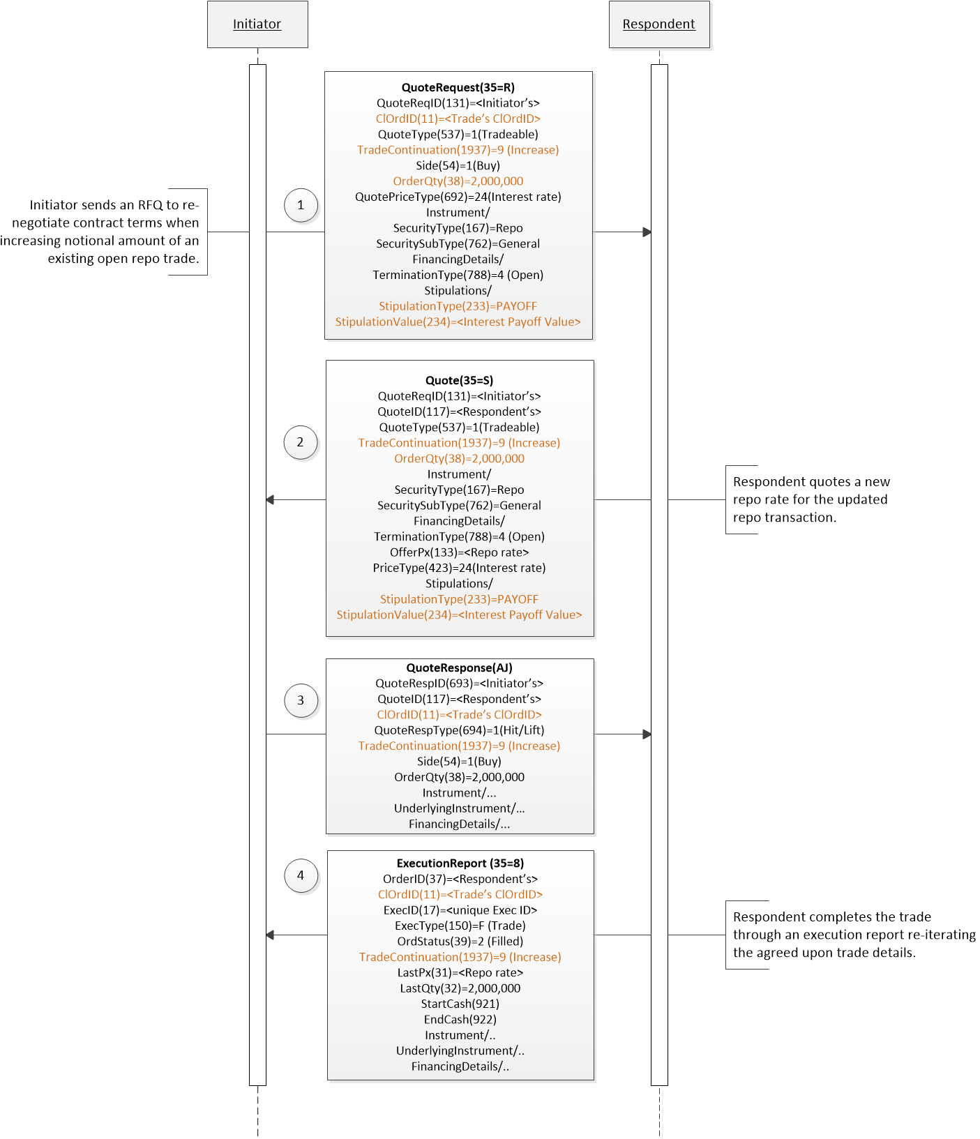

Rerate
Move in market conditions can lead to parties requesting a re-rate of an existing open repo contract. A re-rate is to renegotiate and adjust the repo rate based on market conditions. An interested party can initiate the request using QuoteRequest(35=R) message with TradeContinuation(1937)=TBD (Rerate).
Figure 2: Rerate of an open repo
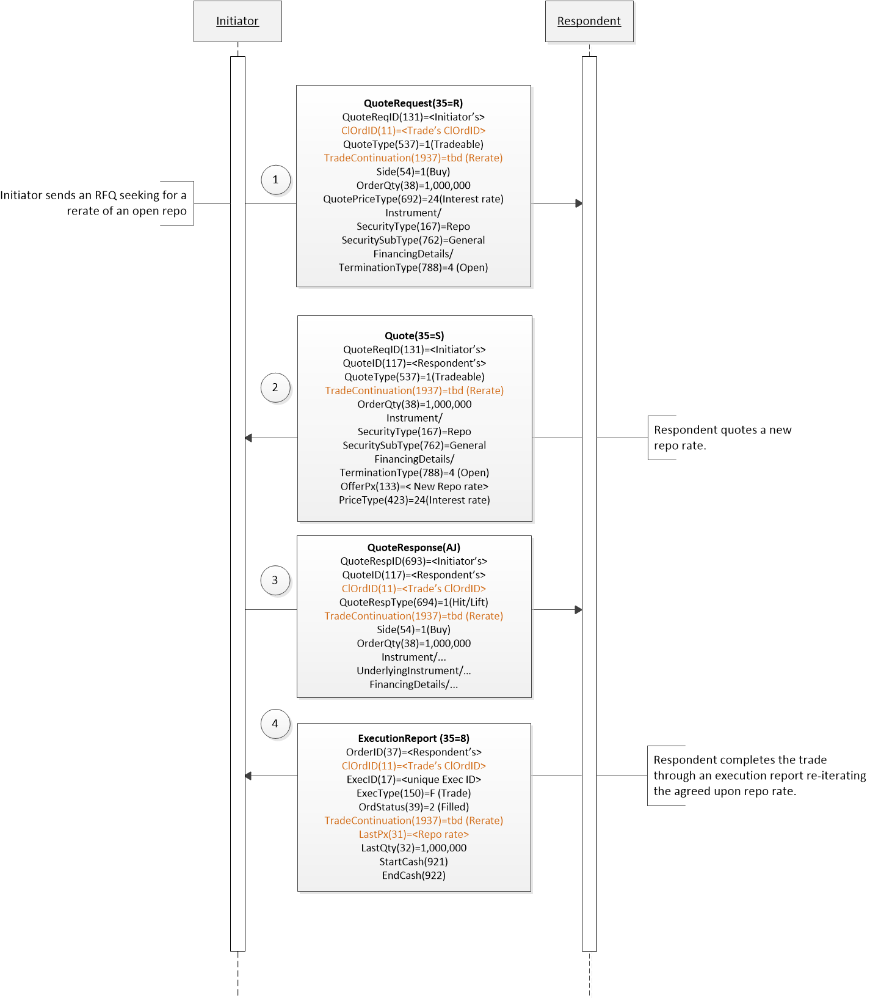

Early termination

Early termination during re-negotiation
Either of the trading parties can send an early termination message during the re-negotiation of an existing open repo trade.
Figure 3: An early termination message initiated by RFQ initiator
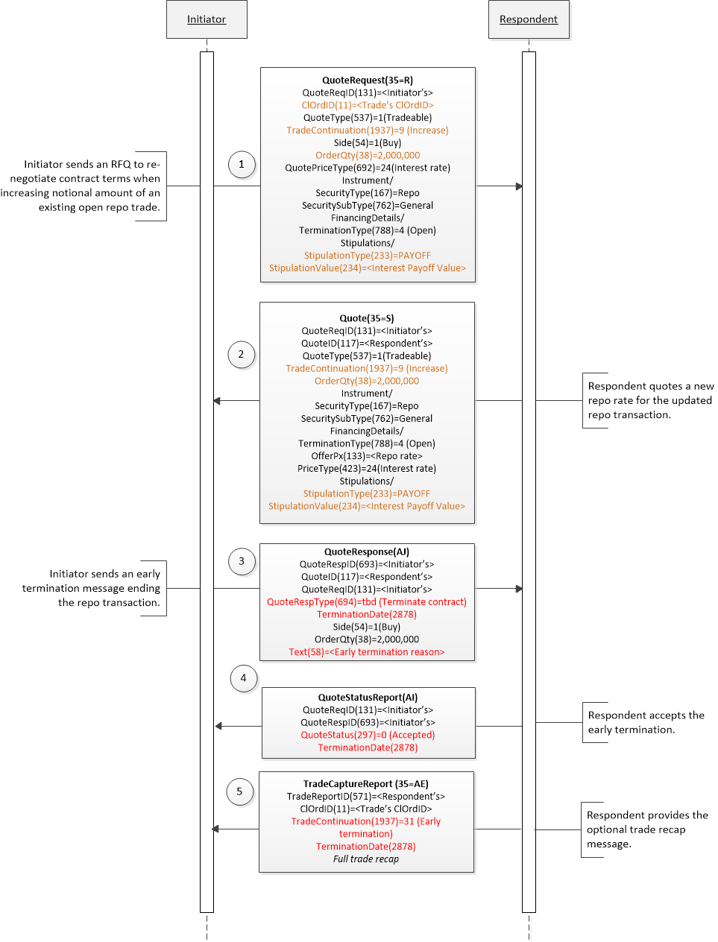
Figure 4: An early termination message initiated by RFQ receiver
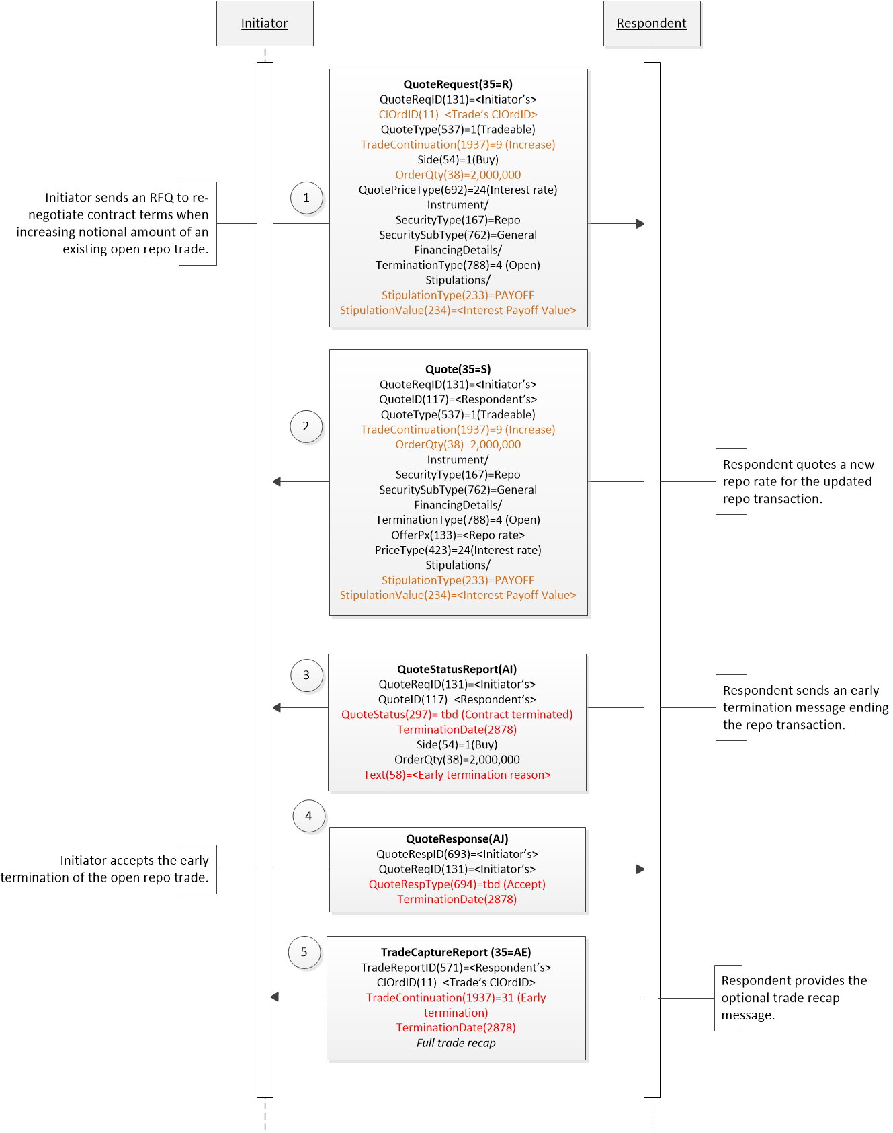

Post-trade Early termination
An existing repo trade can be terminated early by either of the trading parties using TradeCaptureReport(35=AE) message. For early termination, use TradeContinuation(1937)=31 (Early termination) along with termination date in TerminationDate(2878) and reason behind termination in TradeContinuationText(2374).
Figure 5: Early termination of an existing repo trade
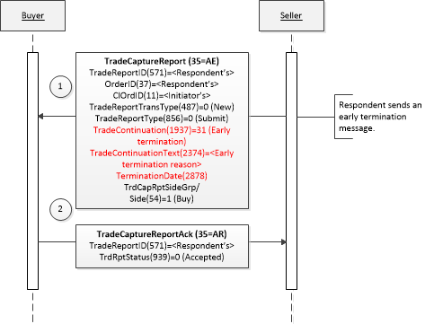

FIX Message Tables

Quote(35=S)

To be completed at the time of the proposal – all information provided will be stored in the repository
Message Name |  | Quote
Message Abbreviated Name (for FIXML)
Category
Action |  | __New _X_Change
Message Synopsis

Message Elaboration

To be finalized by FPL Technical Office
(MsgType(tag 35) Enumeration
Repository Component ID

Tag | Field Name | Req'd | Action | Mappings and Usage Comments | FIX Spec Comments
 | Standard Header | Y |  |  | MsgType = S
131 | QuoteReqID
117 | QuoteID
(…truncated…)
QuotQualGrp
828 | TrdType | N | ADD | Used when rolling over an existing repo trade. | Type of trade.
2115 | TradeNegotiationMethod
(…truncated…)
54 | Side
OrderQtyData |  | N | Change | Nominal collateral amount for a securities driven repo is specified in UnderlyingQty(879). | Conditionally Rrequired for Tradeable or Counter quotes of single instruments when applicable for the type of instrument.
63 | SettlType
(…truncated…)
RoutingGrp
1937 | TradeContinuation | N | ADD | Specifies the post-execution trade continuation or lifecycle event while negotiating for an existing repo trade. | Specifies the post-execution trade continuation or lifecycle event.
2374 | TradeContinuationText | N | ADD
(…truncated…)
 | Standard Trailer | Y

QuoteResponse(35=AJ)

To be completed at the time of the proposal – all information provided will be stored in the repository
Message Name |  | QuoteResponse
Message Abbreviated Name (for FIXML)
Category
Action |  | __New _X_Change
Message Synopsis

Message Elaboration

To be finalized by FPL Technical Office
(MsgType(tag 35) Enumeration
Repository Component ID

Tag | Field Name | Req'd | Action | Mappings and Usage Comments | FIX Spec Comments
 | Standard Header | Y |  |  | MsgType = AJ
693 | QuoteRespID
117 | QuoteID
(…truncated…)
54 | Side
OrderQtyData |  | N | Change | Nominal collateral amount for a securities driven repo is specified in UnderlyingQty(879). | Conditionally rRequired when countering a single instrument quote or "hit/lift" an IOI or Quote when applicable for the type of instrument.
110 | MinQty
63 | SettlType
64 | SettlDate
2878 | TerminationDate | N | ADD | Early termination date of an open repo trade.
(…truncated…)
YieldData
1937 | TradeContinuation | N | ADD | Specifies the post-execution trade continuation or lifecycle event while negotiating for an existing repo trade. | Specifies the post-execution trade continuation or lifecycle event.
2374 | TradeContinuationText | N | ADD
(…truncated…)
 | Standard Trailer | Y

QuoteStatusReport(35=AI)

To be completed at the time of the proposal – all information provided will be stored in the repository
Message Name |  | QuoteStatusReport
Message Abbreviated Name (for FIXML)
Category
Action |  | __New _X_Change
Message Synopsis

Message Elaboration

To be finalized by FPL Technical Office
(MsgType(tag 35) Enumeration
Repository Component ID

Tag | Field Name | Req'd | Action | Mappings and Usage Comments | FIX Spec Comments
 | Standard Header | Y |  |  | MsgType = AI
649 | QuoteStatusReqID
131 | QuoteReqID
(…truncated…)
54 | Side
OrderQtyData |  | N | Change | Nominal collateral amount for a securities driven repo is specified in UnderlyingQty(879). | Conditionally required for quotes of single instrument depending on the type of instrument when QuoteType(537)=1 (Tradeable).
63 | SettlType
64 | SettlDate
2878 | TerminationDate | N | ADD | Early termination date of an open repo trade.
(…truncated…)
1328 | RejectText
1937 | TradeContinuation | N | ADD | Specifies the post-execution trade continuation or lifecycle event while negotiating for an existing repo trade. | Specifies the post-execution trade continuation or lifecycle event.
2374 | TradeContinuationText | N | ADD
(…truncated…)
 | Standard Trailer | Y

ExecutionReport(35=8)

To be completed at the time of the proposal – all information provided will be stored in the repository
Message Name |  | ExecutionReport
Message Abbreviated Name (for FIXML)
Category
Action |  | __New _X_Change
Message Synopsis

Message Elaboration

To be finalized by FPL Technical Office
(MsgType(tag 35) Enumeration
Repository Component ID

Tag | Field Name | Req'd | Action | Mappings and Usage Comments | FIX Spec Comments
 | Standard Header | Y |  |  | MsgType = 8
37 | OrderID
2422 | OrderRequestID
(…truncated…)
TradePriceConditionGrp
1937 | TradeContinuation | N | ADD | Specifies the post-execution trade continuation or lifecycle event while negotiating for an existing repo trade. | Specifies the post-execution trade continuation or lifecycle event.
2374 | TradeContinuationText | N | ADD
(…truncated…)
 | Standard Trailer | Y

AllocationInstruction(35=J)

To be completed at the time of the proposal – all information provided will be stored in the repository
Message Name |  | AllocationInstruction
Message Abbreviated Name (for FIXML)
Category
Action |  | __New _X_Change
Message Synopsis

Message Elaboration

To be finalized by FPL Technical Office
(MsgType(tag 35) Enumeration
Repository Component ID

Tag | Field Name | Req'd | Action | Mappings and Usage Comments | FIX Spec Comments
 | Standard Header | Y |  |  | MsgType = J
70 | AllocID | Y
2758 | AllocRequestID | N
(…truncated…)
1937 | TradeContinuation | N
2374 | TradeContinuationText | N | ADD
(…truncated…)
 | Standard Trailer | Y

AllocationReport(35=AS)

To be completed at the time of the proposal – all information provided will be stored in the repository
Message Name |  | AllocationReport
Message Abbreviated Name (for FIXML)
Category
Action |  | __New _X_Change
Message Synopsis

Message Elaboration

To be finalized by FPL Technical Office
(MsgType(tag 35) Enumeration
Repository Component ID

Tag | Field Name | Req'd | Action | Mappings and Usage Comments | FIX Spec Comments
 | Standard Header | Y |  |  | MsgType = AS
755 | AllocReportID | Y
70 | AllocID | N
(…truncated…)
1937 | TradeContinuation | N
2374 | TradeContinuationText | N | ADD
(…truncated…)
 | Standard Trailer | Y

Confirmation(35=AK)

To be completed at the time of the proposal – all information provided will be stored in the repository
Message Name |  | Confirmation
Message Abbreviated Name (for FIXML)
Category
Action |  | __New _X_Change
Message Synopsis

Message Elaboration

To be finalized by FPL Technical Office
(MsgType(tag 35) Enumeration
Repository Component ID

Tag | Field Name | Req'd | Action | Mappings and Usage Comments | FIX Spec Comments
 | Standard Header | Y |  |  | MsgType = AK
664 | ConfirmID | Y
772 | ConfirmRefID
(…truncated…)
1937 | TradeContinuation | N
2374 | TradeContinuationText | N | ADD
(…truncated…)
381 | GrossTradeAmt | Y | Change | For repos, this is same as AllocQty(80), i.e. cash consideration allocated to this account. | AllocQty(80) * AvgPx(6)  Gross trade amount for the allocated account being confirmed.
(…truncated…)
 | Standard Trailer | Y

FIX Component Blocks

QuotReqGrp

To be completed at the time of the proposal – all information provided will be included in the repository
Component Name |  | QuotReqGrp
Component Abbreviated Name (for FIXML)
Component Type |  | __X_ Block Repeating ___ Block
Category |  | [enter the category name here]
Action |  | __New _X_Change
Component Synopsis | (no change)
Component Elaboration | (no change)
To be finalized by FPL Technical Office
Repository Component ID

Component FIXML Abbreviation: <QuotReq>
Tag | Field Name |  | Req'd | Action | Mappings and Usage Comments | FIX Spec Comments
146 | NoRelatedSym
 | Instrument
 | FinancingDetails
(…truncated…)
 | OrderQtyData |  | N | Change | Nominal collateral amount for a securities driven repo is specified in UnderlyingQty(879). | Conditionally rRequired for single instrument quoting when applicable for the type of instrument.
 | 110 | MinQty
 | 63 | SettlDate
(…truncated…)
 | QuotQualGrp
 | 828 | TrdType
 | 2347 | RegulatoryTransactionType
 | RegulatoryTradeIDGrp |  | N | ADD | Specifies UTI (unique trade identifier) of the trade being modified.
(…truncated…)
 | Parties |  | N
 | 1937 | TradeContinuation | N | ADD | Specifies the post-execution trade continuation or lifecycle event while negotiating for an existing repo trade. | Specifies the post-execution trade continuation or lifecycle event.
 | 2374 | TradeContinuationText | N | ADD
 | 443 | StrikeTime
(…truncated…)
 | Standard Trailer |  | Y

UnderlyingInstrument

To be completed at the time of the proposal – all information provided will be included in the repository
Component Name |  | UnderlyingInstrument
Component Abbreviated Name (for FIXML) |  | Undly
Component Type |  | ___ Block Repeating _X__ Block
Category |  | [enter the category name here]
Action |  | __New _X_Change
Component Synopsis | (no change)
Component Elaboration | (no change)
To be finalized by FPL Technical Office
Repository Component ID

Component FIXML Abbreviation: <Undly>
Tag | Field Name | Req'd | Action | Mappings and Usage Comments | FIX Spec Comments
311 | UnderlyingSymbol
(…truncated…)
886 | UnderlyingEndValue
TBD | UnderlyingAccruedInterestAmt | N | ADD | Reference data for security used as collateral for a repo trade. | Amount of accrued interest of the underlying security.
TBD | UnderlyingNumDaysInterest | N | ADD | Reference data for security used as collateral for a security. | Number of days of interest for the underlying security.
(…truncated…)
</Undly>

Category Changes

To be completed at the time of the proposal – all information provided is stored in the repository
Category Name |  | [enter the category name here]
Section |  | __PreTrade  __Trade  __PostTrade  __Infrastructure
Category Synopsis | [enter the category synopsis here]
Category Elaboration | [enter the category elaboration here]
To be finalized by FPL Technical Office
Category Filename

Appendix A - Data Dictionary

Tag | Field Name | Action | Datatype | Description | FIXML Abbreviation | Add to / Deprecate from Message type or Component block
TBD | UnderlyingAccruedInterestAmt | New | Amt | Amount of accrued interest of underlying security. | AcrdIntAmt | Add to:  UnderlyingInstrument component
TBD | UnderlyingNumDaysInterest | New | int | Number of days of interest for underlying security. | NumDaysInt | Add to:  UnderlyingInstrument component
233 | StipulationType | Change | String | Type of stipulation.  Values:  REFTRADE=Rreference to rolling or closing trade  REFPRIN=Pprincipal to rolling or closing trade  REFINT=Iinterest of rolling or closing trade  PAYOFF=Interest payoff of rolling or amending trade.
297 | QuoteStatus | Change | int | Identifies the status of the quote acknowledgement.  Values:  TBD=Contract terminated  [Elaboration: Indicates a contract has been or is being terminated.]
381 | GrossTradeAmt | Change | Amt | Total amount traded (i.e. quantity * price) expressed in units of currency - usually quantity * price. For FX Futures this is used to express the notional value of a fill when quantity fields are expressed in terms of contract size (i.e. quantity * price * contract size).
694 | QuoteRespType | Change | int | Identifies the type of QuoteResponse(35=AJ).  Values:  7 = End trade  [Elaboration: Indicates an end to the trade negotiation.]  TBD=Accept  [Elaboration: Used in a response to acknowledge an action communicated by the counterparty]  TBD=Terminate contract  [Elaboration: Used to communicate the termination of an existing contract.]
828 | TrdType | Change | int | Type of trade.  Values:  TBD=Roll trade  [Elaboration: Trade is a roll from one contract that is about to expire to a new contract.]
1937 | TradeContinuation | Change | int | Specifies the post-execution trade continuation or lifecycle event.  Supported values:  TBD = Rerate  [Elaboration: Change in the repo rate of an open repo contract due to shift in the market conditions.]
2374 | TradeContinuationText | Change | String | Elaboration of the purpose or action of the regulatory report when TradeContinuation(1937)=99 (Other).  Free form text to specify additional trade continuation information or data.

Appendix B - Glossary Entries

Term | Definition | Field where used

Appendix C - Abbreviations

Term | Proposed Abbreviation | Proposed Messages, Components, Fields where used

Appendix D - Usage Examples

[Examples may be entered below this line]

Appendix E – Disposition of Public Comments

Repo Best Practices - Public comments:
Willson <company>:
- It would be better if Trade continuation(2374) have enum values to support collateral substitution and Re-Rate in the TradeCaptureReport(AE) as they are also standard lifecycle events for Repos.

Resolution: We are introducing a new enum for TradeContinuation(1937)= TBD (Rerate). The trade and post-trade recommended practices will include the suggested workflows.

Collateral substitution is performed using CollateralAssignment(35=AY) messages where CollAction(944) identifies the action being performed. REPO WG doesn’t recommend using TradeCaptureReport(35=AE) for actions performed at collateral level.

Action: Introduce TradeContinuation(1937)=TBD (Rerate).

Ramjee Penta <company>:

- Instead of using the generic field Text(58), can we introduce a new field like TerminationReasonText(tbd) similar to TradeContinuationText(2374). TradeCaptureReport(AE) is a multipurpose message and the generic field Text(58) is already used for a variety of reasons in different contexts. Hence a separate field TerminationReasonText(tbd) would be better.

Resolution: The suggested new field will not be added. The data dictionary description for TradeContinuationText(2374) was updated in the Gap Analysis proposal to include any text that further provides information associated with the TradeContinuation(1937) enum value.

Action: None

- Can we have a life cycle event for RERATE similar to REPRICE? Or is the practice suggesting to use the same approach and messages both for REPRICE and RERATE? We do have certain vendors who support RERATE and REPRICE as distinct events.

Resolution: Rerate and reprice are considered two separate life-cycle events involving different FIX messages.

RERATE comprises of re-negotiation flow between the two counterparties, propagating the new rate down to allocation and confirmation messages. We are introducing a new value for TradeContinuation(1937)=TBD (Rerate) to reflect this is a Rerate life cycle event. Please keep in mind, this value should be used when an existing open repo contract is re-rated due to shift in market conditions. For cases when repo contract has a new rate due to a change in contract details, TradeContinuation(1937)=8 (Amendment) is more appropriate. Please refer to section 'Increase/decrease open repo terms' in the trade recommended practices document for more information.

REPRICE is mark-to-market price update of a collateral security and thus, doesn’t impact pre-trade or trade workflow. REPO WG's recommendation is to use the CollateralReport(35=BA) message to provide unsolicited update of a collateral security.

Trade and Post-trade recommended practices documents will include the suggested workflows for Rerate and Reprice.

Action: Introduce TradeContinuation(1937)=TBD (Rerate). Add TradeContinuationText(2374) to AllocationInstruction(35=J), AllocationReport(35=AS), and Confirmation(35=AK) messages.

- How do we specify the reject reason for TrdRptStatus being rejected?
TradeReportRejectReason is used to specify the reject reason whenTrdAckStatus is rejected

Resolution: RejectText(1328) can be used to specify reject reason.

Action: None

- Why not encourage a BIC in PartyIDSource in AllocationInstruction or AllocationReport or Confirmation?

Resolution: REPO WG suggests using LEI (Legal Entity Identifier) instead since it is adopted due to regulatory requirements especially for ESMA reporting in Europe. If needed, BIC can also be used.

Action: None

- How do we represent closing leg details in Allocation Instruction or Allocation Report? It doesn’t cater for details like Start Cash, End Cash etc., wherever applicable. Also can it be made explicit that AllocAvgPx is the repo rate for the respective allocation instance?

Resolution: The AllocGrossTradeAmt(2300) can be used for Starting cash consideration and
TradeAllocAmtGrp/TradeAllocAmtType(1845)=ENDV (End Value) for end cash consideration. Repo WG thinks it is implicit that AllocAvgPx, if populated, will represent repo rate. The group also recommends not populating the field to avoid confusion as the repo rate for the respective allocation instance should not be different from the trade's repo rate.

Action: None

- How do represent life cycle events in Confirmations? Is the proposal to represent everything as an amendment? We have certain vendors and clients, where once the trade was already matched, they treat subsequent changes in some fields as life cycle events which are distinct from the original trade confirmation process.
e.g. any changes in the following fields are preferred to be sent as distinct Confirmation events rather than as amendments on the original Confirmation.
  - Rate or Spread Lifecycle Event
  - Price Lifecycle Event
  - Close out Lifecycle Event
  - End Date Lifecycle Event
  - Substitution Lifecycle Event
  - Roll-over Lifecycle Event

Resolution:

  - Rate or Spread Lifecycle Event - TradeContinuation(1937)=TBD (Rerate); Please see the 'Rerate' workflow added to Post-trade recommended practices document.
  - Price Lifecycle Event - Assuming this is referring to the collateral mark-to-market price, this would be done through CollateralReport(35=BA) message. Please refer to the 'Reprice' workflow added to Post-trade recommended practices document.
  - Close out Lifecycle Event - The closeout event is initially notified using TradeCaptureReport(35=AE) message with TradeContinuation(1937)=31 (Early termination) and close out date in TerminationDate(2878). Please refer to 'Early termination' workflow in Post-trade recommended practices document. The same fields can be used in Confirmation(35=AK) message for this life-cycle event.
  - End Date Lifecycle Event - TradeContinuation(1937)=8 (Amend) with new End date. Repo WG recommends this to be an amendment of the original trade with revised end date.
  - Substitution Lifecycle Event - Please refer to 'Collateral substitution' workflow in the Post-trade recommended practices. Account(1) can be used to specify allocated account for which substitution has been performed.
  - Roll-over Lifecycle Event - TrdType(828)=TBD (Roll trade); Please refer to 'Repo Rollover' section in Trade recommended practices document. For workflow, 'Rerate' workflow can be used as an example.

Action: None

