Global Technical Committee and CME Group

AllocationInstructionAlertRequest Proposal

September 26, 2017

Revision 0.6

Proposal Status: Public Comment

DISCLAIMER

THE INFORMATION CONTAINED HEREIN AND THE FINANCIAL INFORMATION EXCHANGE PROTOCOL (COLLECTIVELY, THE "FIX PROTOCOL") ARE PROVIDED "AS IS" AND NO PERSON OR ENTITY ASSOCIATED WITH THE FIX PROTOCOL MAKES ANY REPRESENTATION OR WARRANTY, EXPRESS OR IMPLIED, AS TO THE FIX PROTOCOL (OR THE RESULTS TO BE OBTAINED BY THE USE THEREOF) OR ANY OTHER MATTER AND EACH SUCH PERSON AND ENTITY SPECIFICALLY DISCLAIMS ANY WARRANTY OF ORIGINALITY, ACCURACY, COMPLETENESS, MERCHANTABILITY OR FITNESS FOR A PARTICULAR PURPOSE. SUCH PERSONS AND ENTITIES DO NOT WARRANT THAT THE FIX PROTOCOL WILL CONFORM TO ANY DESCRIPTION THEREOF OR BE FREE OF ERRORS. THE ENTIRE RISK OF ANY USE OF THE FIX PROTOCOL IS ASSUMED BY THE USER.

NO PERSON OR ENTITY ASSOCIATED WITH THE FIX PROTOCOL SHALL HAVE ANY LIABILITY FOR DAMAGES OF ANY KIND ARISING IN ANY MANNER OUT OF OR IN CONNECTION WITH ANY USER'S USE OF (OR ANY INABILITY TO USE) THE FIX PROTOCOL, WHETHER DIRECT, INDIRECT, INCIDENTAL, SPECIAL OR CONSEQUENTIAL (INCLUDING, WITHOUT LIMITATION, LOSS OF DATA, LOSS OF USE, CLAIMS OF THIRD PARTIES OR LOST PROFITS OR REVENUES OR OTHER ECONOMIC LOSS), WHETHER IN TORT (INCLUDING NEGLIGENCE AND STRICT LIABILITY), CONTRACT OR OTHERWISE, WHETHER OR NOT ANY SUCH PERSON OR ENTITY HAS BEEN ADVISED OF, OR OTHERWISE MIGHT HAVE ANTICIPATED THE POSSIBILITY OF, SUCH DAMAGES.

DRAFT OR NOT RATIFIED PROPOSALS (REFER TO PROPOSAL STATUS AND/OR SUBMISSION STATUS ON COVER PAGE) ARE PROVIDED "AS IS" TO INTERESTED PARTIES FOR DISCUSSION ONLY. PARTIES THAT CHOOSE TO IMPLEMENT THIS DRAFT PROPOSAL DO SO AT THEIR OWN RISK. IT IS A DRAFT DOCUMENT AND MAY BE UPDATED, REPLACED, OR MADE OBSOLETE BY OTHER DOCUMENTS AT ANY TIME. THE FPL GLOBAL TECHNICAL COMMITTEE WILL NOT ALLOW EARLY IMPLEMENTATION TO CONSTRAIN ITS ABILITY TO MAKE CHANGES TO THIS SPECIFICATION PRIOR TO FINAL RELEASE. IT IS INAPPROPRIATE TO USE FPL WORKING DRAFTS AS REFERENCE MATERIAL OR TO CITE THEM AS OTHER THAN “WORKS IN PROGRESS”. THE FPL GLOBAL TECHNICAL COMMITTEE WILL ISSUE, UPON COMPLETION OF REVIEW AND RATIFICATION, AN OFFICIAL STATUS ("APPROVED") OF/FOR THE PROPOSAL AND A RELEASE NUMBER.

No proprietary or ownership interest of any kind is granted with respect to the FIX Protocol (or any rights therein).

Copyright 2003-2017 FIX Protocol Limited, all rights reserved.

Table of Contents

Document History 5
1 Introduction 6
1.1 Summary of Proposed Changes 6
2 Business Requirements 6
2.1 Notional Value Average Price Allocations 6
2.2 Notification of NVAP Group Creation 7
2.3 NVAP Group Status Request 7
2.4 NVAP Group Status Response 7
2.5 Notification of NVAP Group Allocations 7
3 Issues and Discussion Points 7
4 Proposed Message Flow 9
5 FIX Message Tables 9
5.1 AllocationInstructionAlertRequest (35=tbd) 9
5.2 AllocationInstructionAlert (35=BM) 10
6 FIX Component Blocks 12
6.1 Component AllocGrp 12
7 Category Changes 13
Appendix A - Data Dictionary 14
Appendix B - Glossary Entries 17
Appendix C - Abbreviations 17
Appendix D - Usage Examples 17

Table of Figures

Document History
Revision | Date | Author | Revision Comments
0.1 | Sept. 19, 2017 | Brook Path Partners, Inc. for CME Group | Initial draft
0.2 | Sept. 25, 2017 | CME | Sections 1 and 2
0.3 | Sept. 26,  2017 | CME | Section 4
0.4 | Sept. 26, 2017 | CME | Updated Section 4
0.5 | Sept. 26, 2017 | Brook Path Partners, Inc. for CME Group | Additional updates based on discussions of remaining requirements.
0.6 | Sept. 27, 2017 | CME | In table 5.1 edited the name of tag 1731 from AllocPxGroupID to AvgPxGroupID, changed “an” to “a” as appropriate based on edits.

Introduction

This proposal includes several enhancements required to support a new average pricing concept for allocated trades called Notional Value Average Price (NVAP). In this model, clients allocate all of their trades to one group, which they do not have to close, but rather keep as a continuously updated record of what they have available to allocate. Enhancements include new values for AllocType (626) and AvPxIndicator (819), as well as extension to the AllocGrp component, the AllocationInstructionAlert (35=J) message, and a new AllocationInstructionAlertRequest (35=tbd) message.

Summary of Proposed Changes
The summary of proposed changes to support the business requirements described in Section 2 are:
- to add an enumeration for Notional Value Average Price to AvgPxIndicator (819),
- to add an enumeration for Notional Value Average Price to AllocType (626),
- to extend the AllocGrp component by adding AllocGroupAmount (tbd) to contain the notional value an allocation
- to extend the AllocInstructionAlert (35=J) message to include a GroupAmount (tbd) to show the total notional value of an NVAP group, GroupRemainingAmount (tbd) to show the notional value not yet allocated from the group, HighPx (332) to indicate the highest price in the group, and LowPx (333) to indicate the lowest price in the group,
- to create a new light-weight AllocationInstructionAlertReqeust (35=tbd) message to request an AllocationInstructionAlert (35=J) message showing the current status of an allocation group, which would contain an AllocRequestID (tbd), AllocGrpID (1730), AvgPxGroupID (1731), and TradeDate (75).

Business Requirements

Notional Value Average Price Allocations
Clients allocating a trade need a way to indicate that the trade they are marking for allocation should be allocated using the NVAP model. Clients will continue to be able to submit trades for allocation as they have done previously, however, they will now have an additional option of using the NVAP allocation model. In order to determine the client's intention, we need a way for the client to indicate that they would like a trade to be allocated to a NVAP group. This can be accomplished by adding a new enumeration for Notional Value Average Price to AvgPxIndicator (819). A similar enumeration can be added to AllocType (626) to communicate what type of allocation they are receiving information about.

Notification of NVAP Group Creation
When a trade is marked for allocation using NVAP method and a group does not yet exist to which the trade can be added, one must be created. The client must be informed of the new group creation, and the details of the group in its initial state. This can be accomplished by extending the AllocationInstructionAlert (35=J) message with a GroupAmount (tbd) field to indicate the notional value not yet allocated, a GroupRemainingAmount (tbd) field to show the remaining notional that can be allocated, the HighPx (332) field to show the highest price in the group, and the LowPx (333) to show the lowest price in the group.

NVAP Group Status Request
NVAP allocation groups remain open which allows clients to continuously add trades to it and allocated from it, clients may not have, or may not want to keep track of the correct value of the group's NVAP on their own. However, an accurate picture of the state of the group is necessary in order to manage and allocate from it. Consequently, clients must have a way to request the current status of a particular group. This can be accomplished using a new AllocationInstructionAlertRequest (35=tbd) message, containing an AllocRequestID (tbd), AllocGrpID (1730), AvgPxGroupID (1731), and TradeDate (75).
The new proposed message will allow clients to request the status of the group on a per request basis (i.e. status snapshot).

NVAP Group Status Response
Customers must be able to receive a response to their status request messages. These can be in the form of an AllocatoinInstructionAlert (35=J) message, with the extensions detailed in section 2.2 so that clients know what is available to them to allocate.

Notification of NVAP Group Allocations
Once an allocation has been made from a NVAP group, the client must be informed of the details of how much notional value from the group was actually used on each allocation. This can be accomplished using an AllocationReport (35=AS) message containing multiple instances of the AllocGrp component extended with an AllocGroupAmt (tbd) to contain the notional value per an allocation.

Issues and Discussion Points

 | Issue | Date | Status | Discussion
1

Proposed Message Flow
There is no change to the message flow for allocation group method of allocating with the CCP. The diagram below illustrates the typical flow for NVAP group allocation using existing FIX messages.

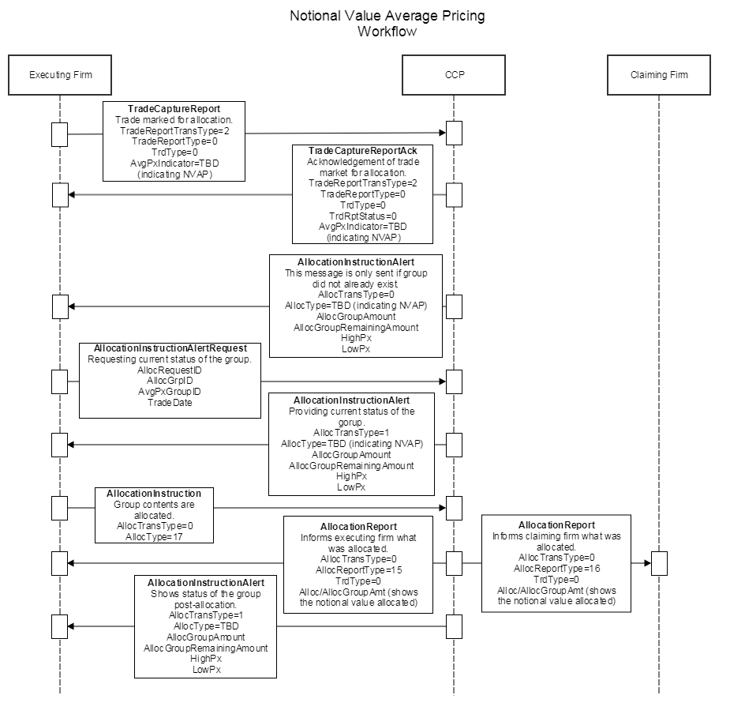

FIX Message Tables

AllocationInstructionAlertRequest (35=tbd)

To be completed at the time of the proposal – all information provided will be stored in the repository
Message Name |  | AllocationInstructionAlertRequest
Message Abbreviated Name (for FIXML) |  | AllocInstrAlertReq
Category |  | Allocation
Action |  | _X_New __Change
Message Synopsis | This message is used in a clearinghouse 3-party allocation model to request for AllocationInstructionAlert(35=BM) from the clearinghouse. The request may be used to obtain a one-time notification of the status of an allocation group.
Message Elaboration | [enter the message elaboration here]
To be finalized by FPL Technical Office
(MsgType(tag 35) Enumeration
Repository Component ID

Tag | Field Name | Req'd | Action | Mappings and Usage Comments | FIX Spec Comments
Standard Header |  | Y |  |  | MsgType=(TBD)
tbd | AllocRequestID | N | NEW |  | Unique identifier for this message.
1730 | AllocGrpID | N | ADD
1731 | AvgPxGroupID | N | ADD
75 | TradeDate | N | ADD
Standard Trailer |  | Y

AllocationInstructionAlert (35=BM)

To be completed at the time of the proposal – all information provided will be stored in the repository
Message Name |  | AllocationInstructionAlert
Message Abbreviated Name (for FIXML) |  | AllocInstrAlert
Category |  | (no change)
Action |  | __New _X_Change
Message Synopsis | (no change)
Message Elaboration | (no change)
To be finalized by FPL Technical Office
(MsgType(tag 35) Enumeration |  | BM
Repository Component ID

Tag | Field Name | Req'd | Action | Mappings and Usage Comments | FIX Spec Comments
Standard Header |  | Y |  |  | MsgType=BM
(…truncated…)
626 | AllocType | Y
tbd | AllocRequestID | N | NEW |  | Identifier of the request this message is responding to when responding to an AllocationInstructionAlertRequest(35=tbd).
793 | SecondaryAllocID | N
(…truncated…)
1736 | AllocGroupQuantity | N | CHANGE | remove redundant field usage text - duplicates data dictionary | Indicates the total quantity of an allocation group. Includes any allocated quantity.
1737 | AllocGroupRemainingQuantity | N | CHANGE | remove redundant field usage text - duplicates data dictionary | Indicates the remaining quantity of an allocation group that has not yet been allocated.
tbd | GroupAmount | N | NEW
tbd | GroupRemainingAmount | N | NEW
30 | LastMkt | N
229 | TradeOriginationDate | N
(…truncated…)
6 | AvgPx | N
860 | AvgParPx | N
332 | HighPx | N | ADD |  | Maybe used to indicate the highest price within the specified allocation group.
333 | LowPx | N | ADD |  | Maybe used to indicate the lowest price within the specified allocation group.
SpreadOrBenchmarkCurveData component
(…truncated…)
Standard Trailer |  | Y

FIX Component Blocks

Component AllocGrp

To be completed at the time of the proposal – all information provided will be included in the repository
Component Name |  | AllocGrp
Component Abbreviated Name (for FIXML) |  | Alloc
Component Type |  | _X__ Block Repeating ___ Block
Category |  | [enter the category name here]
Action |  | __New _X_Change
Component Synopsis | (no change)
Component Elaboration | (no change)
To be finalized by FPL Technical Office
Repository Component ID

[Other additional text detailing usage of the component may be entered below this line]

Component FIXML Abbreviation: <Alloc>
Tag | Field Name | Req'd | Action | Mappings and Usage Comments | Comments
78 | NoAllocs
79 | AllocAccount
(…truncated…)
2393 | AllocRefRiskLimitCheckIDType
2483 | AllocRiskLimitCheckStatus
tbd | AllocGroupAmount | N | NEW
TradeAllocAmtGrp component
(…truncated…)
</Alloc>

Category Changes

To be completed at the time of the proposal – all information provided is stored in the repository
Category Name |  | [enter the category name here]
Section |  | __PreTrade  __Trade  __PostTrade  __Infrastructure
Category Synopsis | [enter the category synopsis here]
Category Elaboration | [enter the category elaboration here]
To be finalized by FPL Technical Office
Category Filename

Appendix A - Data Dictionary

Tag | FieldName | Action | Datatype | Description | FIXML Abbreviation | Add to / Deprecate from Message type or Component block
TBD | AllocRequestID | NEW | String | Unique identifier for the request message. | @ReqID | AllocationInstructionAlertRequest  AllocationInstructionAlert
TBD | GroupAmount | NEW | Amt | Indicates the total notional units or amount of an allocation group. Includes any allocated units or amount.  [Elaboration: Whether notional units or amount is used depends on the type of listed derivative contract and the clearinghouse. A notional unit is (price x quantity) without the derivative's contract value factor.] | @GrpAmt | AllocationInstructionAlert
TBD | GroupRemainingAmount | NEW | Amt | Indicates the remaining notional units or amount of an allocation group that has not yet been allocated.  [Elaboration: Whether notional units or amount is used depends on the type of listed derivative contract and the clearinghouse. A notional unit is (price x quantity) without the derivative's contract value factor.] | @RemAmt | AllocationInstructionAlert
TBD | AllocGroupAmount | NEW | Amt | Indicates the notional units or amount being allocated.  [Elaboration: Whether notional units or amount is used depends on the type of listed derivative contract and the clearinghouse. A notional unit is (price x quantity) without the derivative's contract value factor.] | @GrpAmt | AllocGrp
626 | AllocType | CHANGE | int | Describes the specific type of purpose of an Allocation message (i.e. "Buyside Calculated")  1 = Calculated (includes MiscFees and NetMoney)  …  25 = Approve take-up  tbd = Notional value average price group allocation  [Elaboration: Used when conducting notional value average price (NVAP) group allocation with a clearinghouse.]
819 | AvgPxIndicator | CHANGE | int | Average Ppricing Iindicator.  0 = No average pricing  1 = Trade is part of an average price group identified by the AvgPxGroupID(1731)  2 = Last trade of the average price group identified by the AvgPxGroupID(1731)  tbd = Trade is part of a notional value average price (NVAP) group  [Elaboration: A NVAP group is effectively closed and available for allocation as long as the NVAP of the group is non-zero.]

Appendix B - Glossary Entries

Term | Definition | Field where used

Appendix C - Abbreviations

Term | Proposed Abbreviation | Proposed Messages, Components, Fields where used

Appendix D - Usage Examples

