

MiFID Best Execution Subgroup

Recommended Practices for Best Execution Reporting as required by MiFID II RTS 27 & 28 with reference to

Delegated Act 2398 Article 65.6

12/10/2017

Revision 35

Proposal Status: Final

DISCLAIMER

THE INFORMATION CONTAINED HEREIN AND THE FINANCIAL INFORMATION EXCHANGE PROTOCOL (COLLECTIVELY, THE "FIX PROTOCOL") ARE PROVIDED "AS IS" AND NO PERSON OR ENTITY ASSOCIATED WITH THE FIX PROTOCOL MAKES ANY REPRESENTATION OR WARRANTY, EXPRESS OR IMPLIED, AS TO THE FIX PROTOCOL (OR THE RESULTS TO BE OBTAINED BY THE USE THEREOF) OR ANY OTHER MATTER AND EACH SUCH PERSON AND ENTITY SPECIFICALLY DISCLAIMS ANY WARRANTY OF ORIGINALITY, ACCURACY, COMPLETENESS, MERCHANTABILITY OR FITNESS FOR A PARTICULAR PURPOSE. SUCH PERSONS AND ENTITIES DO NOT WARRANT THAT THE FIX PROTOCOL WILL CONFORM TO ANY DESCRIPTION THEREOF OR BE FREE OF ERRORS. THE ENTIRE RISK OF ANY USE OF THE FIX PROTOCOL IS ASSUMED BY THE USER.

NO PERSON OR ENTITY ASSOCIATED WITH THE FIX PROTOCOL SHALL HAVE ANY LIABILITY FOR DAMAGES OF ANY KIND ARISING IN ANY MANNER OUT OF OR IN CONNECTION WITH ANY USER'S USE OF (OR ANY INABILITY TO USE) THE FIX PROTOCOL, WHETHER DIRECT, INDIRECT, INCIDENTAL, SPECIAL OR CONSEQUENTIAL (INCLUDING, WITHOUT LIMITATION, LOSS OF DATA, LOSS OF USE, CLAIMS OF THIRD PARTIES OR LOST PROFITS OR REVENUES OR OTHER ECONOMIC LOSS), WHETHER IN TORT (INCLUDING NEGLIGENCE AND STRICT LIABILITY), CONTRACT OR OTHERWISE, WHETHER OR NOT ANY SUCH PERSON OR ENTITY HAS BEEN ADVISED OF, OR OTHERWISE MIGHT HAVE ANTICIPATED THE POSSIBILITY OF, SUCH DAMAGES.

**DRAFT OR NOT RATIFIED PROPOSALS** (REFER TO PROPOSAL STATUS AND/OR SUBMISSION STATUS ON COVER PAGE) ARE PROVIDED "AS IS" TO INTERESTED PARTIES FOR DISCUSSION ONLY. PARTIES THAT CHOOSE TO IMPLEMENT THIS DRAFT PROPOSAL DO SO AT THEIR OWN RISK. IT IS A DRAFT DOCUMENT AND MAY BE UPDATED, REPLACED, OR MADE OBSOLETE BY OTHER DOCUMENTS AT ANY TIME. THE FIX TRADING COMMUNITY GLOBAL TECHNICAL COMMITTEE WILL NOT ALLOW EARLY IMPLEMENTATION TO CONSTRAIN ITS ABILITY TO MAKE CHANGES TO THIS SPECIFICATION PRIOR TO FINAL RELEASE. IT IS INAPPROPRIATE TO USE FIX TRADING COMMUNITY WORKING DRAFTS AS REFERENCE MATERIAL OR TO CITE THEM AS OTHER THAN “WORKS IN PROGRESS”. THE FIX TRADING COMMUNITY GLOBAL TECHNICAL COMMITTEE WILL ISSUE, UPON COMPLETION OF REVIEW AND RATIFICATION, AN OFFICIAL STATUS ("APPROVED") FOR THE PROPOSAL AND A RELEASE NUMBER.

No proprietary or ownership interest of any kind is granted with respect to the FIX Protocol (or any rights therein).

Copyright 2003-2017 FIX Protocol Limited, all rights reserved.

Table of Contents

Auto-generate the entire table of contents (press F9) here - or customize up to 3 levels deep.

Document History 4

Definitions 6

1 Executive Summary 9

2 Objective 10

3 Document Scope 10

4 Target Audience 11

5 Scope of Reporting 12

5.1 Equities and Equity Type Instruments 12

5.2 Bonds 16

5.3 Derivatives 19

6 RTS 27 Reporting Requirements 22

6.1 Generic Requirements 22

6.1.1 Table 1 - Article 3(1): Market Information 24

6.1.2 Table 2 - Article 3(2): Instrument Identifier 25

6.1.3 Table 3 - Article 4(a): Price information: Intra-Day 25

6.1.4 Table 4 - Article 4(b): Price Information: Daily 27

6.1.5 Table 5 – Article 5: Cost information by instrument 28

6.1.6 Table 6 – Article 6: Likelihood of Execution by instrument (daily) 29

6.1.7 Table 7 – Likelihood of Execution - additional information by continuous auction order book and continuous quote driven execution venues – periodic (Article 7 (1)) 30

6.1.8 Table 8 – - additional information by continuous auction order book and continuous quote driven execution venues – daily (Article 7(2)/(3)) 31

6.1.9 Table 9 – Article 8: Likelihood of Execution by instrument 33

6.2 Entities operating a Central Limit Order Book 33

6.2.1 Frequency of Publication 33

6.2.2 Tables to be completed 33

6.3 Entities operating a Request for Quote Mechanism 34

6.3.1 Frequency of Publication 34

6.3.2 Tables to complete 34

6.3.3 Specific Scenarios 34

6.4 Other Trading Models 34

6.5 Specific Scenarios for Bonds 37

6.5.1 Firm Quote 37

6.5.2 Indicative Quote 37

6.6 Specific Scenarios for Derivatives 38

6.6.1 Firm Quote 38

6.6.2 Indicative Quote 38

6.7 Recommended Implementation Practices 38

7 RTS 28 Reporting Requirements 39

Generic Requirements 39

7.1 Which Reports to Produce 39

7.2 Timing of Reports 40

7.3 Accessibility of Reports 41

7.4 Table 1 - Article 3(1) 41

# Document History

| **Revision** | **Date** | **Author/Editor** | **Revision Comments** |
| --- | --- | --- | --- |
| 0.1 | 27/09/2016 | Alex Wolcough | Skeleton |
| 0.4 | 18/10/2016 | Rebecca Healey | Updates |
| 0.5 | 03/11/2016 | Rebecca Healey | Updates |
| 0.6 | 13/11/2016 | Rebecca Healey | Updates |
| 0.7 | 16/11/2016 | Rebecca Healey | Updates |
| 0.8 | 21/11/2016 | Rebecca Healey | Updates |
| 0.9 | 02/12/2016 | Rebecca Healey | Updates after FIX WG Meeting 02/12/2016 |
| 0.10 | 15/12/2016 | Tim Healy | Updated to incl various submissions |
| 0.11 | 15/12/2016 | Rebecca Healey | Update to include Matthew Luff and Matthew Briddon RTS 28 Amendments |
| 0.12 | 11/01/2017 | Rebecca Healey | Updates from meeting 15/12/2016, plus input from Anne Plested, Josh Barton |
| 0.13 | 18/01/2017 | Rebecca Healey & Alex Wolcough | Amendments from Working Group Feedback |
| 0.14 | 19/01/2017 | Rebecca Healey & Alex Wolcough | Amendments from Working Group Feedback |
| 0.15 | 27/01/2017 | Rebecca Healey | Amendments from after meeting with IA and sub WG meeting 27/01/17 |
| 0.16 | 30/01/2017 | Rebecca Healey & Matthew Luff | Amendments to RTS 28 to include Art. 65 |
| 0.17 | 06/02/2017 | Alex Wolcough & Rebecca Healey | Amendments post meeting 03/02/17 |
| 0.18 | 08/02/2017 | Rebecca Healey | Amendments post meeting 08/02/17 |
| 0.19 | 17/02/2017 | Alex Wolcough | Amendments post meeting 15/02/17 |
| 0.20 | 20/02/2017 | Alex Wolcough | Amendments in response to IA |
| 0.22 | 26/02/2017 | Alex Wolcough | Amendments post meeting 24/02/17 |
| 0.23 | 02/03/2017 | Rebecca Healey | Final Draft Version prepared for review meeting 10/03/2017 |
| 0.24 | 13/03/2017 | Rebecca Healey | Revised Final Draft after meeting 10/03/2017 |
| 0.25 | 15/03/2017 | Rebecca Healey | Feedback from Version 24 |
| 0.26 | 16/03/2017 | Rebecca Healey | Revised Final Draft after meeting 16/03/2017 |
| 0.27 | 23/03/2017 | Rebecca Healey | Updates to Revised Final Draft |
| 0.28 | 31/03/2017 | Rebecca Healey | Updates to Revised Final Draft from members of the WG |
| 0.29 | 03/04/2017 | Rebecca Healey | Updates to Revised Final Draft from members of the WG |
| 030 | 05/04/2017 | Rebecca Healey | Updates to Revised Final Draft from members of the WG, incorporating ESMA Q&A Guidance published 04/04/2017 |
| 031 | 26/6/2017 | Silvan Stagni | Formatting of RTS 28 text and addition of text to 7.1 |
| 032 | 06/9/2017 | Rebecca Healey | Updates to Revised Final Draft after feedback from other industry working groups and from EU regulators |
| 033 | 25/9/2017 | Rebecca Healey | Updates to Revised Final Draft after further feedback from EU regulators |
| 035 | 12/10/2017 | Alex Wolcough | Correction to workflow diagrams for DEA |

The above document history section, including date, author, and comments, is required to track editing changes to the document. List revisions in **ascending order**. Please insert additional rows in the table as needed.

Template version information:

r2: 2010-11-13 Revised to support abbreviations, inlined component references

r2.1: 2011-10-01 Revised to add usage clarification

# Definitions

| **Item** | **Reference** | **Definition** |
| --- | --- | --- |
| **Execution Venue** | RTS 27 Recital 2 | Execution venues should include regulated markets, multilateral trading facilities, organised trading facilities, systematic internalisers, market makers and other liquidity providers.  For instruments subject to the trading obligation (incls equity shares) - RM, MTF, SI and OTF (for just non-equity) will be required to publish the RTS 27 report.  For instruments not subject to the trading obligation - RM, MTF, SI, OTF, market makers and other liquidity providers are required to publish the report. |
| **Trading System** | RTS 27 Article 2 | means the way in which an execution venue executes orders as continuous auction order book, continuous quote driven, request for quote, periodic auction or any hybrid system falling into two or more of these categories or into a system where the price determination process is of a different nature than that applicable to the types of system set out above; |
| **Size Specific to the financial instrument** | RTS 27 Article 2 | means size specific to a bond, structured finance product, emission allowance or derivative traded on a trading venue, for which there is not a liquid market and the transaction in these instruments is subject to deferred publication in accordance with Art. 11 of Regulation (EU) 600/2014; |
| **Large in Scale** | RTS 27 Article 2 | means an order large in scale in accordance with Article 7 and 11 of Regulation (EU) No 600/2014; |
| **Failed transaction** | RTS 27 Article 2 | As defined in Art. 2(d) of RTS 27, a transaction that was executed but which was subsequently voided by the execution venue on the same execution date; |
| **Price multiplier** | RTS 27 Article 2 | means the number of units of the underlying instrument represented by a single derivative contract; |
| **Price notation** | RTS 27 Article 2 | means an indication as to whether the price of the transaction is expressed in monetary value, in percentage or in yield; |
| **Quantity notation** | RTS 27 Article 2 | means an indication as to whether the quantity of the transaction is expressed in number of units or in nominal value or in monetary value; |
| **Delivery type** | RTS 27 Article 2 | means an indication as to whether the financial instrument is settled physically or in cash including instances when the counterparty may choose or when it is determined by a third party; |
| **Trading mode** | RTS 27 Article 2 | means scheduled opening, closing or intra-day auction, unscheduled auction, trading at close, trading out of main session, or trade reporting; |
| **Trading platform** | RTS 27 Article 2 | means the type of platform the execution venue operates: electronic, voice or outcry; |
| **Book depth** | RTS 27 Article 2 | means the total available liquidity expressed as the product of price and volume of all bids and offers for a specified number of price increments from the mid-point of the best bid and offer; |
| **Average effective spread** | RTS 27 Article 2 | means the average of twice the difference between the actual execution price compared with mid-point of best bid and offer at time of receipt, for market orders or marketable limit orders; |
| **Average speed of execution for unmodified passive orders at best bid and offer** | RTS 27 Article 2 | means the average time elapsed between a limit order that matches the best bid and offer being received by the execution venue, and the subsequent execution of this order; |
| **Aggressive order** | RTS 28 Article 2 | means an order entered into the order book that took liquidity |
| **Passive order** | RTS 28 Article 2 | means an order entered onto the order book that provided liquidity |
| **Immediate or cancel order** | RTS 27 Article 2 | means an order which is executed upon its entering into the order book and which does not remain in the order book for any remaining quantity that has not been executed; |
| **Fill or kill order** | RTS 27 Article 2 | means an order which is executed upon its entering into the order book provided that it can be fully filled. In the event the order can only be partially executed, then it is automatically rejected and is not executed. |
| **Directed order** | RTS 28 Article 2 | means an order where a specific execution venue was specified by the client prior to the execution of the order |
| **Liquidity Provider** | FIX Trading Community | ISDA definition: Recital 7 indicates that ‘liquidity providers’ means ‘firms that hold themselves out as being willing to deal on own account, and which provide liquidity as part of their normal business activity, whether or not they have formal agreements in place or commit to providing liquidity on a continuous basis’. Other references to ‘market makers’ in MiFID2/MiFIR and the associated technical standards indicate that a ‘market maker’ is a firm under a binding written agreement or an obligation to provide liquidity.  Relevant for instruments not subject to the trading obligation. A firm could fall into the category of “other liquidity provider”, in which case they would be required to provide RTS 27 reports however they will only have to publish information on financial instruments not subject to the trading obligation (given that they are not categorised as trading venues). |
| **Voided Transaction** | FIX Trading Community | A Voided Transaction is a trade that is cancelled because it was erroneous in nature or breached the rules of the trading venue and the transaction is then treated as if it never happened. This is not applicable where the client executes on an SI or with a MM or OLP |
| **Outage** | FIX Trading Community | An outage is where one or more Financial Instruments are prevented from being quoted and/or traded due to a technical malfunction or failure. |
| **Interruption** | FIX Trading Community | An interruption is where one or more Financial Instruments are momentarily prevented from being quoted and/or traded due to an automatic or manual decision. This decision is often linked to volatility or other exceptional market conditions. |
| **Suspension** | FIX Trading Community | A suspension is where a Financial Instrument is deliberately prevented from being quoted and/or traded for a period of time due to a decision taken by the Execution Venue or National Competent Authority. This decision is often linked to the status of the Financial Instrument issuer. |

# Executive Summary

Provide an introduction to the content, purpose, or impetus of the proposal; the business need / problem being solved; and the scope. Include and label any references, supporting documentation, and related proposals. If the proposal is based on existing implementations, describe them here in the appropriate subsections.

While the concept of Best Execution for the European Financial Markets was introduced back in 2007 under MiFID I, MiFID II has now introduced new requirements on what data must be published to the market to help firms comply with their Best Execution mandate.

While this Best Execution mandate principally applies to Investment Firms only looking after clients classified as Retail or Professional under the MiFID rules, the data publication requirements published by ESMA on 28th September 2015 under the regulatory technical standards apply to a much broader community. Please note that any reference to Buy-Side or Sell-Side through out the document refers to **Investment Firms subject to the MiFID II obligations only.**

This document will explain which entities must report under these new requirements, what data they must publish, how often and provide clarity as to how these reports apply to different scenarios based on the entity, their role in the trading workflow and the trading model they employ.

There are 3 main reporting requirements:

* RTS 27: the data to be published by venues on the quality of execution of transactions including investment firms operating as a Systematic Internaliser or as a Organised Trading Facility (OTF) for non-equity instruments
* RTS 28: the data to be published by investment firms on the identity of execution venues used and on the quality of execution, plus a summary of the analysis and conclusions drawn from monitoring the quality of execution provided by the venues it used, including itself when executing using its own Systematic Internaliser or other liquidity provider.
* Delegated Act 2398 Article 65 of MIFIR; the data to be published by investment firms on the identity of the top five brokers in terms of trading volumes where it transmitted orders or placed orders which resulted in an execution and this should be consistent with the information published under RTS 28.

It is important to note that execution venue includes Regulated Markets (RM), Multilateral Trading Facilities (MTF), Organised Trading Facilities (OTF), Systematic Internalisers (SI), Market Makers and Liquidity Providers regardless of whether these entities are bound to provide Best Execution or not.

**On that basis, these reporting requirements should be treated as a separate requirement to the full Best Execution mandate and this document will only act as a guide as to how to complete the necessary reports under RTS 27, 28 and Article 65 in a consistent and compliant way.**

# Objective

Describe the business problem or workflow that is the source for the proposed changes to the FIX Protocol. The descriptions should help the Global Technical Committee understand the business areas and context and should use business or layman's terms. Business flow diagrams may also be helpful.

The objective of this document is to provide guidance to entities regulated by MiFID II on how to populate the reports required under MiFID II RTS 27 and RTS 28 with the appropriate data in a compliant and consistent manner. Where Article 65.6 is referenced, this is referring to the additional obligations under MiFID II Delegated Regulation (DA 2398) Article 65 Paragraph 6.

# Document Scope

The scope of this document will address:

* RTS 27: The data to be published by execution venues on the quality of execution of transactions, including:
  + The types of entity that are included under the definition of an execution venue and must publish this data
  + The Frequency of Reporting
  + The scope and resolution of reporting by instrument
  + The tables that must be completed and the associated attributes based on:
    - Trading Model
    - Any asset class specific variations by Trading Model
  + While the Regulatory Technology Standards apply to all trading scenarios, this document will look to provide clarifications around certain edge case scenarios or trading models that may not have been considered when drafting the standards
* RTS 28: The data to be published by investment firms on the identity of execution venues used and on the quality of execution, including:
  + The scenarios where an investment firm will be expected to provide a report in accordance with RTS 28
  + The Frequency of Reporting
  + The scope and resolution of reporting by instrument
  + The tables that must be completed and the associated attributes based on:
    - Trading Model
    - Any asset class specific variations by Trading Model
  + Clarifications around certain edge case scenarios or trading models that may not have been considered as part of the Regulatory Technical Standards
* MiFID II Delegated Regulation (DA 2398) Article 65 Paragraph 6; the data to be published by investment firms on the identity of the top five brokers in terms of trading volumes where it transmitted orders to resulting in an execution and on the quality of execution, including:
  + The scenarios where an investment firm will be expected to provide a report in accordance with Article 65
  + The frequency of reporting
  + The scope and resolution of reporting by instrument
  + The tables that must be completed and the associated attributes based on asset class specific variations by Trading Model

# Target Audience

This document is relevant to all venues and firms which execute, receive and transmit or place orders for execution, including portfolio managers.

The Target Audience includes MiFID II Change Teams, Business Analysts, Compliance at the following types of entity:

* RTS 27:
  + Execution Venues in the EEA which includes:
    - Regulated Markets
    - Multilateral Trading Facilities
    - Investment Firms acting as Organised Trading Facilities
    - Investment Firms acting as Systematic Internalisers
    - Investment Firms acting as Market Makers
    - Investment Firms acting as Liquidity Providers
  + Entities looking for guidance on how to interpret data published in response to RTS 27
* RTS 28:
  + Investment Firms executing orders on venue, or on behalf of clients
  + Entities looking for guidance on how to interpret data published in response to RTS 28
* MiFID II Delegated Regulation (DA 2398) Article 65 Paragraph 6:
  + Investment Firms transmitting orders to other investment firms to execute on their behalf,
  + Investment Firms placing orders with other entities to execute on their behalf, including Third Country Firms (TCF),
  + Entities looking for guidance on how to interpret data published in response to Article 65

# Scope of Reporting

This section will provide a brief outline of the reporting obligations by entity type for a number of different typical scenarios based on the usual activity by asset class. Each scenario is considered in isolation but, of course, in reality will combine a number of these scenarios for each of the asset classes.

In the majority of cases the venue will complete an RTS 27 report; the MiFID Investment firm will complete an RTS 28 report when they are a member of the venue and an Article 65.6 report where the MiFID II Investment Firm has passed an order to another legal entity to execute the order on their behalf, such as the receipt and transmission of orders or placing orders with another entity to execute on their behalf. This could potentially include branches of the same organisation if they operate as a separate legal entity.

Where a client order enters into a proporietary trade, industry consensus is to acknowledge the work conducted by CESR-07-320, which cites that in certain cases proprietary trades will incur best execution obligiations. “The application or otherwise of best execution will depend on whether the execution of the client’s order can be seen as truly done *on behalf of* the client” using the four-fold test. The objective of this document however is only to determine where a report is required to be published, not whether or not best execution is owed.

Please note that any reference to Buy-Side or Sell-Side in this document refers to **Investment Firms subject to the MiFID II obligations only.**

## Equities and Equity Type Instruments

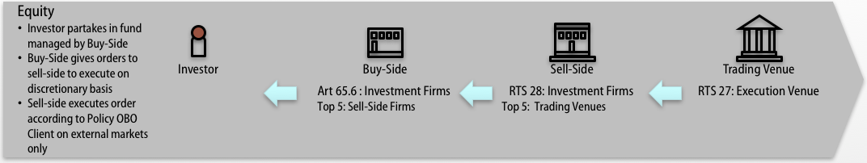

Figure 1: Equity Scenario – Agency-style Trading on Trading Venue

The first equity scenario in Figure 1, represents the situation where the Buy-Side firm uses a Sell-Side firm to get access to liquidity either on a Regulated Market (RM) or Multilateral Trading Facility (MTF). The Sell-Side firm, takes the client order and places it on the RM/MTF on their behalf.

* **The Buy-Side** transmitting an order must produce a report under Article 65.6 identifying the Sell-Side Firm as one of the Top 5 brokers in terms of trading volumes where it transmitted orders to which resulted in an execution (if it qualifies) and this should be consistent with the information published under RTS 28
* **The Sell-Side** must generate an RTS 28 report, identifying the Trading Venue as one of the Top 5 Execution Venues (if it qualifies).
* **The Trading Venue** must generate an RTS 27 report.
* **In this instance, there is no obligation for the Sell-Side firm to provide an RTS 27 report as the Sell-Side firm does not provide any of its own liquidity to the buy-side.**

On those scenarios where a firm transmits orders to other firms for execution alongside its execution activity as a member of a trading venue (shown in figure 2) they will need to provide two separate reports disclosing on one hand the top five execution venues and on the other hand the top five entities (brokers) where client orders were routed

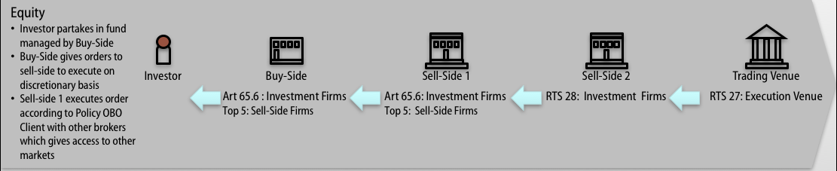

Figure 2: Equity Scenario - Routing an order through another Broker

The second equity scenario in Figure 2, represents the situation where the Buy-Side firm uses a Sell-Side firm to get access to liquidity, but Sell-Side 1 does not have membership of the required market and must use Sell-Side 2 to access the appropriate Regulated Market (RM) or Multilateral Trading Facility (MTF). The Sell-Side firm, takes the client order and passes it to Sell-Side 2 to place it on the RM/MTF on the Buy-Side’s behalf.

* **The Buy-Side** transmitting an order must produce a report under Article 65.6 identifying the Sell-Side Firm as one of the Top 5 brokers in terms of trading volumes where it transmitted orders to (if it qualifies) and this should be consistent with the information published under RTS 28
* **The Sell-Side 1 Firm** transmitting an order must produce a report under Article 65.6 identifying the **Sell-Side Firm 2** as one of the Top 5 brokers in terms of trading volumes where it transmitted orders to (if it qualifies) and this should be consistent with the information published under RTS 28.
* **The Sell-Side 2 Firm** must generate an RTS 28 report, identifying the Trading Venue as one of the Top 5 Execution Venues (if it qualifies).
* **The Trading Venue** must generate an RTS 27 report.

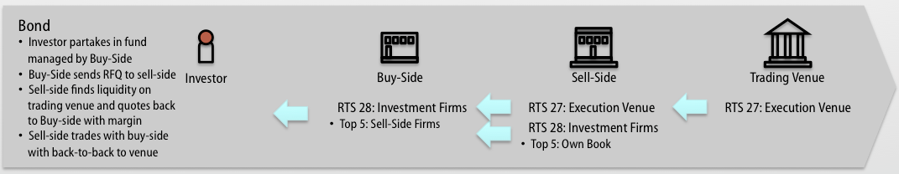

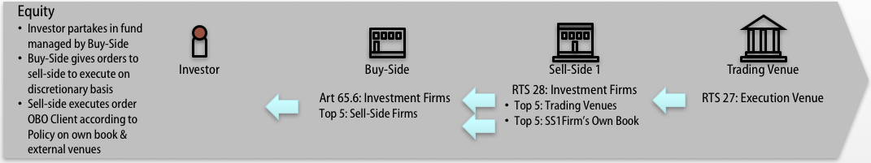

Figure 3: Equity Scenario - Sell-Side will do matched principal trading as well as on Trading Venues

The third equity scenario in Figure 3, represents the situation where the Buy-Side firm uses a Sell-Side firm to get access to liquidity. This time, the Sell-Side may act in a matched principal capacity trading OTC, or acting as agent in an ad-hoc, infrequent, non-systematic basis, or hold or take a position in the security rather than automatically route the order to a Regulated Market (RM) or Multilateral Trading Facility (MTF). The Sell-Side firm has the option to Trade off own book (with permission) or take the client order and place it on a RM/MTF on the Buy-Side’s behalf.

* **The Buy-Side** transmitting an order must produce a report under Article 65.6 identifying Sell-Side Firm 1 as one of the Top 5 brokers in terms of trading volumes where it transmitted orders to (if it qualifies) and this should be consistent with the information published under RTS 28
* **The Sell-Side** must generate an RTS 28 report, identifying itself, as well Trading Venues, as one of the Top 5 Execution Venues (if it qualifies).
* **As the Sell-Side firm is providing liquidity to the Buy-Side, in this case trading OTC on an ad-hoc and infrequent basis, but in an instrument which is subject to a Trading obligation, the Sell-Side does NOT produce an RTS 27 report.**
* **The Trading Venue** must generate an RTS 27 report.

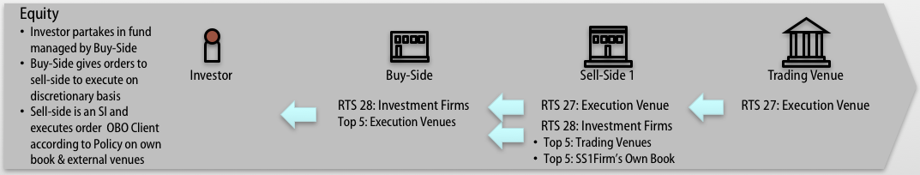

Figure 4: Equity Scenario - Sell-Side acts as a Systematic Internaliser and trades off own book as well as on Trading Venues

The fourth equity scenario in Figure 4, represents the situation where the Buy-Side firm uses a Sell-Side firm to get access to liquidity. This time, the Sell-Side is a Systematic Internaliser and therefore willing to hold or take a position in the security rather than automatically route the order to a Regulated Market (RM) or Multilateral Trading Facility (MTF). The Sell-Side firm has the option to Trade off own book (with permission) or take the client order and place it on a RM/MTF on the Buy-Side’s behalf.

* **The Buy-Side** transmitting an order must produce a report under RTS28 if using Sell-Side Firm 1 as one of the Top 5 Execution Venues (such as SI) in terms of trading volumes (if it qualifies)
* **The Sell-Side** must generate an RTS 28 report, identifying itself, as well Trading Venues, as one of the Top 5 Execution Venues (if it qualifies).
* **If the Sell-Side firm is providing liquidity to the Buy-Side in the capacity of an SI the Sell-Side firm must produce an RTS 27 report**
* **The Trading Venue** must generate an RTS 27 report.

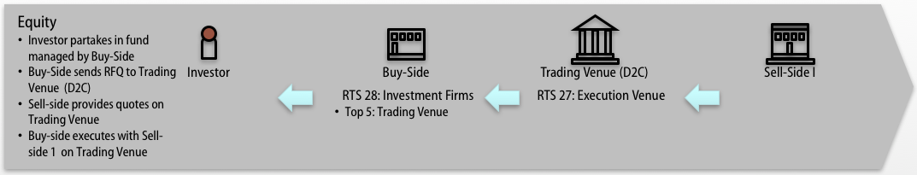

Figure 5: Equity Scenario - Buy-Side uses D2C Trading Venue to access Liquidity

The fifth equity scenario in Figure 5 represents the situation where the Buy-Side firm uses a D2C (Direct to Counterparty) Trading Venue to access liquidity.

The Buy-Side firm sends an RFQ to the Trading Venue which distributes the request to multiple providers of liquidity.

* **The Buy-Side** must generate an RTS 28 report, which identifies the Top 5 Execution Venues it transmitted orders to which resulted in an execution
* **The Counterparty Firm** does not include this flow in its RTS 28 report as it is not dealing directly with client orders.  
  As the firm is providing liquidity on the Trading Venue and is not the Execution Venue, the Sell-Side firm does not produce an RTS 27 Report.
* **The Trading Venue** must generate an RTS 27 report.



Figure 6: Equity Scenario - Buy-Side uses Sell-Side DEA to access Trading Venue

The sixth equity scenario in Figure 6 represents the situation where the Buy-Side firm uses Direct Electronic Access to the Trading Venue provided by the Sell-Side Firm.

* **The Buy-Side** must generate a report under Article 65.6 identifying the firm that has provided DEA access and an RTS 28 report report, identifying the relevant venue as one of their Top 5 Execution Venues (if it qualifies).
* The **DEA Provider** completes an RTS 28 report, identifying the relevant venue as one of their Top 5 Execution Venues (if it qualifies) including this in its % of directed orders.
* **The relevant venue** must generate an RTS 27 report.

## Bonds

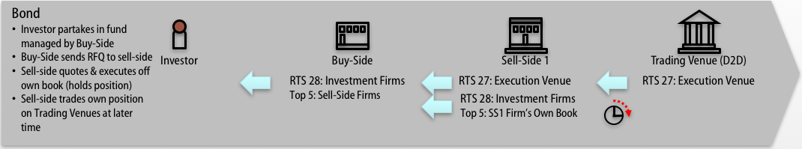

Figure 7: Bond Scenario – Buy-Side RFQ with Sell-Side (1). Sell-Side quotes & trades off own book.

The first bond scenario in Figure 7, represents the situation where the Buy-Side firm requests a quote from the Sell-Side firm to get access to liquidity. The Sell-Side may hold or is willing to take a position in the security rather than route the order to a Regulated Market (RM) or Multilateral Trading Facility (MTF). The Sell-Side firm trades off own book but at a later stage, it may trade on a Trading Venue in order to get out of its position.

* **The Buy-Side** must generate an RTS 28 report, identifying Sell-side 1 as one of the Top 5 Execution Venues (if it qualifies).
* **The Sell-Side** must generate an RTS 28 report, identifying itself as the one Top 5 Execution Venues (if it qualifies)
* As the firm is providing liquidity to the Buy-Side, the Sell-Side firm must include this flow in an RTS 27 Report.
* **The Trading Venue** must generate an RTS 27 report.

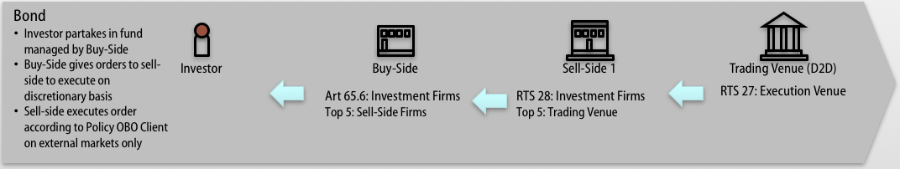

Figure 8: Bond Scenario – Buy-side leaves order with Sell-Side. Sell-side places client order on Trading Venue.

The second bond scenario in Figure 8, represents the situation where the Buy-Side firm uses a Sell-Side firm to get access to liquidity either on a Regulated Market (RM) or Multilateral Trading Facility (MTF) or Organised Trading Facility (OTF). The Sell-Side firm is not willing to take a position and acts purely as an agent: it takes the client order and places it on the RM/MTF on their behalf. This scenario would be similar irrespective of whether DEA is provided or not.

* **The Buy-Side** transmitting an order must produce a report under Article 65.6 identifying the Sell-Side Firm as one of the Top 5 brokers in terms of trading volumes where it transmitted orders to (if it qualifies) and this should be consistent with the information published under RTS 28
* **The Sell-Side** must generate an RTS 28 report, identifying the Trading Venue as one of the Top 5 Execution Venues (if it qualifies).
* **The Sell-Side is not obligated to complete an** RTS 27 report as the Sell-Side firm does not hold any position and does not provide any of its own liquidity to the Buy-Side.
* **The Trading Venue** must generate an RTS 27 report.

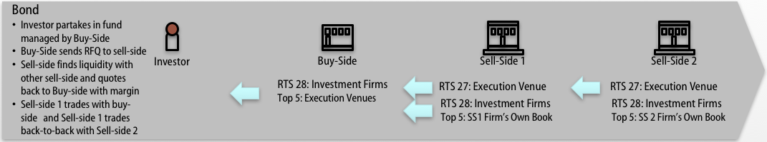

Figure 9: Bond Scenario – Buy-Side RFQ with Sell-Side 1. Sell-Side 1 firm finds liquidity at Sell-Side 2: Principal

The third bond scenario in Figure 9 represents the situation where the Buy-Side firm uses a Sell-Side firm to get access to liquidity, but Sell-Side 1 does not hold a position in the security and must go out to another bank to find liquidity.

Sell-Side 1 requests Sell-Side 2 for a quote and, on receiving the quote, adds an additional spread before providing a quote back to the Buy-Side. When the Buy-Side executes the trade with Sell-Side 1, Sell-Side 1 does a back-to-back trade with Sell Side 2, acting as principal.

* **The Buy-Side** sending an order must produce a report under RTS 28, identifying the Sell-Side 1 as one of the Top 5 Execution Venues in terms of trading volumes. The Buy-Side firm may not even know that the order has been sent on to another bank.
* **Sell-Side 1** must generate an RTS 28 report, identifying **itself** as one of its Top 5 Execution Venues (if it qualifies).
* As **Sell-Side 1** is providing liquidity to the buy-side, Sell Side 1 must produce an RTS 27 report.
* As **Sell-Side 1** is considered an eligible counterparty there is no obligation for **Sell-Side 2** to include this data in its RTS 28 report, however Sell-Side 2 must provide an RTS 27 rerport
* The above example is caveated by the fact that the industry is waiting for clarity on whether a sell-side firm offering liquidity off its own book would be obligated to complete an RTS 28 report identifying itself as one of its Top 5 execution venue (if it qualifies) This will be updated once further guidance has been received from ESMA.

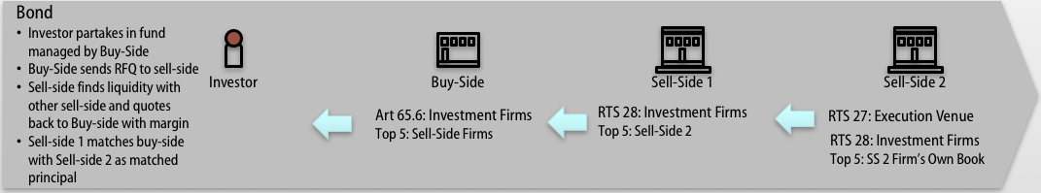

Figure 10: Bond Scenario – Buy-Side RFQ with Sell-Side 1. Sell-Side 1 firm finds liquidity at Sell-Side 2: Matched Principal

The fourth bond scenario in Figure 10 is similar to the previous scenario, it represents the situation where the Buy-Side firm uses a Sell-Side firm to get access to liquidity, but Sell-Side 1 does not hold a position in the security and must go out to another bank to find liquidity.This time when Sell-Side 1 requests Sell-Side 2 for a quote, the quote is passed straight through to the Buy-Side unaltered. When the Buy-Side executes the trade with Sell-Side 1, it is effectively matching the trade with Sell Side 2: Matched Principal. Only a pre-arranged commission is charged.

* **The Buy-Side** transmitting an order must produce a report under Article 65.6, identifying the Sell-Side 1 Firm as one of the Top 5 brokers in terms of trading volumes where it transmitted orders to (if it qualifies) and this should be consistent with the information published under RTS 28
* **The Sell-Side 1 Firm** must generate an RTS 28 report, identifying **Sell-Side 2 Firm** as one of the Top 5 venues in terms of trading volumes where it executed orders.
* **The Sell-Side 2 Firm** must generate an RTS 27 report and an RTS 28 report, identifying itself as one of the Top 5 Execution Venues (if it qualifies).

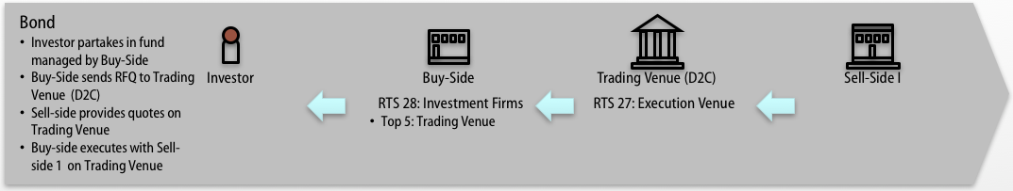

Figure 11: Bond Scenario - Buy-Side uses D2C Trading Venue to access Sell-Side Liquidity

The fifth bond scenario in Figure 11 represents the situation where the Buy-Side firm uses a D2C (Dealer to Client) Trading Venue to access Sell-Side firm liquidity. The Buy-Side firm sends an RFQ to the Trading Venue which distributes the request to multiple Sell-Side firms.

* **The Buy-Side** firm must generate an RTS 28 report, identifying **the venue** as one of the Top 5 Execution Venues (if it qualifies) – not the dealer as the transaction as occurred on the relevant venue.
* **The Sell-Side 1 Firm** does not include this flow in its RTS 28 report as it is not dealing directly with client orders.  
  As the firm is providing liquidity on the Trading Venue and is not the Execution Venue, the Sell-Side firm does not produce an RTS 27 Report.
* **The Trading Venue** must generate an RTS 27 report.
* The above example is caveated by the fact that the industry is waiting for clarity on whether the buy-side firm would be obligated to complete an RTS 28 report identifying the venue or the underlying counterparty (broker) as one of its Top 5 execution venue (if it qualifies) This will be updated once further guidance has been received from ESMA.

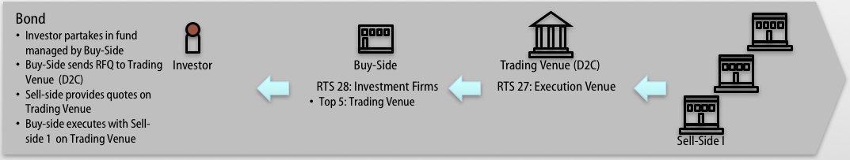

Figure 12: Bond Scenario - Buy-Side uses D2C Trading Venue to source Sell-Side liquidity from multiple providers

The final bond scenario in Figure 12 represents the situation where the Buy-Side firm uses a D2C (Dealer to Client) Trading Venue to access Sell-Side liquidity from multiple providers.

The Buy-Side firm sends an RFQ to the Trading Venue which distributes the request to multiple Sell-Side firms. The trade is then executed once electronically confirmed via FIX Message.

* **The Buy-Side** must generate an RTS 28 report, identifying **the venue** as one of the Top 5 Execution Venues (if it qualifies) – not the dealer as the transaction occurred on the venue.
* **The Sell-Side 1 Firm** does not include this flow in its RTS 28 report as it is not dealing directly with client orders. As the Sell-Side 1 firm is providing liquidity on the Trading Venue and is not the Execution Venue, the Sell-Side firm does not produce an RTS 27 Report.
* **The Trading Venue** must generate an RTS 27 report.

## Derivatives

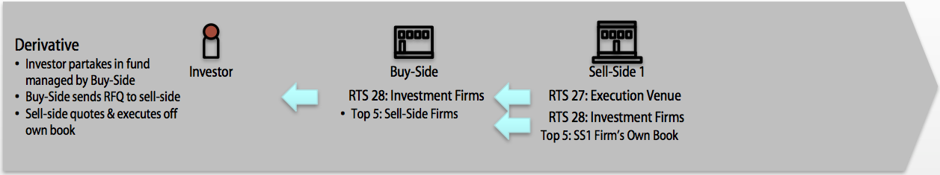

Figure 13: Derivative Scenario - Buy-Side trades OTC with Sell-Side

The first derivative scenario in Figure 13, represents the situation where the Buy-Side firm requests a quote from the Sell-Side firm for a derivative to hedge a position. The Sell-Side “manufactures” a specific derivative for the Buy-Side tailored for the hedge.

* **The Buy-Side** must generate an RTS 28 report, identifying the Sell-Side 1 Firm as one of the Top 5 Execution Venues (if it qualifies).  
  **N.B.** The client in this case is often a Corporate instead of a regulated Buy-Side firm and, if this is the case, the Corporate is not obliged to generate an RTS 28 Report.
* **The Sell-Side** must generate an RTS 28 report, identifying itself as one of the Top 5 Execution Venues.   
  The Sell-Side firm must produce an RTS 27 Report as well.

This is a common flow for Fixed Income and FX derivatives as well as other derivatives where there is a high level of customization.

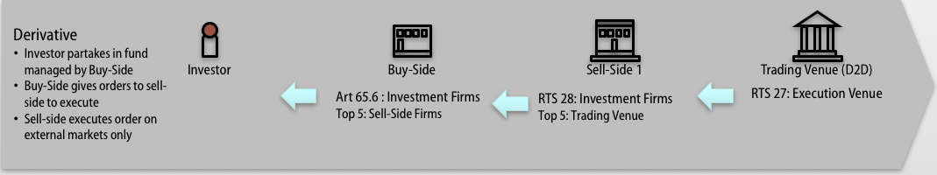

Figure 14: Derivative Scenario - Buy-Side uses Sell-Side to access Trading Venue Liquidity

The second derivative scenario in Figure 14, represents the situation where the Buy-Side firm uses the Sell-Side firm to get access to liquidity either on a Regulated Market (RM) or Multilateral Trading Facility (MTF). The Sell-Side firm, takes the client order and places it on the RM/MTF on their behalf.

* **The Buy-Side** transmitting an order must produce a report under Article 65.6 identifying the Sell-Side Firm as one of the Top 5 brokers in terms of trading volumes where it transmitted orders to (if it qualifies) and this should be consistent with the information published under RTS 28
* **The Sell-Side** must generate an RTS 28 report, identifying the Trading Venue as one of the Top 5 Execution Venues (if it qualifies).
* **The Trading Venue** must generate an RTS 27 report.
* **In this instance, there is no obligation for the Sell-Side firm to provide an RTS 27 report as the Sell-Side firm does not provide any of its own liquidity to the buy-side.**

This flow is typical for Exchange Traded Derivatives.

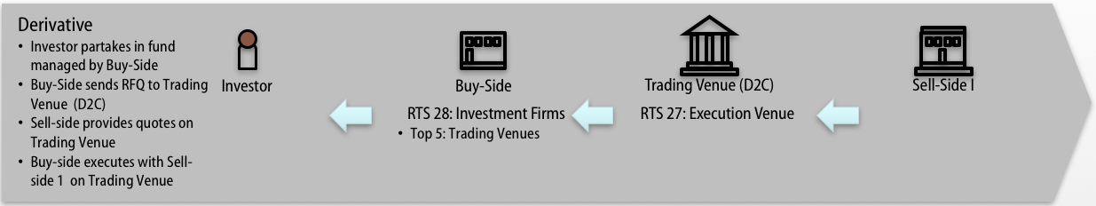

Figure 15: Derivative Scenario - Buy-Side uses D2C Trading Venue to access Sell-Side Liquidity

The third derivative scenario in Figure 15 represents the situation where the Buy-Side firm uses a D2C (Dealer to Client) Trading Venue to access Sell-Side firm liquidity.

The Buy-Side firm sends an RFQ to the Trading Venue which distributes the request to multiple Sell-Side firms. The Buy-Side executes against the best price on the Trading Venue.

* **The Buy-Side** must generate an RTS 28 report, identifying the Trading Venues as one of the Top 5 Execution Venues (if it qualifies).
* **The Sell-Side 1 Firm** does not include this flow in its RTS 28 report as it is not dealing directly with client orders.  
  As the firm is providing liquidity on the Trading Venue and is not the Execution Venue, the Sell-Side firm does not produce an RTS 27 Report.
* **The Trading Venue** must generate an RTS 27 report.

This flow is typical for flow FX Derivatives and Fixed Income Derivatives

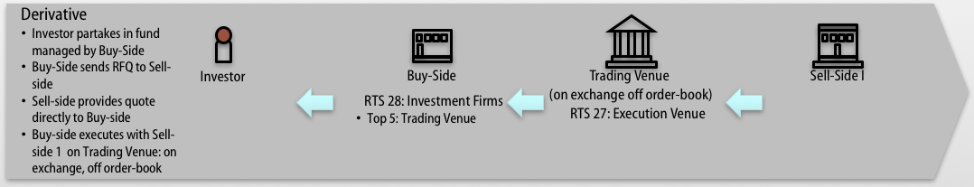

Figure 16: Derivative Scenario: Buy-Side negotiates OTC but concludes transaction on Trading Venue with Sell-Side

The forth derivative scenario in Figure 16 represents the situation where the Buy-Side negotiates with a Sell-Side firm bilaterally but the trade is executed on the Trading Venue (under the rules of the exchange but off the order-book).

* **The Buy-Side** must generate an RTS 28 report, identifying the Trading Venues as one of the Top 5 Execution Venues (if it qualifies).
* **The Sell-Side 1 Firm** does not include this flow in its RTS 28 report as it is not dealing directly with client orders.  
  As the firm is effectively providing liquidity on the Trading Venue and **is not the Execution Venue**, the Sell-Side firm does not include this data in its RTS 27 Report.
* **The Trading Venue** must generate an RTS 27 report.

This flow is typical of vanilla Equity Derivatives.



Figure 17: Derivative Scenario - Buy-Side uses Sell-Side DEA to access Trading Venue

The final derivative scenario in Figure 17 represents the situation where the Buy-Side firm uses Direct Electronic Access to the Trading Venue provided by the Sell-Side Firm.

* **The Buy-Side** must generate a report under Article 65.6 identifying the firm that has provided DEA access and an RTS 28 report report, identifying the relevant venue as one of their Top 5 Execution Venues (if it qualifies).
* **The Sell-Side Firm** completes an RTS 28 report, identifying the relevant venue as one of their Top 5 Execution Venues (if it qualifies) including this in its % of directed orders.
* **The Trading Venue** must generate an RTS 27 report.

# RTS 27 Reporting Requirements

## Generic Requirements

In order to fully assess the extent of the quality of execution of transactions that take place in the Union, it is appropriate that execution venues which may be selected by investment firms to execute client orders comply with requirements on data to be provided by execution venues in accordance with this Regulation.

To this effect, these execution venues should include regulated markets (RMs), multilateral trading facilities (MTFs), organised trading facilities (OTFs), systematic internalisers (Sis), market makers (MMs) and other liquidity providers.

**Equities**

Article 23 of MiFIR state that “shares admitted to trading on a regulated market or Traded on a trading venue shall take place on a regulated market, MTF or systematic internaliser, or a third-country trading venue assessed as equivalent in accordance with Article 25 (4) (a) of directive 2014/65/EU” MiFID II effectively requires broker crossing networks (BCN) to register either as a systematic Internaliser (SI) or a multilateral trading facility (MTF).

For Equities (subject to the trading obligation) the only entities generally to be required to submit an RTS 27 report would be a RM, MTF or SI where those instruments are in the most part traded.

MIC codes should be used for all different levels of market segment to appropriately identify whether the execution was:

* Exchange Lit or Dark
* Execution venue (SI) Lit or Dark

LEI codes will be used to identify the legal entity of a broker when trading OTC.

It is also assumed that the LEI code will be used in the production of Article 65.6 reports..

**Bonds**

MiFID II/MiFIR does not place any restrictions on how or where cash bonds are traded but at the point that the legislation comes into force, the majority of liquidity is provided by the banks (sell-side) and either traded directly with clients off-venue or traded through Dealer-to-Client multilateral trading facilities (MTF).

This means that a significant number of banks will become Systematic Internalisers in a number of issues (the number depending on the range of issues regularly being traded off own book) unless these banks choose to operate an OTF or move the majority of their business to be concluded on an MTF.

When a bank offers a price through an MTF to a client, while the liquidity is offered by a bank, the actual execution venue is the MTF and current industry consensus is that the bank does not include this RFQ/trading activity in the RTS 27 report. However where an investment firm operates an OTF, ESMA is of the view equivalent requirements apply to the investment firm or the market operator operating an OTF.

It is noted that some asset managers may provide some liquidity back to the market on an ad-hoc basis but again the consensus is that an RTS 27 report for this activity will not be required.

SIs are anticipated to apply for a MIC in order to correctly complete the associated reports which may mean the production of multiple MICs per individual broker.

**Derivatives**

Article 28 of MiFIR requires that certain derivatives traded between financial counterparties (FC) or between a financial counterparty and non-financial counterparties above a particular size (NFC+) must be concluded on a Trading Venue or a 3rd Country Venue. The list of these derivatives will be declared by ESMA on the basis that they are mandated to clear, are already traded on a trading venue, and there is enough buying/selling interest.

Financial Counterparties will still be able to trade OTC/Bilaterally with smaller non-financial counterparties (NFC-) in declared derivatives, while the remaining derivative universe can be freely traded bilaterally or on venue (subject to any EMIR clearing mandates).

The sell-side manufacture and provide liquidity for the majority of derivatives. However, like bonds, the sell-side is only the execution venue when the transaction is concluded bilaterally and not through a Trading Venue (or Third Country Venue), and therefore only this data should be used in the RTS 27 Report provided by the sell-side firm.

**Timing and Format**

RTS 27 requires that Execution Venues create the Execution Venue reports on a quarterly basis and no later than three months after the end of each quarter, as follows:

1. by 30 June, information regarding the time period 1 January to 31 March;
2. by 30 September, information regarding the time period 1 April to 30 June;
3. by 31 December, information regarding the time period 1 July to 30 September;
4. by 31 March, information regarding the time period 1 October to 31 December.

The first report, therefore, is expected to be published by 30th June 2018.

The following sections cover the generic format and tables that make up the components of an RTS 27 Report:

### Table 1 - Article 3(1): Market Information

#### Table Format (one table per market segment)

|  |  |  |  |
| --- | --- | --- | --- |
| Venue as a Systematic Internaliser | 1a) | 1b) |  |
| Country of Competent Authority | 1c) |  |  |
| Market Segment | 1d) | 1e) |  |
| Date | 1f) |  |  |
| Outages | 1g) | 1h) | 1i) |
| Scheduled Auction | 1j) | 1k) | 1l) |
| Failed Transactions |  | 1m) | 1n) |

|  |  |  |  |
| --- | --- | --- | --- |
| Venue as a Market Maker | 1a) | 1b) |  |
| Country of Competent Authority | 1c) |  |  |
| Market Segment | 1d) | 1e) |  |
| Date | 1f) |  |  |
| Outages | 1g) | 1h) | 1i) |
| Scheduled Auction | 1j) | 1k) | 1l) |
| Failed Transactions |  | 1m) | 1n) |

#### Attributes

The Table is populated with the following attributes:

1a) Name of Venue

1b) Venue identifier; [LEI or MIC]

1c) Country of Competent Authority

1d) Name of Market Segment

1e) Market Segment identifier; [MIC]

1f) Date ISO 8601

1g) Nature of Outage

1h) Number of Outages

1i) Average Duration of Outages

1j) Nature of Scheduled Auction

1k) Number of Scheduled Auctions

1l) Average Duration of Scheduled Auctions

1m) Number of Failed Transactions

1n) Value of Failed Transactions: as %age of total value of transactions executed on that day

The table should be viewed as a summary of the activity on a venue over a day Here the concept of an outage should be interpreted as an interruption to all instruments on a venue (see Article 3(i)(e)).

The first six fields of information can be held as venue level information.

If there is only one segment in the venue and a MIC is used in 1b), the same MIC should be re-used to populate 1e).

### Table 2 - Article 3(2): Instrument Identifier

#### Table Format (one table per instrument)

|  |  |  |
| --- | --- | --- |
| Financial Instrument | 2a) | 2b) |
| Written Description of Financial Instrument | 2c) | |
| Instrument Classification | 2d) | |
| Currency | 2e) | |

#### Attributes

The Table is populated with the following attributes:

2a) Financial Instrument Name

2b) Instrument Identifier - ISIN [ISO6166]

2c) If no Instrument Identifier available, a written description of financial instrument, (including the currency of the underlying instrument, price multiplier, price notation, quantity notation and delivery type)

2d) Instrument Classification - CFI code [ISO10962]

2e) Currency - CCY [ISO4217]

It is the consensus of the FIX Trading Community that the Currency stated in 2e) is the currency the financial instrument is traded in.

### Table 3 - Article 4(a): Price information: Intra-Day

#### Table Format (one table per instrument per market segment per day)

|  |  |  |  |  |  |  |  |  |  |  |
| --- | --- | --- | --- | --- | --- | --- | --- | --- | --- | --- |
|  | Size Range | All Trades Executed within 2 minutes after time T | | First Transaction after time T (if no transaction within two minutes after time T) | | | | | | |
| Time (T) |  | Simple average executed price | Total Value Executed | Price | Time of Execution | Transaction Size | Trading System | Trading Mode | Trading Platform | Best Bid/Offer or suitable reference price at time of execution |
| 09.30.00 | 1 | 3a) | 3b) | 3c) | 3d) | 3e) | 3f) | 3g) | 3h) | 3i) |
|  | 2 |  |  |  |  |  |  |  |  |  |
|  | 3 |  |  |  |  |  |  |  |  |  |
| 11.30.00 | 1 |  |  |  |  |  |  |  |  |  |
|  | 2 |  |  |  |  |  |  |  |  |  |
|  | 3 |  |  |  |  |  |  |  |  |  |
| 13.30.00 | 1 |  |  |  |  |  |  |  |  |  |
|  | 2 |  |  |  |  |  |  |  |  |  |
|  | 3 |  |  |  |  |  |  |  |  |  |
| 15.30.00 | 1 |  |  |  |  |  |  |  |  |  |
|  | 2 |  |  |  |  |  |  |  |  |  |
|  | 3 |  |  |  |  |  |  |  |  |  |

#### Attributes

The Table is populated with the following attributes if there is a trade within 2 minutes of time T, fill in the following attributes ONLY::

3a) the simple average price of all transactions for 2 mins after time T

3b) Total value of all transactions for 2 mins after time T

However, if there is no data for 3a) or 3b) the table should be populated with all of the following:

3c) Price of First Transaction after time T (if no 3a/3b)

3d) Time of Execution of First Transaction after time T (if no 3a/3b)

3e) Transaction size of First Transaction after time T (if no 3a/3b)

3f) Trading System of First Transaction after time T (if no 3a/3b)

3g) Trading Mode [scheduled opening auction, scheduled closing auction, scheduled intraday auction, unscheduled auction, trading at close, trading out of main session, trade reporting] of First Transaction after time T (if no 3a/3b)

3h) Trading Platform [electronic, voice, outcry] of First Transaction after time T (if no 3a/3b)

3i) OR Best bid/offer or suitable reference price at time of execution of First Transaction after time T (if no 3a/3b)

The data is based on four points of time for T: 09:30, 11:30.00, 13:30.00 and 15:30.00 where T is stated as Coordinated Universal Time (UTC) and does not observe daylight saving time.

Each row is repeated 3 times according to the transaction sizes identified in section 6.1.3.3.

Where trades are subsequently cancelled or fail, no adjustments to this report are required.

#### Size Ranges

|  |  |  |  |  |  |  |
| --- | --- | --- | --- | --- | --- | --- |
|  | All financial instruments other than Money Mkt | | Illiquid Shares, Exchange Traded Funds or Certs | | Money Market Instruments | |
| Size Range | Trading Venues | SIs, Market Makers,  Other liquidity providers | Trading Venues | SIs, Market Makers,  Other liquidity providers | Trading Venues | SIs, Market Makers,  Other liquidity providers |
| 1 | >€0 and  =<Standard Market Size or SSTI (PostTrd) | >€0 and  =<Standard Market Size (SMS) or SSTI (for all other instruments) | >€0 and  =< smallest available Standard Market Size (SMS) for type of instrument | >€0 and  =< smallest available Standard Market Size for type of instrument | >€0 <=€10m | >€0 <=€10m |
| 2 | >Standard Market Size or SSTI =<Large in Scale (PostTrd) |  | >smallest available Standard Market Size for type of instrument =<Large in Scale (PostTrd) |  | >€10m <=€50m |  |
| 3 | > Large in Scale (PostTrd) |  | > Large in Scale (PostTrd) |  | >€50m |  |

### Table 4 - Article 4(b): Price Information: Daily

#### Table Format (one table per instrument per market segment per day)

|  |  |
| --- | --- |
| Simple average transaction price | 4a) |
| volume-weighted transaction price | 4b) |
| highest executed price | 4c) |
| lowest executed price | 4d) |

#### Attributes

The Table is populated with the following attributes:

4a) simple average transaction price, if more than one transaction occurred

4b) volume-weighted average transaction price, if more than one transaction occurred

4c) highest executed price, if more than two transactions occurred

4d) lowest executed price, if more than two transactions occurred

### Table 5 – Article 5: Cost information by instrument

#### Table Format (one table per market segment)

|  |  |
| --- | --- |
| Information required under Article 5(a) to (d) | 5a), 5b), 5c), 5d) |
| Link to a website or other source where further information on costs is available | 5e) |
| Total value of all rebates, discounts, or other payments offered (as % of total traded value during the reporting period) | 5f) |
| Total value of all costs (as a % of total traded value during the reporting period volume) | 5g) |

The consensus opinion of the FIX Trading Community Best Execution Working Group is that the inclusion of all relevant costs (including clearing and settlement fees), taxes and levies within the relevant costs of execution should only include the costs applied by the Execution Venue in question as per guidance from ESMA Q&A on Investor Protection,Q9, July 10th 2017[1]. External costs which are not applied by the Execution Venue, such as clearing and settlement fees or taxes not associated with the Execution Venue in question should not be included. Costs are to be aggregated at a venue level – venues are expected to provide costs at a venue level and any market segment at the appropriate level. Costs that are currently not available on a per instrument basis such as country specific market data should only be provided on a per market segment.

#### Attributes

The Table is populated with the following attributes:

5a) Costs before rebates including:

1. Execution Fees,
2. fees for submission modification or cancellation of orders or quote withdrawals,
3. fees related to market data access and use of terminals,
4. any clearing and settlement fees and any other fees paid to third parties involved in execution of the order

5b) a description of the nature and level of any rebates, discounts or other payments offered to users of the execution venue including information on how those rebates, discounts or other payments differ according to the user or financial instrument involved and the amounts by which they differ;

5c) a description of the nature and amount of any non-monetary benefits offered to users of the execution venue, including information on how those non-monetary benefits differ according to the user or financial instrument involved and the value by which they differ

5d) a description of the nature and level of any taxes or levies invoiced to, or incurred by the execution venue on behalf of the members or users of the venue;

5e) a link to the website of the venue or to another source where further information on costs is available;

5f) total value of all costs as set out in point (a), excluding the total value of rebates and discounts, non-monetary benefits or other payment as set out in point (b) and (c) of paragraph 1, expressed as a percentage of the total traded value during the reporting period.

5g) the total value of all costs as set out in point (a), excluding the total value of rebates and discounts, non-monetary benefits or other payment as set out in points (b) and (c), expressed as a percentage of the total traded value during the reporting period

### Table 6 – Article 6: Likelihood of Execution by instrument (daily)

#### Table Format (one table per instrument per market segment per day)

|  |  |
| --- | --- |
| Number of orders or request for quotes received | 6a) |
| Number of transactions executed | 6b) |
| Total value of transactions executed | 6c) |
| Number of orders or request for quotes received cancelled or withdrawn | 6d) |
| Number of orders or request for quotes received modified | 6e) |
| Median transaction size | 6f) |
| Median size of all orders or request for quotes | 6g) |
| number of designated market makers | 6h) |

Each trading venue and systematic internaliser is required to publish for each financial instrument subject to the trading obligation in Article 23(1) and 28 of Regulation (EU) No 600/2014 and for each market segment it operates, information as regards likelihood of execution for each trading day. The consensus opinion of the FIX Trading Community Best Execution Working Group is that the requirement to include the number of orders or request for quotes which may be cancelled or withdrawn is included to provide an overall picture as to the quality of the venue in terms of execution capability based on actual data captured by the execution venue in question. This is to enable users of the venue to establish the likelihood of execution on the type of venue in question and is not to provide a comparison of different execution models.

#### Attributes

The Table is populated with the following attributes:

6a) number of orders or requests for quotes (RFQ) that were received

6b) number of transactions that were executed, if more than one

6c) value of transactions that were executed, if more than one

6d) number of orders or request for quotes (RFQ) received that were cancelled or withdrawn excluding passive orders with instructions to expire or to be cancelled at the end of the day

6e) number of orders or request for quotes received that were modified on that date;

6f) median transaction size on that date if more than one transaction occurred

6g) median size of all orders or requests for quote on that date if more than one order or request for quote was received

6h) number of designated market makers

### Table 7 – Likelihood of Execution - additional information by continuous auction order book and continuous quote driven execution venues – periodic (Article 7 (1))

Execution Venues operating under a continuous auction order book, continuous quote driven trading system or other type of trading system for which that information is available shall publish for each market segment they operate and each financial instrument. A Systematic Internaliser in liquid equity instruments with continuous quotes would fall into this category.

#### Table Format (one table per instrument per market segment per day)

|  |  |  |  |  |  |
| --- | --- | --- | --- | --- | --- |
| Time | Best Bid Price | Best Offer Price | Bid Size | Offer Sizes | Book depth within 3 price increments |
| 09.30.00 | 7a) | 7b) | 7c) | 7d) | 7e) |
| 11.30.00 |  |  |  |  |  |
| 13.30.00 |  |  |  |  |  |
| 15.30.00 |  |  |  |  |  |

#### Attributes

The Table is populated with the following attributes at time T (09:30.00, 11:30.00, 13:30.00, 15:30.00 UTC) as per RTS 25:

7a) best bid price

7b) best offer price

7c) Bid size corresponding to Best Bid Price

7d) Offer size corresponding to Best Offer Price

7e) Book depth with 3 price increments where book depth means the total available liquidity expressed as the product of price and volume of all bids and offers for a specified number of price increments from the mid- point of the best bid and offer

### Table 8 – - additional information by continuous auction order book and continuous quote driven execution venues – daily (Article 7(2)/(3))

Execution Venues operating under a continuous auction order book, continuous quote driven trading system or other type of trading system for which that information is available shall publish for each market segment they operate and each financial instrument

#### Table Format (one table per instrument per market segment per day)

|  |  |
| --- | --- |
| Average effective spread | 8a) |
| Average volume at best bid and offer | 8b) |
| Average Spread at best bid and offer | 8c) |
| Number of cancellations at best bid and offer | 8d) |
| Number of modifications at best bid and offer | 8e) |
| Average book depth at 3 price increments | 8f) |
| Mean time elapsed (to the milli-second) between an aggressive order or quote acceptance being received by the execution venue and the subsequent total or partial execution | 8g) |
| Median time elapsed (to the mili-second) between a market order being received by the execution venue and the subsequent total or partial execution | 8h) |
| Average speed of execution for unmodified passive orders at best bid and offer | 8i) |
| Number of Fill or Kill orders that failed | 8j) |
| Number of Immediate or Cancel orders that got zero fill | 8k) |
| Number of transactions executed on the trading venue that are Large in Scale pursuant to Article 4 or 9 of Regulation (EU) No 600/2014 | 8l) |
| Value of transactions executed on the trading venue that are Large in Scale pursuant to Article 4 or 9 of Regulation (EU) No 600/2014 | 8m) |
| Number of transactions that were executed on the trading venue pursuant to Article 4 or 9 of MiFIR, except for orders that are held in an order management facility of the trading venue pending disclosure and not Large in Scale | 8n) |
| Value of transactions that were executed on the trading venue pursuant to Article 4 or 9 of MiFIR, except for orders that are held in an order management facility of the trading venue pending disclosure and not Large in Scale | 8o) |
| Number of trading interruptions | 8p) |
| Average duration of trading interruptions | 8q) |
| Number of suspensions | 8r) |
| Nature of suspensions | 8s) |
| Average duration of suspensions | 8t) |
| For continuous quote venues, number of periods during which no quotes were provided | 8u) |
| For continuous quote venues, average duration of periods during which no quotes were provided | 8v) |
| Average quote presence | 8w) |

The consensus opinion of the FIX Trading Community Best Execution Working Group is that the requirement to capture and publish the mean and median time from order to execution is to highlight differences between similar methods of execution. Therefore, the interpretation of mean and medium should be an indication of the time elapsed between the order and the execution as a reference point for each type of venue in question.

Here the concept of suspension should be interpreted as an interruption to the specific instrument on a trading venue outside of any that were in Table 1 under Article 3(1) (e), see Article 7,(2)(n).

#### Attributes

The Table is populated with the following attributes:

8a) average effective spread, which means the average of twice the difference between the actual execution price compared with mid-point of best bid and offer at time of receipt, for market orders or marketable limit orders

8b) Average volume at best bid and offer

8c) Average spread at best bid and offer

8d) Number of cancellations at best bid and offer

8e) Number of modifications at best bid and offer

8f) Average book depth for 3 price increments, where book depth means the total available liquidity expressed as the product of price and volume of all bids and offers for a specified number of price increments from the mid- point of the best bid and offer

8g) mean time elapsed between an aggressive order or quote acceptance being received by the execution venue and the subsequent total or partial execution. It is the collective view that the term “market” here means aggressive order.

8h) median time elapsed between an aggressive order or quote acceptance being received by the execution venue and the subsequent total or partial execution

8i) Average speed of execution for unmodified passive orders at best bid and offer which means the average time elapsed between a limit order that matches the best bid and offer being received by the execution venue, and the subsequent execution of this order

8j) Number of Fill or Kill orders that failed

8k) Number of Immediate or Cancel orders that got zero fill

8l) Number of transactions that were executed on the trading venue that are Large in Scale pursuant to Article 4 or 9 of Regulation (EU) No 600/2014

8m) Value of transactions that were executed on the trading venue that are Large in Scale pursuant to Article 4 or 9 of Regulation (EU) No 600/2014

8n) "Number of transactions that were executed on

the trading venue pursuant to Article 4 or 9 of MiFIR, except for orders that are held in an order management facility of the trading venue pending disclosure and not Large in Scale"

8o) Value of transactions that were executed on the trading venue pursuant to Article 4 or 9 of MiFIR, except for orders that are held in an order management facility of the trading venue pending disclosure and not Large in Scale

8p) Number of trading interruptions as the result of any volatility auction or circuit breaker which occurred within the venue’s normal trading period

8q) Average duration of trading interruptions as the result of any volatility auction or circuit breaker which occurred within the venue’s normal trading period

8r) Number of any trading suspension in an individual instrument that occurred as a result of a decision by the venue within the venue’s normal trading period, outside of any that were reported under Article 3(1)(e)

8s) Nature of any trading suspension in an individual instrument that occurred as a result of a decision by the venue within the venue’s normal trading period, outside of any that were reported under Article 3(1)(e)

8t) Average duration of any trading suspension in an individual instrument that occurred as a result of a decision by the venue within the venue’s normal trading period, outside of any that were reported under Article 3(1)(e)

8u) For continuous quote trading systems, the number of any periods lasting more than 15 minutes during which no bid or offers were provided during the venue’s normal trading hours for each trading day

8v) For continuous quote trading systems, the average duration of any periods lasting more than 15 minutes during which no bid or offers were provided during the venue’s normal trading hours, for each trading day

8w) The average quote presence expressed in percentage of the venue’s normal trading period on that date.

The consensus opinion of the FIX Trading Community Best Execution Working Group is that the number of FOK and IOC orders should not be included in the count of cancelled orders (8d).

### Table 9 – Article 8: Likelihood of Execution by instrument

#### Table Format (one table per instrument per market segment per day)

|  |  |
| --- | --- |
| Mean time elapsed between acceptance and execution | 9a) |
| Median time elapsed between acceptance and execution | 9b) |
| Mean time elapsed between request and provision of any corresponding quotes | 9c) |
| Median time elapsed between request and provision of any corresponding quotes | 9d) |

#### Attributes

The Table is populated with the following attributes:

9a) the mean amount of time elapsed between the acceptance of a quote and execution, for all transactions in that financial instrument

9b) the median amount of time elapsed between the acceptance of a quote and execution, for all transactions in that financial instrument

9c) the mean amount of time and median amount of time elapsed between a request for a quote and provision of any corresponding quotes, for all quotes in that financial instrument

9d) the median amount of time elapsed between a request for a quote and provision of any corresponding quotes, for all quotes in that financial instrument

## Entities operating a Central Limit Order Book

### Frequency of Publication

Execution Venues are required to publish data four times a year and no later than three months after the end of each quarter.

### Tables to be completed

Table 1 – Identification Information to be published in accordance with Article 3

Table 2 – Identification Information to be published in accordance with Article 3

Table 3 – Price Information to be published in accordance with Article 4(I)(a)

Table 4 – Price Information to be published in accordance with Article 4(I)(b)

Table 5 – costs information to be published in accordance with Article 5

Table 6 – Likelihood of Execution by instrument (daily) in accordance with Article 6

Table 7 - Likelihood of Execution - additional information by continuous auction order book and continuous quote driven execution venues (Article 7 (1))

Table 8 – Likelihood of Execution by instrument (daily) in accordance with Article 7 (2) /(3)

## Entities operating a Request for Quote Mechanism

### Frequency of Publication

Execution Venues are required to publish data four times a year and no later than three months after the end of each quarter.

### Tables to complete

Table 1 – Identification Information to be published in accordance with Article 3

Table 2 - Article 3(2): Instrument Identifier

Table 3 – Price Information to be published in accordance with Article 4(I)(a)

Table 4 – Price Information to be published in accordance with Article 4(I)(b) - when prices are transacted after 09:30am to provide details of the first singular transaction after T if nothing happens in the first 2 minutes

Table 5 – Costs information to be published in accordance with Article 5Table 6 – Likelihood of Execution by instrument (daily) in accordance with Article 6Table 9 – Information to be published as referred to in Article 8

### Specific Scenarios

#### Firm Quote

It is the consensus of this working group that details on the number of firm quotes must exclude where one party cancels and withdraws quote and should only include those quotes where the party accepts and has the intention to trade – ie when it is firm vs. when it is indicative.

#### Indicative Quote

It is the consensus of this working group that Indicative Quotes would fall out of the scope of Best Execution reporting.

## Other Trading Models

#### Dark Pool – Block Model (No firm resting orders)

Table 1 – Identification Information to be published in accordance with Article 3

Table 2 - Article 3(2): Instrument Identifier

Table 3 – Price Information to be published in accordance with Article 4(I)(a) - when prices are transacted after 09:30am to provide details of the first singular transaction after T if nothing happens in the first 2 minutes

Table 4 – Price Information to be published in accordance with Article 4(I)(b)

Table 5 – Costs information to be published in accordance with Article 5

Table 6 – Likelihood of Execution by instrument (daily) in accordance with Article 6

Table 9 – Information to be published as referred to in Article 8

#### Dark Pool – Firm Order Model

Table 1 – Identification Information to be published in accordance with Article 3

Table 2 - Article 3(2): Instrument Identifier

Table 3 – Price Information to be published in accordance with Article 4(I)(a)

Table 4 – Price Information to be published in accordance with Article 4(I)(b)

Table 5 – Costs information to be published in accordance with Article 5

Table 6 – Likelihood of Execution by instrument (daily) in accordance with Article 6

Table 8 - Likelihood of Execution by instrument (daily) in accordance with Article 7.2

#### Voice Trading

Table 1 – Identification Information to be published in accordance with Article 3

Table 2 - Article 3(2): Instrument Identifier

Table 3 – Price Information to be published in accordance with Article 4(I)(a)

Table 4 – Price Information to be published in accordance with Article 4(I)(b)

Table 5 – Costs information to be published in accordance with Article 5

Table 6 – Likelihood of Execution by instrument (daily) in accordance with Article 6

Table 9 – Information to be published as referred to in Article 8

#### Auction

Table 1 – Identification Information to be published in accordance with Article 3

Table 2 - Article 3(2): Instrument Identifier

Table 3 – Price Information to be published in accordance with Article 4(I)(a)

Table 4 – Price Information to be published in accordance with Article 4(I)(b)

Table 5 – Costs information to be published in accordance with Article 5

Table 6 – Likelihood of Execution by instrument (daily) in accordance with Article 6

Table 8 - Likelihood of Execution by instrument (daily) in accordance with Article 7.2

**Table 1**

No implications with regards to auctions.

**Table 2**

No implications with regards to auctions.

**Table 3**

|  |  |  |  |  |  |  |  |  |  |  |
| --- | --- | --- | --- | --- | --- | --- | --- | --- | --- | --- |
|  | Size Range | All Trades Executed within 2 minutes after time T | | First Transaction after time T (if no transaction within two minutes after time T) | | | | | | |
| Time (T) |  | Simple average executed price | Total Value Executed | Price | Time of Execution | Transaction Size | Trading System | Trading Mode | Trading Platform | Best Bid/Offer or suitable reference price at time of execution |
| 09.30.00 | 1 | 3a) | 3b) | 3c) | 3d) | 3i) | 3f) | 3g) | 3h) | N/A |
|  | 2 |  |  |  |  |  |  |  |  |  |
|  | 3 |  |  |  |  |  |  |  |  |  |
| 11.30.00 | 1 |  |  |  |  |  |  |  |  |  |
|  | 2 |  |  |  |  |  |  |  |  |  |
|  | 3 |  |  |  |  |  |  |  |  |  |
| 13.30.00 | 1 |  |  |  |  |  |  |  |  |  |
|  | 2 |  |  |  |  |  |  |  |  |  |
|  | 3 |  |  |  |  |  |  |  |  |  |
| 15.30.00 | 1 |  |  |  |  |  |  |  |  |  |
|  | 2 |  |  |  |  |  |  |  |  |  |
|  | 3 |  |  |  |  |  |  |  |  |  |

The execution is to be used for the purpose of table 3 in the case where no trade executed within 2 minutes after time T and the trading status is an auction is the total size of the transaction(s) that occurred at the uncrossing (auction).

**Table 4**

No impact with regards to auctions.

**Table 5**

No impact with regards to auctions.

**Table 6**

No impact with regards to auctions.

**Table 7**

If the order book is in an auction as trading status.

Suggestion:

|  |  |  |  |  |  |
| --- | --- | --- | --- | --- | --- |
| Time | Best Bid Price | Best Offer Price | Bid Size | Offer Sizes | Book depth within 3 price increments |
| 09.30.00 | 7f) | 7f) | 7g) | 7g) | N/A |
| 11.30.00 |  |  |  |  |  |
| 13.30.00 |  |  |  |  |  |
| 15.30.00 |  |  |  |  |  |

7f) indicative auction price

7g) indicative auction volume

**Table 8**

No impact with regards to auctions.

Question to discuss:

In the case of a periodic auction book or similar type of trading system.

|  |  |
| --- | --- |
| Average effective spread | N/A |
| Average volume at best bid and offer | N/A |
| Average Spread at best bid and offer | N/A |
| Number of cancellations at best bid and offer | N/A |
| Number of modifications at best bid and offer | N/A |
| Average book depth at 3 price increments | N/A |
| Mean time elapsed (to the mili-second) between an aggressive order or quote acceptance being received by the execution venue and the subsequent total or partial execution | N/A |
| Median time elapsed (to the mili-second) between a market order being received by the execution venue and the subsequent total or partial execution | N/A |
| Average speed of execution for unmodified passive orders at best bid and offer | N/A |
| Number of Fill or Kill orders that failed | N/A |
| Number of Immediate or Cancel orders that got zero fill | N/A |
| Number of transactions executed on the trading venue that are Large in Scale pursuant to Article 4 or 9 of Regulation (EU) No 600/2014 | N/A |
| Value of transactions executed on the trading venue that are Large in Scale pursuant to Article 4 or 9 of Regulation (EU) No 600/2014 | N/A |
| Number of transactions that were executed on the trading venue pursuant to Article 4 or 9 of MiFIR, except for orders that are held in an order management facility of the trading venue pending disclosure and not Large in Scale | N/A |
| Value of transactions that were executed on the trading venue pursuant to Article 4 or 9 of MiFIR, except for orders that are held in an order management facility of the trading venue pending disclosure and not Large in Scale | N/A |
| Number of trading interruptions | 8p) |
| Average duration of trading interruptions | 8q) |
| Number of suspensions | 8r) |
| Nature of suspensions | 8s) |
| Average duration of suspensions | 8t) |
| For continuous quote venues, number of periods during which no quotes were provided | N/A |
| For continuous quote venues, average duration of periods during which no quotes were provided | N/A |
| Average quote presence | N/A |

## Specific Scenarios for Bonds

### Firm Quote

Single firm quote with time to live (FX Derivatives, Fixed Income Cash, FI Derivative)

Streaming firm quote

### Indicative Quote

It is the consenus of this FIX Regulatory Subgroup that for the purposes of Best Execution reporting , indicative quotes would not be in scope.

## Specific Scenarios for Derivatives

### Firm Quote

Single firm quote with time to live (FX Derivatives, FI Derivative)

Streaming firm quote

### Indicative Quote

It is the consenus of this FIX Regulatory Subgroup that for the purposes of Best Execution reporting , indicative quotes would not be in scope.

## Recommended Implementation Practices

Under latest ESMA Q&A guidance (10 July 2017) execution venues and firms are required to make the RTS 27 reports available to the public, without any charges, in a machine readable and electronic format.

The regulatory objective is that industry participants should be able to compare execution performance, depth of liquidity and speed of execution between multiple venues across the same asset class.

To ensure that such reports are freely accessible, firms should publish these reports on their respective websites in an easily identifiable location on a page without any access limitiations. ESMA notes in Q&A guidance that these preorts should not be placed behind a firewall, registration page or be subject to password encryption or other restrictions.

It is the consensus of the group that RTS 27 data should be made available to download on a per instrument basis or collectively in one download to ensure there is no restriction in accessing RTS 27 data in the format required.

As the file must be machine readable, the FIX Trading Community recommends providing this data using XML schema. FIX Extension Packs EP231 (RTS 27) and EP236 (RTS 28) are being provided by the GTC.

# RTS 28 Reporting Requirements

## Generic Requirements

In order to fully assess the extent of the quality of execution being obtained on execution venues used by investment firms to execute client orders, including execution venues in third countries, it is appropriate to require investment firms to publish information required under this Regulation in relation to trading venues, market makers or other liquidity providers or any entity that performs a similar function in a third country to the functions performed by any of the foregoing.

As previously noted, reports should be provided for both retail and professional clients separately as per RTS 28.9[2].

## Which Reports to Produce

According to recent guidance from ESMA Q&A (p16,a7)[3] the Top 5 Venues cited in the RTS 28 report should be determined as follows:

1. For those that transmit orders – their Top 5 Brokers under Article 65.6 of the Directed Regulation
2. For those that execute orders – the MIC codes of the underlying exchange or venue where the venue MIC (not broker) returns FIX Tag 851.

Where a firm provides both the services of order execution and reception and transmission of orders, guidance from ESMA Q&A quoted above (Question 7) states that they will need to provide two separate reports in relation to these services, in other words both their top 5 Brokers under Article 65.6 of the Directed Regulatio and, separately, their top 5 execution venues under RTS 28.

It is important that these reports are distinct so that, investment firms disclose on one hand the top five execution venues and on the other hand the top five entities (brokers) to which client orders were routed during the relevant period. This does not preclude firms from, in addition, providing a single consolidated report on the execution venues and entities the firms uses most frequently to execute client orders.

Where portfolio managers or receivers and transmitters send orders for execution to different brokers or entities within a group, ESMA are of the view that year end information should be provided at the individual firm and not be aggregated or consolidated at the group level[4]. However, if the top five entities listed are dominated by entities from a single group which displaces other third party brokers or entities used on a regular basis, then the investment firm can provide additional information on the entities it selects for execution services (in line with Recital 15 of RTS 28).

## Timing of Reports

As per guidance in ESMA Q&A on Investor Protection Question 6 (dated July 10th 2017), firms should release their first RTS 28 report (covering a full calendar year period) by the end of the fourth month of the calendar year in which the legislation enters into force (i.e. April 2018). ESMA recognises that for the frst set of RTS 28 reports, investment firms may not be able to fully report on information which is not available or applicable in relation to the preceding year, which may mean the first report lacks detail. However firms should complete information on the top five venues and a summary of the outcomes achieved on a best efforts basis in order to provide information to investors.

In mitigation of this situation, the FCA agreed that this first report should be completed on a ‘best efforts’ basis. It was agreed that, as ESMA would not have produced its tables setting out information on tick sizes for equities, that asset managers need not subdivide equities into three classes based on tick sizes, for this first set of reports.

During the creation of these tables we have concentrated on the application and usefulness of the information provided to the end client. The Buy Side has control over which counterparty that they execute with. Whilst that broker has a best execution obligation it is still necessary to show that the buy side uses the correct broker in the correct situation based on analysis of the quality of that broker’s execution.

Investment firms providing portfolio management or reception and transmission of orders services are required to publish information that is consistent with the RTS 28 which includes, among others, data on passive and aggressive orders. The relevance of these descriptive terms in the context of portfolio managers will however vary according to the nature of the activities undertaken, the trading system used and the classes of financial instruments. If a portfolio manager, or a receiver and transmitter of orders, sends an order to an entity for execution (broker), the distinction between passive and aggressive orders as defined in Article 2 of RTS 28 is likely not relevant and will not need to be disclosed in the report to be published in accordance with Article 65(6) of the Delegated Regulation.

An exception to this is where the portfolio manager or transmitter of orders has attached a specific instruction to an order, and that instruction is understood to mean that the broker will execute the order in a fashion that is either passive or aggressive within the meaning of the definition provided under RTS 28.

However, when a portfolio manager is executing orders directly on an execution venue then Article 27 of MiFID II and RTS 28 apply and the distinction between passive and aggressive will be relevant and should be disclosed in the report, where applicable.

In the case of Passive/Aggressive on partial fill and fill order events the field will be populated to indicate whether the order was already resting on the order book and providing liquidity (passive) or the order initiated the trade and thus took liquidity (aggressive). Broker capacity, market of execution and Passive/Aggressive indicators are required by investment firms in order to demonstrate they are taking all sufficient steps to deliver best execution for their clients and will be used in Article 3(3) discursive text.

Please note that “FIX Execution Venue Reporting Best Practice Guidelines” under <https://www.fixtrading.org/recommended-practicesguidelines/> does reference explicit tags and provides details on Broker capacity (Tag 29), market of execution (Tag 30) and Passive/Aggressive indicators (Tag 851).

Directed orders under Article 65 refer to when the trader responsible for execution does not have discretion as to where to execute the trade.

**The reports described in table 1 and 2 should exclude all the orders for SFT.**

## Accessibility of Reports

Under latest ESMA Q&A guidance (10 July 2017) execution venues and firms are reuired to make the RTS 28 reports available to the public, without any charges, in a machine readable and electronic format.

The regulatory objective is that industry participants should be able to compare execution performance, depth of liquidity and speed of execution between multiple investment firms across the same asset class.

To ensure that such reports are freely accessible, firms should publish these reports on their respective websites in an easily identifiable location on a page without any access limitiations. ESMA notes in Q&A guidance that these preorts should not be placed behind a firewall, registration page or be subject to password encryption or other restrictions.

As the file must be machine readable, the FIX Trading Community recommends providing this data using XML schema. FIX Extension Packs EP231 (RTS 27) and EP236 (RTS 28) are being provided by the GTC.

## Table 1 - Article 3(1)

**Sell Side or Buy Side with significant direct access to market trading or trading against an SI**

Assumed that Tag 851 is used as the Passive/Aggressive Indicator

1. Class of Instrument according to Appendix 1 Equities will not be subdivided by tick size in 2018 report
2. Whether or not there were on average more than one trade a day in this instrument class. Logic = Total no. trades/250
3. Venue of execution. For sell side this will typically be MIC.
4. Notional of trades within that class of trade e.g. Notional of Equity trades with Broker X/Total Notional of all Equity
5. Number of allocations within that class of trade e.g. Number of Equity allocations with Broker X/Total Number of Equity
6. Percentage of trades with that LEI/MIC that Tag 851 returns as Passive where the venue returns the passive/aggressive tag against the relevant MIC
7. Percentage of trades with that LEI/MIC that Tag 851 returns as Aggressive where the venue returns the passive/aggressive tag against the relevant MIC
8. Percentage of trades with that LEI/MIC resulting from orders considered to be Directed Orders e.g. An order whose execution destination has been decided by the client not the execution desk or sell side trader.

|  |  |  |  |  |  |
| --- | --- | --- | --- | --- | --- |
| Class of Instrument **(1)** | Equities | | | | |
| Notification if <1 average trade per business day in the previous year **(2)** | N | | | | |
| Top five execution venues ranked in terms of trading volumes (descending order) **(3)** | Proportion of volume traded as a percentage of total in that class **(4)** | Proportion of orders executed as percentage of total in that class **(5)** | Percentage of passive orders **(6)** | Percentage of aggressive orders  **(7)** | Percentage of directed orders **(8)(** |
| BATS Europe BCXE | 16.3% | 21.3% | 14.2% | 48.9% | 0.3% |
| London Stock Exchange XLON | 12.1% | 4.2% | 5% | 11% | 0% |
| Euronext AG XLDN | 8.9% | 6.5% | 28% | 62.9% | 0% |
| Turquoise TRQX | 8.2% | 6.4% | 21.3% | 49.1% | 0% |
| Deutsche Borse XFRA | 6.3% | 7.1% | 14.9% | 52.7% | 0.1% |

**Sell Side/Buy Side with no direct access to market trading (Article 65.6)**

Assumed that no Aggressive or Passive columns as buy side are unable to affect execution by “crossing the spread”

Assumed that Venue will be Broker as per Article 65.

Assumed that it makes no difference to report if broker acts as SI or broker as it is their choice to do so and not the Buy Side

|  |  |  |  |
| --- | --- | --- | --- |
| Class of Instrument **(1)** | Equities | | |
| Notification if <1 average trade per business day in the previous year **(2)** | N | | |
| Top five execution venues ranked in terms of trading volumes (descending order) **(3)** | Proportion of volume traded as a percentage of total in that class **(4)** | Proportion of orders executed as percentage of total in that class **(5)** | Percentage of directed orders **(6)** |
| UBS | 16.5% | 14.3% | 0% |
| Deutsche Bank | 14.1% | 4.2% | 0.5% |
| Goldman Sachs | 12.2% | 6.5% | 0% |
| Barclays | 11.6% | 6.4% | 0% |
| RBS | 10.8% | 7.1% | 0.% |

1. Class of Instrument according to Appendix 1. Equities will not be subdivided by tick size in 2018 report
2. Whether or not there were on average more than one trade a day in this instrument class. Logic = Total no. trades/250
3. Venue of transmission. Where portfolio managers or receivers and transmitters send orders for execution to different brokers or entities within a group, ESMA are of the view that year end information should be provided at the individual firm and not be aggregated or consolidated at the group level[5]. As per ESMA Q&A on Investor Protection Question 11 (10th July 2017) – where an investment firm’s top five entities listed in the annual report and dominate by individual brokers or entities form a single group, thereby potentially displacing other third party brokers or entities that it uses on a regular basis, the investment firm could consider providing additional information on those third party brokers, in order to provide a complete picture of the various entities it selects for execution services (as per Recital 15 of RTS 28).
4. Notional of trades within that class of trade e.g. Notional of all Equity trades with Broker X/Total Notional of Equity trades
5. Number of allocations within that class of trade e.g. Number of Equity allocations with Broker X/Total Number of Equity allocations
6. Percentage of trades with that counterparty considered to be Directed Orders e.g. An order whose execution destination has been decided by the client rather than the execution desk

**Sell Side/Buy Side– Trading via a MTF/OTF - (RTS 28)**

* Assumed that no Aggressive of Passive columns as there is no TAG 851 available as yet in this asset class
* Assumed venue MIC will be denoted in **(3)** as the buy-side firm is executing on a venue, buy-side firm would be obligated to complete an RTS 28 report identifying the venue or the underlying counterparty (broker) as one of its Top 5 execution venue when concluding voice trades on a venue.
* As per ESMA Q&A on Investor Protection Question 11 (10th July 2017) – where an investment firm’s top five entities listed in the annual report and dominate by individual brokers or entities from a single group, thereby potentially displacing other third party brokers or entities that it uses on a regular basis, the investment firm could consider providing additional information on those third party brokers, in order to provide a complete picture of the various entities it selects for execution services (as per Recital 15 of RTS 28).

|  |  |  |  |
| --- | --- | --- | --- |
| Class of Instrument **(1)** | Debt Instrument: Bonds | | |
| Notification if <1 average trade per business day in the previous year **(2)** | N | | |
| Top five execution venues ranked in terms of trading volumes (descending order) **(3)** | Proportion of volume traded as a percentage of total in that class **(4)** | Proportion of orders executed as percentage of total in that class **(5)** | Percentage of directed orders **(6)** |
| MIC 001 | 10.5% | 9.3% | 0% |
| MIC 002 | 8.2% | 4.2% | 0.5% |
| MIC 003 | 8.1% | 8.5% | 0% |
| MIC 004 | 7.8% | 5.4% | 0% |
| MIC 005 | 6.9% | 7.1% | 0.% |

1. Class of Instrument according to Appendix 1.
2. Whether or not there were on average more than one trade a day in this instrument class. Logic = Total no. trades/250
3. Venue of execution identified by MIC code.
4. Notional of trades within that class of trade e.g. Notional of all Bond trades with Broker X/Total Notional of Bond trades
5. Number of allocations within that class of trade e.g. Number of Bond allocations with Broker X/Total Number of Bond allocations
6. Percentage of trades with that counterparty considered to be Directed Orders e.g. An order whose execution destination has been decided by the client rather than the execution desk

**SFT – TABLE 3**

Since for SFT transactions the choice of the execution venue is reduced due to the terms that are bilaterally agreed in advance and given that their large size would likely distort the more representative set of client transactions (namely, those not involving SFTs), it is necessary to exclude them from the tables concerning the top five execution venues on which investment firms execute other client orders.

|  |  |  |
| --- | --- | --- |
| Class of Instrument |  | |
| Notification if <1 average trade per business day in the previous year | Yes/No | |
| Top five execution venues ranked in terms of volumes (descending order) | Proportion of volume traded as a percentage of total in that class | Proportion of orders executed as percentage of total in that class |
| Name and Venue Identifier (MIC or LEI) |  |  |
| Name and Venue identifier (MIC or LEI) |  |  |
| Name and venue identifier (MIC or LEI) |  |  |
| Name and venue identifier (MIC or LEI) |  |  |
| Name and venue identifier (MIC or LEI) |  |  |

1. **ESMA Q&A investor protection Question 9 [Last update: 10 July 2017**

   *Where RTS 27 (Article 5) requires a venue to disclose costs, can this report be aggregated and presented as venue-level information?*

   **Answer 9**

   Article 27(3) of MiFID II requires that execution venues (regulated markets, MTFs, OTFs, SIs, market makers and other liquidity providers) make information on the quality of execution available to the public in relation to price, costs, speed and likelihood of execution for individual financial instruments. Consequently, Article 5 of RTS 27 requires venues to publish for each financial instrument quarterly information on the costs applied by the venue to its members or users.

   It is worth clarifying that venues are expected to provide information on costs aggregated at the level of the venue and any market segment(s) they operate (e.g. standard, high growth, dark book, lit book etc.). This approach is supported by Recital 4 of RTS 27 which provides that to avoid inappropriate comparison between execution venues and to ensure the relevance of collected data, execution venues should submit separate reports corresponding to segments that operate different order books or that are regulated differently or use different market segment identifiers. In addition, it may be relevant to differentiate cost information in relation to the business model or fee structure of the venue e.g. where venues apply different fees depending on the type of client or member e.g. maker taker fee models. In this way, venues should ensure that cost information is consolidated at the appropriate level so as to facilitate comparability between other execution venues.
2. https://www.esma.europa.eu/sites/default/files/library/2015/11/2015-esma-1464_annex_i_-_draft_rts_and_its_on_mifid_ii_and_mifir.pdf
3. https://www.esma.europa.eu/press-news/esma-news/esma-publishes-new-qa-investor-protection-under-mifid-ii
4. ESMA Q&A Investor Protection, Q11 (10th July 2017)
5. ESMA Q&A Investor Protection, Q11 (10th July 2017)