FIX Global Technical Committee

Extension of BeginString for FIX Latest

October 28, 2021

Revision 0.3

Proposal Status: Public Comment

DISCLAIMER

THE INFORMATION CONTAINED HEREIN AND THE FINANCIAL INFORMATION EXCHANGE PROTOCOL (COLLECTIVELY, THE "FIX PROTOCOL") ARE PROVIDED "AS IS" AND NO PERSON OR ENTITY ASSOCIATED WITH THE FIX PROTOCOL MAKES ANY REPRESENTATION OR WARRANTY, EXPRESS OR IMPLIED, AS TO THE FIX PROTOCOL (OR THE RESULTS TO BE OBTAINED BY THE USE THEREOF) OR ANY OTHER MATTER AND EACH SUCH PERSON AND ENTITY SPECIFICALLY DISCLAIMS ANY WARRANTY OF ORIGINALITY, ACCURACY, COMPLETENESS, MERCHANTABILITY OR FITNESS FOR A PARTICULAR PURPOSE. SUCH PERSONS AND ENTITIES DO NOT WARRANT THAT THE FIX PROTOCOL WILL CONFORM TO ANY DESCRIPTION THEREOF OR BE FREE OF ERRORS. THE ENTIRE RISK OF ANY USE OF THE FIX PROTOCOL IS ASSUMED BY THE USER.

NO PERSON OR ENTITY ASSOCIATED WITH THE FIX PROTOCOL SHALL HAVE ANY LIABILITY FOR DAMAGES OF ANY KIND ARISING IN ANY MANNER OUT OF OR IN CONNECTION WITH ANY USER'S USE OF (OR ANY INABILITY TO USE) THE FIX PROTOCOL, WHETHER DIRECT, INDIRECT, INCIDENTAL, SPECIAL OR CONSEQUENTIAL (INCLUDING, WITHOUT LIMITATION, LOSS OF DATA, LOSS OF USE, CLAIMS OF THIRD PARTIES OR LOST PROFITS OR REVENUES OR OTHER ECONOMIC LOSS), WHETHER IN TORT (INCLUDING NEGLIGENCE AND STRICT LIABILITY), CONTRACT OR OTHERWISE, WHETHER OR NOT ANY SUCH PERSON OR ENTITY HAS BEEN ADVISED OF, OR OTHERWISE MIGHT HAVE ANTICIPATED THE POSSIBILITY OF, SUCH DAMAGES.

DRAFT OR NOT RATIFIED PROPOSALS (REFER TO PROPOSAL STATUS AND/OR SUBMISSION STATUS ON COVER PAGE) ARE PROVIDED "AS IS" TO INTERESTED PARTIES FOR DISCUSSION ONLY. PARTIES THAT CHOOSE TO IMPLEMENT THIS DRAFT PROPOSAL DO SO AT THEIR OWN RISK. IT IS A DRAFT DOCUMENT AND MAY BE UPDATED, REPLACED, OR MADE OBSOLETE BY OTHER DOCUMENTS AT ANY TIME. THE FPL GLOBAL TECHNICAL COMMITTEE WILL NOT ALLOW EARLY IMPLEMENTATION TO CONSTRAIN ITS ABILITY TO MAKE CHANGES TO THIS SPECIFICATION PRIOR TO FINAL RELEASE. IT IS INAPPROPRIATE TO USE FPL WORKING DRAFTS AS REFERENCE MATERIAL OR TO CITE THEM AS OTHER THAN “WORKS IN PROGRESS”. THE FPL GLOBAL TECHNICAL COMMITTEE WILL ISSUE, UPON COMPLETION OF REVIEW AND RATIFICATION, AN OFFICIAL STATUS ("APPROVED") OF/FOR THE PROPOSAL AND A RELEASE NUMBER.

No proprietary or ownership interest of any kind is granted with respect to the FIX Protocol (or any rights therein).

Copyright 2003-2021 FIX Protocol Limited, all rights reserved.

Table of Contents

Document History 5
1 Introduction 6
2 Business Requirements 6
2.1 Extension of BeginString(8) 7
2.2 Usage of ApplVerID(1128) and CstmApplVerID(1129) 8
3 Issues and Discussion Points 9
4 Proposed Message Flow 9
5 FIX Message Tables 9
6 FIX Component Blocks 9
7 Category Changes 9
Appendix A - Data Dictionary 10
Appendix B - Glossary Entries 11
Appendix C - Abbreviations 11
Appendix D - Usage Examples 11

Table of Figures
Figure 1 - FIX Technical Standard Stack 6

Document History

Revision | Date | Author | Revision Comments
0.1 | September 27, 2021 | Hanno Klein, FIX GTC | Initial draft
0.2 | October 25, 2021 | Hanno Klein, FIX GTC | Minor updates based on internal review
0.3 | October 28, 2021 | Hanno Klein, FIX GTC | Clarification of session profile names versus BeginString(8) values

Introduction
Extension Pack EP260 added FIX Latest as an application version of FIX. Although technically also a version, FIX Latest emphasizes the concept of running a selected subset of FIX messages, components, fields, and values agreed by the counterparties over one of the four session profiles of the FIX Session Layer (see Figure 1 - FIX Technical Standard Stack). This extension proposal incorporates the session profile identifiers FIX.4.2 and FIX4 as values “FIX.4.2” and “FIX.4.4” to the BeginString(8) field in addition to the existing value “FIXT.1.1” representing the session profiles FIXT and LFIXT.
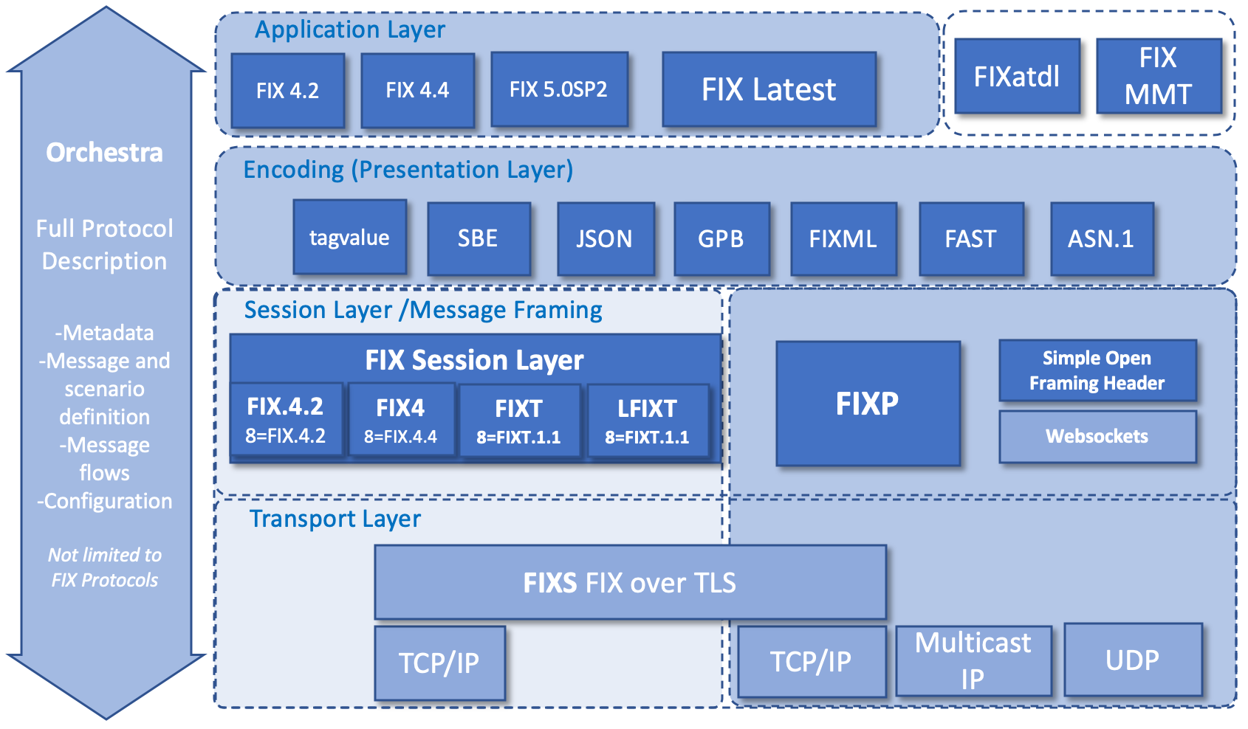
Figure 1 - FIX Technical Standard Stack

Business Requirements
Counterparties have typically agreed on a single FIX version as part of their Rules of Engagement defining the specific messages, fields and values supported between them. In terms of strict FIX compliance, this would exclude the usage of any elements from higher versions, including the usage of new enumerations for existing fields or new message types.
However, regulatory requirements have more or less forced the FIX community to include user-defined fields, values, or to use new standard elements from higher versions - i.e. the notion of a single “FIX version” no longer applied to the vast majority of FIX connections out there. The usage of elements from higher versions is an official FIX policy: The Global Technical Committee (GTC) Governance Board recommends that fields/tags and enumeration values from later versions of FIX which meet the business or implementation requirements of FIX be retro-fitted into the implementation.
The business requirement is to support the use of FIX session protocols other than FIX Transport (FIXT) that was introduced with FIX 5.0, especially to support the FIX session protocols for FIX 4.2 and FIX 4.4. This removes the barrier of having to change the FIX Session Layer in order to fully benefit from FIX Latest, i.e. to change the value of BeginString(8).

Extension of BeginString(8)
Initially, FIX did not offer any choices beneath the application layer in the technical stack. Up to and including FIX 4.2, the encoding had to be tag=value. Prior to FIX 5.0, the application and session layer were tightly coupled with a single value of BeginString(8) identifying both of them. The technical stack of FIX generation 4 (FIX 4.x) was monolithic with respect to the FIX Session Layer.
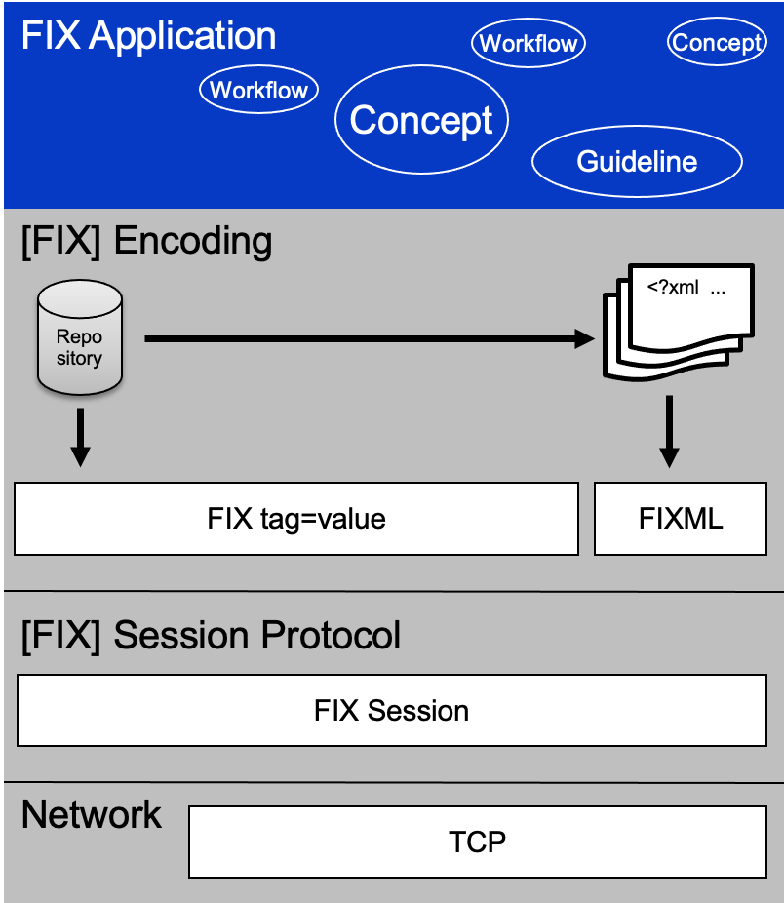

FIX 5.0 changed this paradigm by introducing the concept of Transport Independence and made the session protocol as of FIX 5.0 have its own name (FIX Transport a.k.a. FIXT) and versioning (v1.1). The value of BeginString(8) no longer contained the application layer version. It was replaced with the identification of the session protocol, i.e. “FIXT.1.1”.
As of FIX 5.0, the identification of the application version became optional with either ApplVerID(1128) used on each application message or DefaultApplVerID(1137) used once in the Logon(35=A) message and applying to all messages sent in that session. This has not changed with FIX Latest.
It is proposed to support multiple values for BeginString(8) when using FIX Latest over the FIX Session Layer. It is not proposed to support the of use different values of BeginString(8) in the same session, i.e. the counterparties need to agree on the single value used for all messages of a given session. This value only identifies the session profile and does not limit the use of any messages, components, fields or values from FIX Latest. The following table maps the FIX session profiles to their values in BeginString(8) (source: https://www.fixtrading.org/standards/fix-session-layer-online#fix-session-profiles).

FIX session profile | BeginString(8) | Description
FIX.4.2 | FIX.4.2 | The FIX session profile for use with the FIX 4.2 application layer.
FIX4 | FIX.4.4 | The FIX session profile backward compatible with FIX 4.4 recommended when counterparties will only be using a single application version during the FIX session, such as FIX Latest.
FIXT | FIXT.1.1 | The FIX session profile that must be used when mixing multiple application versions over the same FIX session. May be used with a single application version of FIX such as FIX Latest.
LFIXT | FIXT.1.1 | Lightweight FIXT restricted session layer message recovery to simplify the protocol while maintaining compatibility with FIXT when using LFIXT compatible model of operation.

It is proposed that BeginString(8) supports the following values:
- “FIX.4.2”, i.e. session profile FIX.4.2
- “FIX.4.4”, i.e. session profile FIX4
- “FIXT.1.1”, i.e. session profiles FIXT and LFIXT

Usage of ApplVerID(1128) and CstmApplVerID(1129)
It is possible to explicitly identify the standard application version by using ApplVerID(1128) and ApplExtID(1156) in the StandardHeader component. This does not mean that all messages, components, fields, and values of this version are supported. The supported subset still needs to be agreed between the counterparties.
Note that only the use of BeginString(8)=“FIXT.1.1” together with ApplVerID(1128) continues to support the use of different application versions within a single session. For example, NewOrderSingle(35=D) and ExecutionReport(35=8) messages may use ApplVerID(1128)=4 (FIX42) while TradeCaptureReport(35=AE) uses ApplVerID(1128)=9 (FIX50SP2).
However, it is recommended to rather exchange FIX Orchestra XML files out-of-band to define the supported messages, components, fields, and values.
The <repository> element of a FIX Orchestra XML file contains the attribute “version” that can be used to define the one's own version of the meta-data used for the given interface. This value can then be conveyed in the field CstmApplVerID(1129) to identify the correct meta-data file.
Linking CstmApplVerID(1129) to Orchestra meta-data file is also an option to support backward compatibility by allowing two different values (e.g. current and previous interface version) in application messages. The message recipient can then draw upon the correct Orchestra XML file to validate the message content. Furthermore, the Orchestra pedigree attributes (e.g. added, updated, deprecated) may be used to reflect the changes in your interface.

Issues and Discussion Points

There are no issues or discussion points.

Proposed Message Flow
There are no changes to existing FIX message flows.

FIX Message Tables
There are no changes to existing FIX message tables.

FIX Component Blocks
There are no changes to existing FIX component blocks.

Category Changes
There are no changes to existing categories.

Appendix A - Data Dictionary

Tag | FieldName | Action | Datatype | Description | FIXML Abbreviation | Add to / Deprecate from Message type or Component block
8 | BeginString | CHANGE | String | Identifies beginning of new message and session protocol version by means of a session profile identifier (see FIX Session Layer for details). ALWAYS FIRST FIELD IN MESSAGE. (Always unencrypted).  Valid values:  FIX.4.2 = Session profile FIX.4.2  FIX.4.4 = Session profile FIX4  FIXT.1.1 = Session profile FIXT or LFXIT [Elaboration: The choice between FIXT and LFIXT is subject to counterparty agreement.] | @BeginString
1128 | ApplVerID | CHANGE | String | Specifies the service pack release application layer version being applied at message level. Enumerated field with values assigned at time of service pack release | @ApplVerID

Appendix B - Glossary Entries

Term | Definition | Field where used

Appendix C - Abbreviations

Term | Proposed Abbreviation | Proposed Messages, Components, Fields where used

Appendix D - Usage Examples

Example 1: New enumeration value
- FIX session runs FIX 4.2 (BeginString(8)=“FIX.4.2”)
- Business requirement to support SEC rule change (SR-FINRA-2012-026) relating to the handling of stop and stop limit orders
- A stop order that is triggered by a bid or offer price movement (quote) at which point the stopped order becomes a market/limit order, also known as “stop [limit] on quote” in the US
- FIX Latest is to use new values of OrdType(40) that were added by EP166
  - BeginString(8)=“FIX.4.2”
  - OrdType(40)=R (Stop on Bid or Offer) a.k.a. “stop on quote” in the US
  - OrdType(40)=S (Stop Limit on Bid or Offer) a.k.a. “stop limit on quote” in the US

Example 2: Repeating group structure
- FIX session runs FIX 4.2 (BeginString(8)=“FIX.4.2”)
- Application currently uses ExecBroker(76) to identify the executing firm
- MiFID II requirement to convey LEI of the executing firm as well as the investment decision maker
- FIX Latest is to move away from ExecBroker(76) and use the Parties component instead
  - BeginString(8)=“FIX.4.2”
  - NoPartyIDs(453)=2
  - PartyRole(452)=1 (Executing firm), PartyIDSource(447)=N (LEI)
  - PartyRole(452)=122 (Investment decision maker)

Example 3: New message type
- FIX session runs FIX 4.2 (BeginString(8)=“FIX.4.2”)
- Business requirement to support trade reports in addition to execution reports
- Choices
  - Use a user-defined message TradeCaptureReport(35=UAE)
  - Use the standard message TradeCaptureReport(35=AE) with its required fields and values
- FIX Latest is to use the TradeCaptureReport(35=AE) message as-is
  - BeginString(8)=“FIX.4.2” in both ExecutionReport(35=8) and TradeCaptureReport(35=AE)

The LFIXT session profile uses the same BeginString(8) value as the FIXT session profile. The use of LFIXT and its mode of operation must be agreed upon out-of-band by counterparty agreement.

